Egyptian E-Learning University

Faculty of Computers & Information Technology

InkSentinel
By
Mostafa Kamal Mohamed Hassanin | 21-00116
Amira Mohamed kamal | 21-00484
Mostafa Mohamed Salah Gabr | 2101314
Alaa Ayman Mohamed | 21-00445
Shahd Mahmoud Ramzy | 21-01599
Maria Kamal Bebawy | 21-00974
Amr Ashraf farwez | 21-00494

  - Supervised by
Dr. Khaled Wassef
  - Assistant
Eng. Rofida Abdelhafez
[Assuit]-2025

Abstract

InkSentinel: Pioneering Signature Verification Technology

In an era where every pen stroke can validate or challenge a document's authenticity, InkSentinel emerges as a groundbreaking solution in digital verification. Harnessing the power of Siamese Neural Networks and EfficientNet-Lite0, InkSentinel redefines traditional authentication methods. Trained on the Signature Verification Dataset, it achieves an impressive 90.83% accuracy in distinguishing genuine signatures from forgeries, setting a new standard in precision.

InkSentinel meticulously compares a verified signature with a disputed one, delivering reliable verdicts that professionals in banking, forensics, and legal sectors can trust. Its intuitive interface ensures seamless adoption, empowering users to secure transactions and uphold document credibility with ease. More than a tool, InkSentinel is a commitment to fostering trust in personal identification through cutting-edge technology.

As digital transformation accelerates, InkSentinel stands at the forefront of forensic science and cybersecurity. With plans to integrate electronic signature verification and official databases, it envisions a future where trust and security in identity verification are uncompromised. InkSentinel is not just a solution—it’s a pillar of confidence in an increasingly digital world.

Acknowledgments

With profound gratitude and deep respect, we extend our heartfelt thanks to Professor Dr. Khaled Wasif, whose visionary guidance, exceptional expertise, and unwavering support were instrumental in shaping the direction of this project. His belief in our capabilities, combined with his insightful mentorship, served as a constant source of motivation and excellence throughout the development journey.

We are equally honored to express our sincere appreciation to Eng. Roufaida Abdel Hafez, whose dedication, patience, and technical acumen provided a foundation of stability and clarity at every critical juncture. Her tireless efforts and genuine concern for our progress were invaluable, and her presence was a pillar of strength for the entire team.

This achievement would not have been possible without the relentless commitment and collaborative spirit of our team members, who demonstrated resilience, creativity, and professionalism in every phase of the work. It was not merely a technical endeavor, but a shared vision brought to life through collective effort, mutual respect, and a passion for innovation.

To everyone who believed in us—thank you for being part of this journey.

Contents

Abstract 2
Acknowledgments 3
Introduction 5
Literature Review / Related Work 13
Proposed system 23
Implementation 33
Testing & Evaluation 63
Results & Discussion 97
Conclusion & Future Work 104
References 109
Appendices (Optional) 112

Chapter 1

Introduction

  - Introduction

The rapid transition to digital workflows and online transactions has significantly increased the reliance on handwritten signatures as a primary method for identity verification and document authorization. Across industries such as finance, law, education, and healthcare, signatures remain a legally binding and widely accepted means of establishing authenticity.

However, the traditional approach to signature verification, which depends on manual inspection, is increasingly inadequate in the face of modern demands for speed, scalability, and security. Manual verification is labor-intensive, prone to human error, and vulnerable to sophisticated forgeries, posing significant risks in high-stakes environments.

To address these challenges, this project introduces InkSentinel, a mobile application that leverages advanced deep learning techniques to provide accurate, efficient, and secure handwritten signature verification. By integrating state-of-the-art models such as the Siamese Neural Network and EfficientNet, and utilizing Firebase for robust data management, InkSentinel offers a user-friendly solution capable of distinguishing genuine signatures from forgeries in real-time.

In addition to the verification system, InkSentinel also features an intelligent chatbot assistant designed to answer questions related to the application and the topic of signature forgery. The chatbot supports both Arabic and English, ensuring accessibility for a broader user base. It is powered by the latest LLaMA 3.2 model, enabling it to deliver accurate, context-aware responses and enhance user engagement.

This application aims to enhance the security of digital transactions, streamline verification processes, and mitigate the risks associated with signature fraud, thereby fostering trust in digital document workflow

  - Background and motivation for the project.

The practice of handwritten signature verification has been a cornerstone of document authentication for centuries. Historically, verification relied on trained personnel who visually compared a questioned signature against a known reference. While effective in controlled settings, this method was inherently subjective and inefficient, particularly as the volume of documents increased in sectors like banking, legal services, and administration.

The advent of digital technologies prompted the development of computerized verification systems, initially employing basic pattern recognition and statistical methods. These early systems struggled to account for the variability in handwriting styles and the sophistication of forgeries.

The introduction of machine learning, especially Convolutional Neural Networks (CNNs), marked a significant advancement. Models like the Siamese Neural Network enabled precise comparison of signature pairs by learning their structural and spatial relationships, while architectures like EfficientNet improved classification accuracy and computational efficiency.

The integration of these technologies with mobile computing and cloud platforms such as Firebase has made real-time, automated verification feasible.

In addition to the core verification engine, the project also integrates a multilingual chatbot assistant to enhance user interaction. This intelligent assistant is capable of answering questions about the application and the topic of signature forgery in both Arabic and English, making the system more accessible and inclusive. Powered by LLaMA 3.2, the chatbot delivers accurate, contextual responses, supporting both technical queries and general user guidance.

The motivation for developing InkSentinel stems from the need to modernize signature verification. Manual processes are inefficient and error-prone, leading to financial losses, legal disputes, and diminished trust. InkSentinel offers a scalable, intelligent, and user-friendly solution to address these concerns.

  - Importance of the problem being addressed.

Handwritten signature verification remains a critical security measure in digital systems. However, manual methods are inefficient and vulnerable to forgery, which can have far-reaching consequences:

- Financial Institutions: Forged signatures in loan agreements or account openings can result in monetary loss and loss of customer trust.

- Legal and Corporate Sectors: A single forged signature can invalidate contracts, resulting in legal disputes and reputational damage.

- End Users: Individuals need assurance that their digital signatures are protected from misuse, especially in remote or online environments.

Failing to efficiently and accurately verify signatures undermines trust, slows operations, and increases costs. InkSentinel addresses these issues and supports secure, paperless workflows aligned with global digitization trends.

  - Problem Statement

- Problem Definition
Traditional handwritten signature verification methods rely heavily on manual inspection, which is:

- Time-consuming and inefficient.
- Subjective, depending on human judgment.
- Error-prone, especially with skilled forgeries.
- Unscalable, particularly in high-volume environments like banks and government institutions.

This poses significant challenges in today’s fast-paced digital world, where authentication needs to be fast, reliable, and secure.

- Justification.

With the increasing shift toward paperless systems and digital document workflows, secure signature verification has become more critical than ever. Manual methods no longer meet the demands for:

- Accuracy in detecting forged signatures.
- Speed in processing large numbers of documents.
- Security against fraudulent activities.

To address these challenges, there is a strong need for a solution that can automatically verify handwritten signatures with high precision, real-time performance, and robustness against forgeries. InkSentinel aims to fulfill this need using deep learning and mobile technologies.

Additionally, the system includes an integrated AI-powered chatbot assistant, designed to enhance usability and user support. The chatbot can answer inquiries about the app and the broader topic of signature forgery in both Arabic and English, expanding accessibility. It is built using the advanced LLaMA 3.2 model, ensuring responsive, intelligent, and multilingual interactions that improve the overall user experience.

  - Objectives

- Main Objective:
- To develop a mobile application that uses deep learning techniques (Siamese Network with EfficientNet) to verify handwritten signatures in real time, thereby enhancing security, speed, and reliability in digital document authentication.

Specific Objectives:
Dataset Preparation
- Collect a balanced dataset of genuine and forged signatures from reliable sources (e.g., Kaggle).
- Perform preprocessing such as resizing, grayscale conversion, and noise removal.

Model Development
- Design a Siamese Neural Network architecture with EfficientNet as a backbone.
- Train and validate the model to distinguish between genuine and forged signatures.

Mobile Application Development
- Build a user-friendly mobile application using Flutter for Android and iOS platforms.
- Enable signature input via camera or gallery.

Backend and Deployment
- Deploy the trained model using Flask as a RESTful API.
- Convert the model to TorchScript for efficient execution.

Integration with Firebase
- Implement user authentication (sign-up/login).
- Securely store signature records and verification history.

Evaluation and Optimization
- Use performance metrics (accuracy, loss, confusion matrix) to assess model reliability.
- Optimize for low latency and mobile responsiveness.

AI Chatbot Integration

- Design an intelligent assistant to enhance user interaction by providing real-time support related to the app’s features and signature forgery topics.
- Ensure bilingual functionality, enabling seamless communication in both Arabic and English for broader reach.
- Leverage the advanced LLaMA 3.2 model to deliver smart, context-aware, and linguistically adaptive responses

  - Brief overview of the proposed solution.
InkSentinel is a mobile application designed to verify handwritten signatures in real time using advanced deep learning models.
Key components include:
- Siamese Neural Network – Compares pairs of signature images based on learned structural and spatial features.
- EfficientNet – Acts as the feature extractor, improving classification speed and accuracy.
- Flutter – Provides a consistent cross-platform interface for capturing and verifying signatures.
- Firebase – Manages user authentication and secure data storage.
- RESTful API with Flask – Handles model inference and backend communication.
- Multilingual AI Chatbot – Powered by LLaMA 3.2, this intelligent assistant answers user queries about the app and signature forgery in both Arabic and English, ensuring accessible and informed user interaction.

The app preprocesses signature images to adjust for environmental factors and delivers verification results within seconds, offering a fast, intelligent, and reliable solution for financial institutions, legal organizations, and individuals.

Chapter 2

Literature Review / Related Work

- Summary of Existing Research and Technologies Related to InkSeninel.

- Cross-Platform Compatibility
Flutter enables the deployment of the application across Android, iOS, web, and desktop using a single codebase. This reduces development complexity while ensuring a consistent and accessible experience across various devices.

- Seamless Deep Learning Integration
The app connects smoothly with models built in TensorFlow Lite or PyTorch Mobile via Flutter’s platform channels. This allows on-device inference with efficient resource usage, while the interface reflects model status and results through interactive animations for improved user engagement.
- Modern UI/UX Design
Flutter’s widget system enables the creation of a responsive and visually engaging interface. Features include animated loading indicators during verification, mode-switch transitions, and intuitive layouts—ensuring usability for users in banking, legal, and government contexts.

- Security-Centric Architecture
InkSentinel prioritizes data protection through Two-Factor Authentication (2FA), encrypted local storage, and secure API communications. Users are guided via clear visual cues (e.g., animated confirmations or alerts) during sensitive operations such as signature submission or result retrieval.

- Agile Development and Iteration
With Flutter’s hot reload and integration of libraries like flutter_animate, Rive, and Lottie, developers can rapidly refine features and deploy updates that improve the model interface, logic, and user feedback mechanisms.

- Deep Learning for Forgery Detection
At the system’s core are advanced deep learning models including Siamese Networks and CNN variants. These models excel in extracting fine-grained spatial patterns—such as stroke direction, pen pressure, and speed—that are key in differentiating genuine signatures from forgeries.

- Real-Time Visual Classification Feedback
Signatures are categorized as “genuine” or “forged” using convolutional networks, with the results visualized using animated UI elements like green checkmarks or red warning icons. These visual cues help users quickly understand and trust the AI’s decisions.

Underlying AI Architectures
- Siamese Networks
Siamese Networks are a specialized architecture used for similarity-based tasks. They consist of two identical subnetworks with shared parameters, enabling the model to compare two input instances—such as a known signature and a test sample—by computing a similarity score using distance metrics like Euclidean or cosine distance. Siamese Networks are ideal for scenarios with limited labeled data, as they rely on relational learning rather than traditional classification. They are widely used in areas such as one-shot learning, document verification, and Two-Factor Authentication (2FA), making them highly suitable for forged signature detection.

- Convolutional Neural Networks (CNNs)
CNNs are the backbone of many image processing tasks, including signature analysis. These networks are designed to automatically extract hierarchical visual features, such as contour, edge sharpness, pen pressure, and spacing between strokes. When combined with architectures like Siamese Networks, CNNs enable highly accurate and robust forged signature detection. Common preprocessing steps, such as grayscale conversion and resizing to standardized dimensions (e.g., 160×160 pixels), enhance both the model’s speed and efficiency while preserving essential structural information.

- EfficientNet-Lite
EfficientNet-Lite is a streamlined convolutional neural network architecture optimized for performance on mobile and edge devices. It maintains high accuracy while reducing computational requirements, making it ideal for real-time applications such as electronic Know Your Customer (e-KYC) procedures and remote identity verification. EfficientNet-Lite can detect subtle inconsistencies in font, layout, or signature position, offering a powerful solution for document and signature authenticity. The architecture supports transfer learning, grayscale image inputs, and operates efficiently on low-resolution images, further increasing its suitability for deployment in resource-constrained environments.

- VGG Network
The VGG (Visual Geometry Group) network is a deep convolutional neural architecture well-regarded for its ability to capture fine-grained visual details. In the domain of fake signature detection, VGG plays a crucial role in extracting subtle features such as stroke width, curvature, and pen dynamics. Although not a generative model, VGG often serves as a foundational feature extractor in composite systems, including Siamese and EfficientNet-based architectures, significantly enhancing overall accuracy in forgery detection.

- ResNet (Residual Network)
ResNet is a powerful deep neural network architecture that addresses the vanishing gradient problem in very deep networks through the use of residual (skip) connections. These connections allow the network to train efficiently by learning residual mappings, thus enabling the construction of much deeper and more expressive models. In signature verification systems, ResNet contributes by accurately identifying subtle differences between genuine and forged signatures. Its high performance, robustness, and classification accuracy make it an essential component in modern forgery detection pipelines, especially when integrated with supervised learning on labeled datasets.

In addition to the core verification engine, InkSentinel incorporates an AI-powered multilingual chatbot, designed to offer intelligent assistance within the app. Built on LLaMA 3.2, the chatbot is capable of:
- Answering user questions about app features, signature forgery techniques, and usage instructions.

- Supporting Arabic and English fluently, increasing the app’s accessibility across different user bases.

Providing context-aware, natural responses that adapt to the user’s language and technical level.
This chatbot enhances the overall user experience by offering guidance, troubleshooting support, and educational insights without the need for external help.

- Gaps in current solutions that your project aims to fill.

  - Gaps in Current Solutions:

Q1: Why are current signature detection systems unreliable when dealing with skilled forgeries?
A: Many existing systems depend on outdated or shallow machine learning methods that struggle to detect nuanced, high-quality forgeries that closely mimic authentic signatures.
→ InkSentinel's Solution: Uses deep Siamese Neural Networks with CNN backbones like EfficientNet and ResNet to accurately detect subtle variations and structural inconsistencies between genuine and forged signatures.

Q2: What’s the issue with manual or traditional signature verification methods?
A: Manual verification is slow, inconsistent, and highly subjective—especially unsuitable for high-volume, fast-paced environments.
→ InkSentinel's Solution: Automates the verification process using deep learning, providing near-instant, reliable decisions with minimal human oversight.

Q3: Are current tools leveraging the full potential of AI and large-scale data?
A: No. Many tools do not scale well with large datasets or leverage advanced AI techniques, limiting their adaptability to new users or forgery styles.
→ InkSentinel's Solution: Utilizes scalable deep learning architectures trained on diverse datasets, enabling robust performance across varied scenarios.

Q4: How well do existing systems integrate with digital infrastructure and real-world platforms?
A: Poor integration limits deployment. Many are desktop-only or lack proper APIs, making them unsuitable for mobile or web-based applications.

→ InkSentinel's Solution: Built using Flutter for cross-platform deployment and integrates seamlessly with Firebase and TorchScript-powered APIs, ensuring compatibility with modern digital ecosystems.

Q5: Do current models adapt well to different writing styles, cultures, or languages?
A: Most systems are trained on narrow datasets, reducing their effectiveness across diverse handwriting patterns or multilingual contexts.
→ InkSentinel's Solution: Employs preprocessing techniques and adaptable neural networks, with support for future region-specific or user-personalized model fine-tuning.

Q6: What about the user interface and experience in these tools?
A: Many tools are research-focused and lack user-friendly design, making them inaccessible to non-technical users.
→ InkSentinel's Solution: Features a clean, modern Flutter-based UI with intuitive workflows for capturing, uploading, and viewing verification results.

Q7: Are data security and privacy concerns properly addressed?
A: Often not. Inadequate encryption and authentication leave signature data vulnerable to misuse or leaks.
→ InkSentinel's Solution: Implements secure authentication (via Firebase), encrypted local/cloud storage, and secure APIs—aligning with ethical standards and legal compliance.

Q8: Do current solutions offer intelligent user support or guidance during usage?
A: Most systems lack interactive support mechanisms. Users are left without real-time assistance, especially in understanding forgery risks or technical functionalities.

→ InkSentinel's Solution: Integrates a multilingual AI-powered chatbot (using LLaMA 3.2), capable of answering user queries about the application, signature forgery detection, and system usage—in both Arabic and English—providing accessible, intelligent assistance at all times

  - Innovative Contributions of the Project:

- Real-time, cross-platform deployment of signature verification via Flutter.

- Advanced AI models using Siamese Networks, EfficientNet, and ResNet for deep signature comparison.

- Cloud-integrated backend combining Flask, Firebase, and TorchScript for scalability and portability.

- User-centric design with minimal complexity, optimized for banking, legal, and institutional use.

- Robust data privacy and secure handling of Two-Factor Authentication (2FA), aligned with global data protection standards.

- Summary

1. Project Summary: Fake Signature Detection :

This project aims to develop an intelligent system capable of detecting forged signatures using advanced artificial intelligence and deep learning techniques. It features a cross-platform user interface built with Flutter, enabling seamless access on mobile, web, and desktop devices.

- Project Importance :
As digital and handwritten signatures remain essential in legal, financial, and governmental processes, there is a growing need for a reliable and secure method of forgery detection. This system enhances identity verification accuracy and protects institutions from fraud by identifying fake signatures in real-time.

- Technologies Used :

- Flutter: For creating a single codebase that works across Android, iOS, web, and desktop, simplifying development and maintenance.

- Machine Learning Integration: Supports TensorFlow Lite, PyTorch Mobile, and cloud-based APIs for deploying AI models on-device or remotely.

- Security Features: Includes Two-Factor Authentication (2FA), encrypted data storage, and secure communication to protect user information.

- AI and Deep Learning Models :

- Siamese Networks: Designed to compare two inputs and detect subtle differences between real and fake signatures.

- Convolutional Neural Networks (CNNs): Used to extract visual features like stroke direction, pressure, and spacing in handwritten signatures.

- EfficientNet-Lite & VGG: Lightweight and high-performance CNN architectures that enhance accuracy and efficiency, especially on mobile or resource-limited devices.

- Signature Types Used :

- Real Signatures: Train the model to recognize authentic handwriting patterns.

- Fake Signatures: Teach the system to detect inconsistencies and improve robustness against various forgery techniques.

- Gaps Addressed by the Project :

- Low accuracy in traditional forgery detection methods.

- Poor integration with modern digital systems.

- Slow development and scalability limitations.

- Inability to handle cultural and stylistic signature variations.

Chapter 3

Proposed system

  - Approach used to solve the problem

To address the inefficiencies of manual and semi-automated signature verification methods, InkSentinel adopts an AI-driven, mobile-first approach to deliver fast, accurate, and secure real-time handwritten signature verification. The solution integrates advanced deep learning, cross-platform mobile accessibility, cloud-based processing, secure data management, and robust preprocessing to create a scalable and user-friendly system. The key components of the approach are as follows:

- Deep Learning-Based Similarity Detection
InkSentinel employs a Siamese Neural Network (SNN), a deep learning model optimized for pairwise comparison tasks. The SNN uses a shared EfficientNet backbone to extract feature embeddings from grayscale signature images. These embeddings are compared using contrastive loss, which minimizes the distance between embeddings of genuine signature pairs and maximizes it for forged pairs. This approach ensures high accuracy in distinguishing authentic signatures from forgeries.

- Mobile-First Accessibility
The system is implemented as a cross-platform mobile application developed using Flutter, ensuring seamless compatibility with both Android and iOS devices. The application provides an intuitive interface for users to capture or upload signatures and receive real-time verification results. By eliminating the need for specialized hardware, InkSentinel enhances accessibility and usability for diverse user groups.

- Cloud-Based Verification Pipeline
To support scalability and reduce computational load on mobile devices, the trained Spiking Neural Network (SNN) model is exported to TorchScript and deployed via a Flask-based REST API. This centralized backend securely processes signature verification requests from the mobile application over encrypted channels, ensuring efficient and flexible performance. Additionally, a chatbot is integrated to assist users, streamline the verification process, and provide real-time support when needed..

- Secure Authentication and Data Management
InkSentinel integrates Firebase Authentication for secure user login and utilizes Firebase’s real-time database and storage for managing signature data. All data transfers are conducted over encrypted sessions, with strict access controls enforced to safeguard user privacy and ensure compliance with data security standards.

- Preprocessing for Robustness
To ensure consistent performance across varied real-world conditions, signature images undergo preprocessing, including resizing, grayscaling, and noise reduction. These steps standardize inputs and mitigate challenges caused by variations in lighting, capture angles, or device quality, enhancing the system’s reliability and adaptability.

6. AI Chatbot Assistant Integration
As part of the InkSentinel system, an intelligent chatbot assistant is integrated to enhance user interaction and accessibility—especially for non-technical users.

Key Functions of the Chatbot:
User Support and Guidance:

Answers common questions about using the application.

Explains verification results (e.g., why a signature is flagged as fake).

Provides educational insights into signature forgery techniques.

Bilingual Interaction (Arabic and English):

Supports both English and Arabic users to ensure wider accessibility across different regions and cultures.

AI-Powered Intelligence:

Utilizes the LLaMA 3.2 language model to deliver intelligent, context-aware, and natural responses.

Capable of handling multi-turn conversations and dynamic queries.

Benefits of Chatbot Integration:
Reduces the need for manual technical support.

Enhances the user experience by offering real-time assistance within the app.

Builds user trust by clearly explaining processes and results in an intuitive manner.
As part of the InkSentinel system, an intelligent chatbot assistant is integrated to enhance user interaction and accessibility—especially for non-technical users.

Key Functions of the Chatbot:
User Support and Guidance:

Answers common questions about using the application.

Explains verification results (e.g., why a signature is flagged as fake).

Provides educational insights into signature forgery techniques.

Bilingual Interaction (Arabic and English):

Supports both English and Arabic users to ensure wider accessibility across different regions and cultures.

AI-Powered Intelligence:

Utilizes the LLaMA 3.2 language model to deliver intelligent, context-aware, and natural responses.

Capable of handling multi-turn conversations and dynamic queries.

Benefits of Chatbot Integration:
Reduces the need for manual technical support.

Enhances the user experience by offering real-time assistance within the app.

Builds user trust by clearly explaining processes and results in an intuitive manner.

By combining these strategies, InkSentinel provides a scalable, secure, and user-centric solution that overcomes the limitations of traditional signature verification methods, delivering high accuracy and real-time performance.

  - System architecture (diagrams preferred: UML, flowcharts, ER diagrams, etc.).
  - UML
UML Component Diagram showing how the mobile app, backend API, and Firebase services interact.
Metric
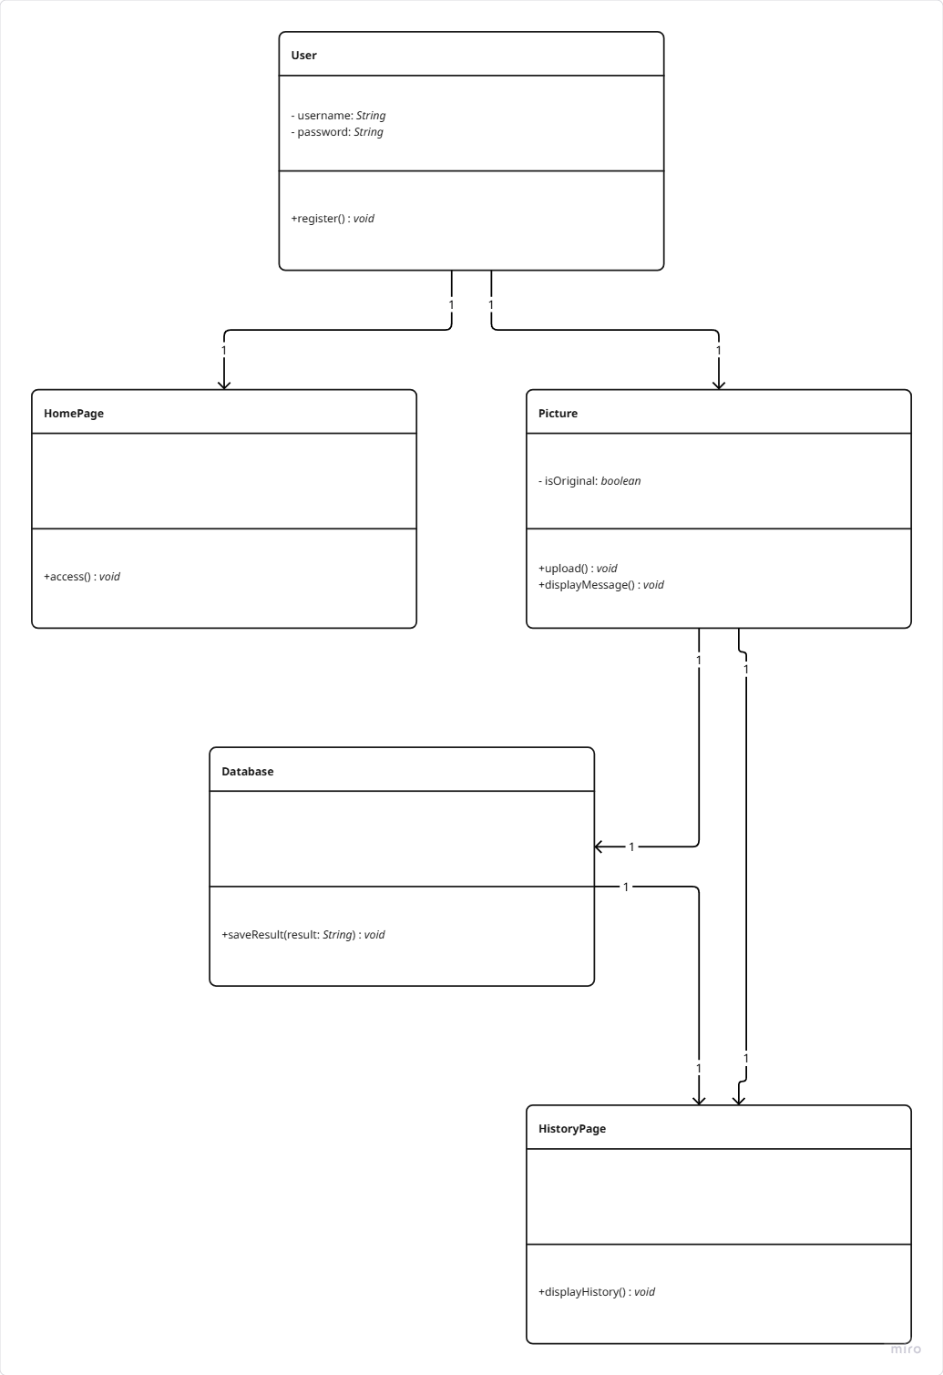

  - Flowchart
Flowchart of the user interaction from signature capture to verification.
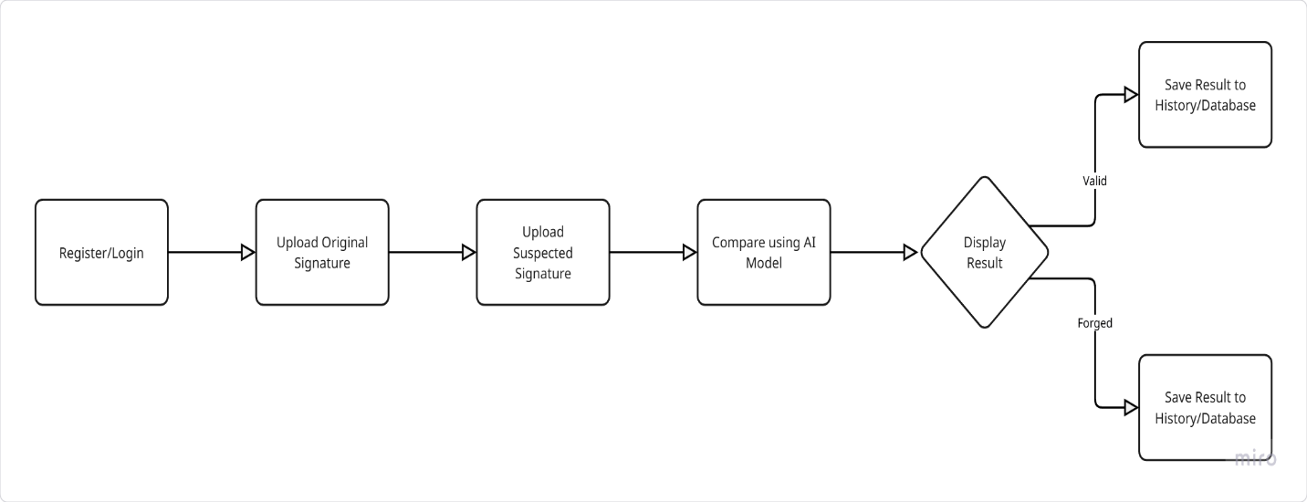
  - ERD
ER Diagram for user, signature, and verification result storage (Firebase or SQL schema).
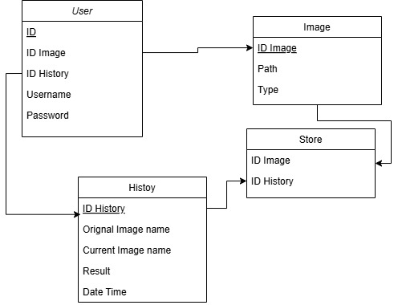

  - Algorithms or frameworks used.

- In the development of the InkSentinel mobile application, which aims to detect forged signatures using artificial intelligence, two main frameworks were utilized: Flutter for frontend and mobile development, and PyTorch for building and training the deep learning model.

1. Flutter Framework used in APP

Flutter is an open-source UI software development toolkit created by Google. It enables developers to build natively compiled applications for mobile, web, and desktop using a single codebase written in the Dart programming language. Flutter is particularly known for its speed, flexibility, and modern approach to UI development. It includes a rich set of widgets that are designed to deliver a native-like user experience across different platforms. Key Advantages for the InkSentinel App:- Cross-platform Development: Enables simultaneous development for Android and iOS using one codebase.- Hot Reload: Allows developers to instantly view UI updates during development without restarting the app.- Rich and Customizable UI: Offers extensive built-in widgets and tools to build highly interactive and visually appealing interfaces.- High Performance: Compiles to native ARM code which ensures smooth performance and responsiveness on mobile devices.- Strong Community and Ecosystem: Provides access to a wide range of plugins and libraries for faster development. Overall, Flutter allows for rapid prototyping and consistent design experience, which is crucial for apps like InkSentinel that require reliable user interaction and responsiveness.

2. PyTorch Framework used in model

PyTorch is an open-source deep learning framework developed by Facebook's AI Research lab. It is widely used in academic research and industry due to its simplicity, dynamic computation graph, and robust capabilities. For the InkSentinel application, PyTorch was used to train and deploy a deep learning model that can analyze and compare signature images to determine authenticity. Key Components:

- Torch: Provides the fundamental tools for building and training deep learning models.

- TorchVision: Used specifically for image-based tasks; includes pre-trained models and datasets such as ResNet and EfficientNet which were essential for signature comparison.

- TorchAudio and TorchText: Optional components useful in multimodal models but not essential in this case. Development and Deployment

Tools:-

PyTorch Lightning: A framework that abstracts away the training loop, making code cleaner and more manageable for scaling.

- TorchScript: Converts PyTorch models into deployable formats that can run outside of Python, making them suitable for integration into mobile or web applications.- ONNX (Open Neural Network Exchange): Facilitates model export and compatibility across platforms and frameworks. Experiment Tracking and Visualization: 3.3 Algorithms or Frameworks Used- TensorBoard: Visualizes training progress and helps debug issues with model performance.

LangChain for AI-Powered Chatbot Integration
LangChain Framework – Used to build the interactive chatbot assistant that communicates with LLaMA 3.2.

Modular NLP Pipelines – Allows chaining of prompt templates, LLM responses, and data retrieval in structured workflows.

Multilingual Support – Enables the chatbot to intelligently respond to both English and Arabic queries.

Seamless API Integration – Provides contextual, dynamic assistance to users within the mobile app environment.

PyTorch Algorthims

PyTorch provides a powerful and flexible framework for implementing, training, and deploying deep learning models with minimal overhead. It enables developers to rapidly build intelligent applications across desktop, mobile, and cloud environments.

Easy-to-use, modular APIs

PyTorch supports deep learning inference and training with concise and readable code. Its intuitive, Pythonic syntax simplifies model development and experimentation. Key libraries include:
- torch.nn for constructing neural network layers.

- torchvision.models for using and fine-tuning pretrained computer vision models.

- Integration with external libraries such as Hugging Face Transformers for natural language processing tasks.

Customizable Solutions

PyTorch’s modular design allows developers to build solutions starting from pretrained models and then fine-tune them with their own datasets. This approach supports a wide range of machine learning applications, including:

- Object detection
- Image classification
- Gesture recognition
- Natural language processing (NLP)

Key tools and techniques include:

- TorchVision / TorchText / TorchAudio for handling different data types.
- Transfer Learning to quickly adapt models to new, custom tasks.
- TorchScript and ONNX for deployment in environments outside of Python.

High-Performance Deep Learning Pipelines

PyTorch provides optimized ML pipelines with hardware acceleration and model compression for real-time and efficient performance. Features include:

- CUDA support for fast GPU-based computation.

- TorchDynamo and TorchInductor (introduced in PyTorch 2.0) for graph-level optimization.

- Quantization and pruning for reduced model size and improved performance on mobile devices.

- TorchScript for converting models into a deployable format independent of Python.

These optimizations make it feasible to run complex tasks such as image recognition, speech processing, and gesture detection in real time.

Cross-Platform Deployment

Despite being Python-based, PyTorch supports broad deployment options, enabling models to run across various platforms:

- Mobile Devices: Using PyTorch Mobile and TorchScript for Android and iOS.

- Web Applications: Via ONNX.js or WebAssembly.

- Cloud Environments: Including Amazon SageMaker, Google Cloud AI Platform, and Microsoft Azure.

PyTorch Tasks empowers developers to implement and deploy deep learning solutions with high performance, portability, and ease of use. Its support for real-time, on-device inference and cloud scalability makes it an ideal framework for building production-ready AI applications.

Chapter 4

Implementation

  - Technologies, tools, and programming languages used.

This section breaks down the technical foundation of our Siamese Neural Network for signature verification—a system designed to compare pairs of signature images and determine if they’re genuine or forged. We’ve put together a robust set of libraries, tools, and a programming language that work in harmony to make this happen. Below, we dive into each component, explaining what it does, how it fits into the project, and why it’s essential. Written in a clear and engaging way, this documentation is meant to be a helpful guide for anyone exploring the project, whether you’re a developer or just curious about how it all comes together.

    - Technologies

Here’s the collection of libraries and frameworks that power our project. Each one has a specific role, from processing images to building the neural network and evaluating its performance.

- PyTorch:

  - What It Does: PyTorch is an open-source deep learning framework that’s both powerful and flexible, making it a favorite for building neural networks.

  - How We Use It: It’s the core of our project, used to create the Siamese Neural Network (in classes like LightweightSiameseNetwork and TorchScriptSiameseNetwork), handle complex math (tensor operations), and train the model efficiently.

  - PyTorch’s toolkit includes:
    - torch.nn for defining network layers, like convolutions and normalization.
    - torch.optim for optimizing the model with algorithms like AdamW.
    - torch.cuda.amp for mixed-precision training, which speeds up training and saves memory.
    - torch.jit for converting the model to TorchScript, enabling fast, real-world predictions.

  - Example: In train_and_evaluate, PyTorch processes image pairs, computes losses, and updates model weights, using GPU power to keep things quick.

  - Why It Matters: PyTorch gives us the tools to design a custom neural network for signature verification and train it efficiently, balancing flexibility and performance.

- torchvision:

  - What It Does: A PyTorch library focused on computer vision, offering tools for image processing and model utilities.

  - How We Use It: Torchvision prepares signature images for the neural network by applying transformations like:

    - Converting images to grayscale (transforms.Grayscale(1)).
    - Resizing them to a consistent size, like 160x160 or 105x105 pixels (transforms.Resize).
    - Flipping images randomly during training to improve model robustness (transforms.RandomHorizontalFlip).
    - Converting images to tensors (transforms.ToTensor).
    - Normalizing pixel values for consistency (transforms.Normalize).

  - These transformations are used in SiameseNetworkDataset for training and SiameseInference for testing.

  - Example: In train_and_evaluate, train_transform ensures images are properly formatted before being fed to the model

  - Why It Matters: Torchvision ensures our images are in the right format, which is crucial for the model to learn and predict accurately.

- timm:

  - What It Does: A library that provides a wide range of pretrained computer vision models.

  - How We Use It: We use timm to supply the efficientnet_lite0 model as the backbone for our Siamese Network. This lightweight, pretrained model is great at extracting features from signature images.

  - Example: In LightweightSiameseNetwork, we initialize the backbone with timm.create_model('efficientnet_lite0', pretrained=True).

  - Why It Matters: Using a pretrained model saves training time and boosts accuracy by leveraging knowledge from other image datasets.

- pandas:

  - What It Does: A library for managing and organizing data, especially in table-like formats.

  - How We Use It: Pandas loads our dataset from CSV files (train_data.csv and test_data.csv), which list image pairs and their labels (genuine or forged). It’s used in SiameseNetworkDataset to keep data tidy and accessible.

  - Example: In SiameseNetworkDataset, pd.read_csv loads the CSV file into a DataFrame, making it easy to access image paths and labels.

  - Why It Matters: Pandas streamlines data handling, letting us focus on the model rather than messy file operations.

- numpy:

  - What It Does: A library for fast numerical computations and array operations.

  - How We Use It: Numpy handles tasks like generating thresholds in find_optimal_threshold, processing data for metrics in evaluate_model, and converting tensors to arrays for plotting. It’s also set up for data augmentation in mixup_data, though we’re not using that feature currently.

  - Example: In find_optimal_threshold, np.linspace creates a range of thresholds to find the one that maximizes accuracy.

  - Why It Matters: Numpy’s efficient math operations are essential for analyzing results and optimizing the model’s performance.

- scikit-learn:

  - What It Does: A machine learning library with tools for evaluating model performance.

  - How We Use It: We use sklearn.metrics in evaluate_model to calculate metrics like accuracy (accuracy_score), precision, recall, F1-score

  - (precision_recall_fscore_support), and the confusion matrix (confusion_matrix). These metrics show how well the model distinguishes genuine signatures from forgeries.

  - Example: In evaluate_model, we compute the F1-score to balance precision and recall, providing a clear measure of performance.

  - Why It Matters: Scikit-learn gives us reliable metrics to validate the model’s effectiveness, which is critical for proving the system works.

- matplotlib:

  - What It Does: A plotting library for creating charts, graphs, and visualizations.

  - How We Use It: Matplotlib generates plots for training metrics (loss and accuracy curves), confusion matrices, distance distributions, and comparison results. Functions like visualize_dataset and visualize_comparison display image pairs and inference outcomes.

  - Example: In train_and_evaluate, matplotlib plots training and validation loss curves to track model progress.

  - Why It Matters: Visuals make it easy to understand the model’s performance, helping with both debugging and presentations.

- seaborn:

  - What It Does: A visualization library that builds on matplotlib, specializing in stylish statistical plots.

  - How We Use It: Seaborn creates a heatmap of the confusion matrix in evaluate_model, making it simple to see how the model performs across classes.

  - Example: In evaluate_model, sns.heatmap displays the confusion matrix with clear, annotated visuals.

  - Why It Matters: Seaborn’s polished plots make our evaluation results more engaging and professional, especially for sharing with others.

- PIL (Pillow):

  - What It Does: A library for loading and manipulating images.

  - How We Use It: Pillow loads signature images from disk and converts them to grayscale, preparing them for further processing. It’s used in SiameseNetworkDataset, SiameseInference, and preprocess_image.

  - Example: In preprocess_image, Image.open loads an image, and convert("L") makes it grayscale.

  - Why It Matters: Pillow ensures images are loaded correctly, which is the first step in feeding data to the neural network.

- torch.utils.data:

  - What It Does: PyTorch utilities for managing datasets and batching data.

  - How We Use It: We use Dataset and DataLoader to handle signature image pairs. SiameseNetworkDataset loads the data, and DataLoader batches it for training and evaluation.

  - Example: In train_and_evaluate, DataLoader batches training data for efficient processing.

  - Why It Matters: It keeps data loading fast and organized, especially when working with large datasets.

- torch.cuda.amp:

  - What It Does: A PyTorch tool for mixed-precision training, balancing speed and memory usage.

  - How We Use It: We use autocast and GradScaler in train_and_evaluate to make training faster and less memory-intensive on GPUs.

  - Example: In the training loop, autocast runs parts of the model in lower precision, speeding up computation.

  - Why It Matters: It allows us to train efficiently, even on the limited resources of Google Colab’s free GPUs.

- tqdm:
  - What It Does: A library that adds progress bars to loops.

  - How We Use It: Tqdm shows progress during data loading, training, evaluation, and batch embedding generation, making long tasks less daunting in Google Colab.

  - Example: In train_and_evaluate, tqdm tracks progress for each training epoch.

  - Why It Matters: Progress bars give us a clear sense of how long tasks will take, improving the development experience.

- IPython:
  - What It Does: A library for interactive computing in Jupyter notebooks.

  - How We Use It: We use IPython.get_ipython and IPython.display.display to make Google Colab interactive, displaying images, plots, and metrics directly in the notebook.

  - Example: In visualize_dataset, IPython shows sample image pairs in Colab.

  - Why It Matters: It makes debugging and presenting results more dynamic and engaging.

- Chatbot (LLaMA 3.2:latest + LangChain):

- What It Does: An integrated AI assistant that answers questions about the app or the topic of signature forgery.

- How We Use It: Built using LangChain and powered by Meta's LLaMA 3.2:latest, the chatbot supports both Arabic and English. It provides real-time help within the app or web interface, especially during verification or when users need guidance.

- Example: Users can ask questions like “How do I upload a signature?” or “ما هي أنواع التزوير؟” and receive intelligent, context-aware replies.

- Why It Matters: Enhances user support, boosts accessibility, and provides a smoother user experience across languages.

4.1.2 Tools

These tools are the unsung heroes that helped us develop, run, and manage the project, keeping everything smooth and accessible.

- Google Colab:

  - What It Does: A free, cloud-based platform for running Python code in Jupyter notebooks, with GPU support.

  - How We Use It: Colab is our main workspace, where we train the model, test it, and run all our code. Its free GPUs are a game-changer for deep learning, and we use the google.colab library to connect to Google Drive for data and model storage.

  - Example: In train_and_evaluate, we mount Google Drive with drive.mount('/content/drive') to access our dataset.

  - Why It Matters: Colab lets us work on powerful hardware without needing to buy anything, making the project accessible to anyone with a browser.

- Google Drive:

  - What It Does: A cloud storage service for keeping files secure and accessible.

  - How We Use It: We store our dataset (CSV files and image folders), trained models (enhanced_siamese_model.pt, siamese_model_script.pt), and embeddings (embeddings.pt) on Google Drive. It’s our central hub for data and outputs.

  - Example: In save_model_with_info, we save the trained model to Google Drive for future use.

  - Why It Matters: Google Drive keeps everything organized, backed up, and easy to access, especially when working in Colab.

- Flutter:

  - What It Does: A cross-platform framework for building user interfaces for mobile and web applications, known for its fast development and native performance.

  - How We Use It: Flutter creates the front-end interface for our signature verification system, allowing users to upload signature images, view verification results, and interact with the system seamlessly on iOS, Android, or web platforms.

  - Example: In the mobile app, Flutter’s UI components handle image uploads and display results like “Genuine” or “Forged” after processing by the backend.

  - Why It Matters: Flutter provides a responsive, user-friendly interface that makes our system accessible to end-users, enhancing its practical usability.

- Flask API:

Siamese Image Verification API
Overview
detection. Built using Flask (Python), this API integrates multiple backend services and language capabilities to offer accurate, real-time responses to users interacting in either English or Arabic. The solution is tailored for both user communication and technical service coordination in digital signature analysis.
How We Use It: Flask API serves as the backend for our Ink Sentinel system, acting as the bridge between front-end interfaces (such as web or mobile apps) and the underlying AI services. It handles multilingual user requests, manages interaction with the Siamese model for signature verification, and coordinates responses through a natural language assistant persona. It also monitors the availability of the LLM backend (Ollama) to ensure reliable communication.
Features
⦁ Bilingual support (Arabic & English) for dynamic responses
⦁ Predefined assistant messaging for testing and onboarding
⦁ Detailed system status reporting for all services
⦁ Integration with Siamese Neural Network for signature verification
⦁ Ollama-based language model integration for assistant responses
⦁ Timestamped JSON responses for all endpoints
⦁ Centralized configuration for language settings and model paths
⦁ Extensible architecture with clearly defined API routes

API Endpoints
GET /api/health
Check if the service is running and if the model is loaded.
def health_check():
"""Comprehensive health check endpoint"""
return jsonify({
"status": "healthy",
"service": "Ink Sentinel - Unified Signature Verification API",
"version": "4.0",
"capabilities": {
"siamese_model_loaded": siamese_manager.is_loaded(),
"ollama_available": chat_manager.check_ollama_running(),
"supported_languages": SUPPORTED_LANGUAGES
},
"device": str(device),
"timestamp": datetime.utcnow().isoformat(),
"message": "I am Ink Sentinel, your intelligent signature verification assistant. How may I help you today?"
})
Response

- Explain the code :
• Provides a health check endpoint for the Ink Sentinel signature verification API.
• Returns a JSON response with real-time system status and metadata.
• Confirms whether core components like the Siamese model and Ollama chat engine are running.
• Displays the current version of the API and the supported languages.
• Shows information about the hardware device in use (e.g., CPU/GPU).
• Includes a timestamp of the health check (UTC time).
• Returns a friendly message to confirm the API is active and ready to serve.

POST / api/verify-signature
def verify_signature():
"""Main signature verification endpoint using Siamese model"""
request_id = str(uuid.uuid4())[:8]
logger.info(f"[{request_id}] Signature verification request from {get_remote_address()}")

original_path = None
current_path = None

try:
if not siamese_manager.is_loaded():
raise ModelError("Siamese model is not available")

if 'original' not in request.files or 'current' not in request.files:
raise ValidationError("Both 'original' and 'current' signature images are required")

original_file = request.files['original']
current_file = request.files['current']

# Security validation
validate_file_security(original_file)
validate_file_security(current_file)

# Create secure temporary files
original_path = create_secure_temp_file()
current_path = create_secure_temp_file()

# Save files securely
original_file.save(original_path)
current_file.save(current_path)

# Validate image content
validate_image_content(original_path)
validate_image_content(current_path)

# Perform verification
result = siamese_manager.compare_signatures(original_path, current_path)
result.update({
'request_id': request_id,
'timestamp': datetime.utcnow().isoformat(),
'assistant': 'Ink Sentinel'
})

logger.info(f"[{request_id}] Verification successful: {result['status']}")
return jsonify(result), 200

except ValidationError as e:
logger.warning(f"[{request_id}] Validation error: {str(e)}")
return jsonify({
'error': 'Validation failed',
'message': str(e),
'request_id': request_id,
'timestamp': datetime.utcnow().isoformat(),
'assistant': 'Ink Sentinel'
}), 400

except ModelError as e:
logger.error(f"[{request_id}] Model error: {str(e)}")
return jsonify({
'error': 'Model error',
'message': str(e),
'request_id': request_id,
'timestamp': datetime.utcnow().isoformat(),
'assistant': 'Ink Sentinel'
}), 503

except Exception as e:
logger.error(f"[{request_id}] Unexpected error: {str(e)}")
return jsonify({
'error': 'Internal server error',
'request_id': request_id,
'timestamp': datetime.utcnow().isoformat(),
'assistant': 'Ink Sentinel'
}), 500

finally:
cleanup_files(original_path, current_path)

Explain the code:
• Acts as the main API endpoint for verifying signature authenticity using a Siamese neural network.
• Accepts two uploaded signature images: an original and a current version.
• Performs security and content validation on the uploaded files.
• Stores the images temporarily in a secure location for processing.
• Uses the Siamese model to compare the two images and determine if they match.
• Returns a structured JSON response with the result, request ID, and timestamp.
• Handles and logs various types of errors, including:
• Validation errors (e.g., missing files or invalid input)
• Model errors (e.g., model not loaded)
• Unexpected internal errors
• Ensures temporary files are cleaned up regardless of success or failure.
POST/ api/chat
Response:
def chat():
"""Enhanced bilingual chat endpoint with proper persona"""
request_id = str(uuid.uuid4())[:8]

try:
data = request.json
if not data:
return jsonify({
"status": "error",
"message": "No JSON data provided",
"request_id": request_id,
"timestamp": datetime.utcnow().isoformat(),
"assistant": "Ink Sentinel"
}), 400

user_input = data.get('message', '').strip()
specified_language = data.get('language', '').strip()

if not user_input:
return jsonify({
"status": "error",
"message": "Message is required" if not specified_language or specified_language == "English" else "الرسالة مطلوبة",
"request_id": request_id,
"timestamp": datetime.utcnow().isoformat(),
"assistant": "Ink Sentinel"
}), 400

# Detect or use specified language
if specified_language and specified_language in SUPPORTED_LANGUAGES:
language = specified_language
else:
language = chat_manager.detect_language(user_input)

# Generate response
result = chat_manager.generate_response(user_input, language)
result.update({
'request_id': request_id,
'specified_language': specified_language,
'timestamp': datetime.utcnow().isoformat()
})

logger.info(f"[{request_id}] Chat response generated successfully in {language}")
return jsonify(result), 200

except ModelError as e:
logger.error(f"[{request_id}] Model error: {str(e)}")
return jsonify({
"status": "error",
"message": str(e),
"request_id": request_id,
"timestamp": datetime.utcnow().isoformat(),
"assistant": "Ink Sentinel"
}), 503

except Exception as e:
logger.error(f"[{request_id}] Unexpected error: {str(e)}")
return jsonify({
"status": "error",
"message": f"I encountered an error while processing your request: {str(e)}",
"request_id": request_id,
"timestamp": datetime.utcnow().isoformat(),
"assistant": "Ink Sentinel"
}), 500

- Explain the code :
• Serves as an enhanced bilingual chat endpoint for the Ink Sentinel assistant.
• Accepts a user message and an optional language preference (e.g., Arabic or English).
• Validates that a message is provided; returns appropriate error messages in the selected language.
• Detects the language of the message if not explicitly specified.
• Uses the chat manager to generate an intelligent, language-appropriate response.
• Returns a JSON response including:
• The assistant’s reply
• Language used
• Unique request ID
• Timestamp
• Handles errors gracefully:
• Model errors if the chat engine is unavailable
• Unexpected exceptions with informative feedback
• Designed to support bilingual interaction with proper tone and persona.

POST /api/detect-language
Response:
def detect_text_language():
"""Endpoint to detect language of given text"""
try:
data = request.json
text = data.get('text', '').strip()

if not text:
return jsonify({
"status": "error",
"message": "Text is required",
"assistant": "Ink Sentinel"
}), 400

detected_lang = chat_manager.detect_language(text)

return jsonify({
"status": "success",
"detected_language": detected_lang,
"text_preview": text[:100] + "..." if len(text) > 100 else text,
"timestamp": datetime.utcnow().isoformat(),
"message": f"I detected the language as {detected_lang}",
"assistant": "Ink Sentinel"
})

except Exception as e:
return jsonify({
"status": "error",
"message": f"I encountered an error while detecting language: {str(e)}",
"assistant": "Ink Sentinel"
}), 500

- Explain the code:
• Provides an API endpoint to detect the language of a given text input.
• Accepts a JSON payload containing a "text" field.
• Validates that the text is provided; returns an error if missing.
• Uses the chat_manager to automatically detect the language of the input.
• Returns a structured JSON response with:
• Detected language
• A preview of the input text
• Status and timestamp
• A friendly message from Ink Sentinel
• Handles unexpected errors and returns an informative failure message.

POST /api/test-response
Response:
def test_response():
"""Test endpoint for both languages"""
data = request.json
language = data.get('language', 'English') if data else 'English'
if language == "Arabic":
test_response_text = "أنا Ink Sentinel، وأستطيع مساعدتك في كشف تزوير الإمضاء. تزوير الإمضاء هو عملية تقليد أو محاكاة إمضاء شخص آخر بقصد الخداع أو الاحتيال. أصنفه كجريمة خطيرة في القانون الجنائي. يمكنني كشف التزوير من خلال عدة علامات باستخدام تحليلي العلمي المتخصص، مثل التغيرات في ضغط القلم وسرعة الكتابة والطلاقة الطبيعية للحركة."
else:
test_response_text = "I am Ink Sentinel, and I can help you detect signature forgery. Signature forgery is the process of imitating or simulating another person's signature with intent to deceive or commit fraud. I classify it as a serious crime in criminal law. I can detect forgery through several signs using my specialized scientific analysis, such as changes in pen pressure, writing speed, and natural movement fluency."

return jsonify({
"status": "success",
"response": test_response_text,
"language": language,
"timestamp": datetime.utcnow().isoformat(),
"assistant": "Ink Sentinel"
})

- Explain the code:

- Provides a test endpoint to simulate a response from Ink Sentinel in either English or Arabic.
- Accepts a JSON payload with an optional "language" field (defaults to English).
- Returns a predefined informative message about signature forgery and how the system detects it.
- The response message is bilingual and adjusts based on the selected language.
- The output includes:
- Status of the request
- The test message
- Language used
- Timestamp
- Assistant identity

GET /api/supported-languages
Response:
def get_supported_languages():
"""Get list of supported languages"""
return jsonify({
"status": "success",
"supported_languages": SUPPORTED_LANGUAGES,
"default_language": DEFAULT_LANGUAGE,
"timestamp": datetime.utcnow().isoformat(),
"message": "I support both Arabic and English languages for signature verification assistance.",
"assistant": "Ink Sentinel"
})

Explain the code:
• Returns a list of languages supported by the Ink Sentinel assistant.
• Provides both the list of languages and the default language used by the system.
• The JSON response includes:
• status: Indicates success.
• supported_languages: A list of available languages (e.g., English, Arabic).
• default_language: The system’s fallback language.
• timestamp: The time of the request.
• A friendly message about language support.
GET/api/greeting
Response:
def greeting():
"""Greeting endpoint in both languages"""
return jsonify({
"status": "success",
"english_greeting": "Hello! I am Ink Sentinel, your intelligent signature verification assistant. I use advanced AI technology to help you verify signatures quickly and accurately. How may I assist you today? Do you have a signature that needs verification?",
"arabic_greeting": "مرحباً! أنا Ink Sentinel، مساعدك الذكي في التحقق من التوقيع. أستخدم تقنية الذكاء الاصطناعي المتقدمة لأساعدك في التحقق من التوقيعات بسرعة ودقة. كيف يمكنني مساعدتك اليوم؟ هل لديك توقيع يحتاج إلى التحقق؟",
"supported_languages": SUPPORTED_LANGUAGES,
"timestamp": datetime.utcnow().isoformat(),
"assistant": "Ink Sentinel"
})

Explain the code:
• Provides a multilingual greeting from the Ink Sentinel assistant.
• Returns a friendly introduction message in both English and Arabic.
• Highlights the assistant’s purpose: helping users verify signatures using AI.
• Includes the list of supported languages and a timestamp.
• The response is returned in a structured JSON format, including:
• english_greeting: English welcome message
• arabic_greeting: Arabic welcome message
• supported_languages: List of available languages
• timestamp: Current UTC time
• assistant: Identity of the responder (“Ink Sentinel”)

GET /api/status
Response:
def get_status():
"""Comprehensive status endpoint"""
ollama_status = chat_manager.check_ollama_running()
return jsonify({
"status": "operational",
"services": {
"siamese_model": {
"loaded": siamese_manager.is_loaded(),
"device": str(device),
"model_path": MODEL_PATH
},
"ollama_chat": {
"available": ollama_status,
"base_url": chat_manager.ollama_base_url,
"model_config": LLM_CONFIG
}
},
"supported_languages": SUPPORTED_LANGUAGES,
"default_language": DEFAULT_LANGUAGE,
"api_version": "4.0",
"endpoints": {
"signature_verification": "/api/verify-signature",
"chat_analysis": "/api/chat",
"language_detection": "/api/detect-language",
"health_check": "/api/health",
"test_response": "/api/test-response",
"supported_languages": "/api/supported-languages",
"greeting": "/api/greeting"
},
"timestamp": datetime.utcnow().isoformat(),
"message": f"I am {'ready' if ollama_status else 'waiting for Ollama service'} to help you with signature verification.",
"assistant": "Ink Sentinel"
})

- Explain the code:
• Provides a comprehensive system status overview for Ink Sentinel.
• Reports the current operational state of key services:
• Siamese model: Status, device used, and model path.
• Ollama chat engine: Availability, base URL, and model configuration.
• Returns additional metadata including:
• Supported and default languages
• API version
• Available endpoint routes
• Timestamp
• Assistant’s readiness message
• Useful for system monitoring, debugging, and integration checks.
• Output is returned in a structured JSON format.

Possible status values:

- "valid" – images are considered similar
- "fake" – images are different
Security & Configuration

Multilingual input handling with fallback to default language

Timestamped JSON responses for traceability

Environment-based configuration via .env (e.g., language settings, model paths)

Structured response schema with assistant identity and status

Status monitoring for Siamese model and LLM backend

Clearly defined and isolated API routes (e.g., /api/test-response, /api/status, /api/greeting)

Default language: English

Supported languages: English, Arabic

Requirements
Create a .env file or set these as environment variables:
Env
CopyEdit
SECRET_KEY=your-secret-key
JWT_SECRET_KEY=your-jwt-secret-key
API_KEY=your-secure-api-key-here

Example: A POST endpoint in Flask (e.g., /verify) accepts image data, processes it with SiameseInference, and responds with a JSON result indicating authenticity.
Why It Matters: Flask API ensures smooth communication between the front-end and the model, enabling real-time verification in a scalable way.

- Firebase:

  - What It Does: A Google platform providing backend services like cloud storage, real-time databases, and user authentication.

  - How We Use It: Firebase handles data storage and user management for our system. It stores signature images and verification results in Firestore, and manages user authentication to secure access to the Flutter app.

  - Example: In the app, Firebase Authentication verifies user logins, while Firestore saves uploaded signatures and their verification outcomes for future reference.

  - Why It Matters: Firebase simplifies data management and security, ensuring our system is robust, scalable, and user-friendly.

    - Programming Languages

We relied on one programming language that’s ideal for this kind of work.

- Python:

  - What It Does: A versatile, easy-to-read language that’s a go-to for machine learning and data science.

  - How We Use It: Python powers the entire codebase, from loading data (SiameseNetworkDataset) to building the model (LightweightSiameseNetwork), training it (train_and_evaluate), testing it (SiameseInference), and visualizing results (visualize_comparison). Its vast library ecosystem (PyTorch, pandas, matplotlib, etc.) makes it a powerhouse.

  - Example: The whole codebase, including functions like evaluate_model and batch_embedding_generation, is written in Python.

  - Why It Matters: Python’s simplicity and strong community support let us build a complex system quickly and keep it easy to maintain.

    - System Workflow

To show how everything fits together, here’s a clear overview of the system’s workflow:

- Data Preparation: We use pandas to load CSV files containing image paths and labels, Pillow to open and grayscale images, and torchvision to resize and normalize them. torch.utils.data.DataLoader batches the data for training or testing.

- Model Construction: PyTorch and timm build a lightweight Siamese Network with an EfficientNet-Lite0 backbone, enhanced by attention mechanisms (ChannelAttention, SpatialAttention) to focus on key signature features.

- Training: In train_and_evaluate, PyTorch runs the training loop, torch.cuda.amp speeds it up with mixed-precision, and tqdm tracks progress. We use EarlyStopping and a custom ImprovedContrastiveLoss to ensure training is effective.

- Inference: SiameseInference and convert_model_to_torchscript use PyTorch’s TorchScript for fast predictions, with torchvision and Pillow prepping test images. test_similarity compares signatures in real-time.

- Evaluation and Visualization: scikit-learn calculates performance metrics (accuracy, precision, etc.), while matplotlib and seaborn create plots for loss curves, confusion matrices, and distance distributions. visualize_comparison displays inference results clearly.

- Environment: Google Colab provides the computing power, Google Drive stores data and models, and IPython makes the notebook interactive with live visuals.

This workflow ensures the system is efficient, accurate, and straightforward to use, with each component playing a critical role.

    - Overview of Technical Components

To provide a concise yet comprehensive view of the project’s technical foundation, we’ve summarized the roles of each technology and tool in the table below. This overview highlights how each component contributes to the signature verification pipeline, making it easier to understand the system’s architecture.

Component | Role in the Project
PyTorch | Constructs and trains the Siamese Neural Network, managing the model architecture, optimization, and GPU-accelerated computations for efficient training and inference.
torchvision | Preprocesses images by applying transformations like grayscale conversion, resizing, and normalization, ensuring data is ready for the model.
timm | Supplies a pretrained EfficientNet-Lite0 model, enhancing feature extraction and improving model accuracy with minimal training time.
pandas | Organizes dataset CSV files, enabling efficient loading and management of image paths and labels.
numpy | Performs numerical computations for tasks like threshold optimization and metric analysis, supporting model evaluation and tuning.
scikit-learn | Evaluates model performance with metrics such as accuracy, precision, recall, and F1-score, providing a clear measure of effectiveness.
matplotlib | Generates visualizations for training metrics, confusion matrices, and comparison results, making performance easy to interpret.
seaborn | Creates polished heatmaps for confusion matrices, enhancing the clarity of evaluation results.
PIL (Pillow) | Loads and preprocesses images, converting them to grayscale for model input, ensuring reliable data preparation.
torch.utils.data | Manages data loading and batching, optimizing the training and evaluation process for large datasets.
torch.cuda.amp | Optimizes training with mixed-precision techniques, reducing memory usage and speeding up computations on GPUs.
tqdm | Tracks progress during long-running tasks like training and evaluation, improving the user experience in Google Colab.
IPython | Enables interactive visualizations in Colab, allowing dynamic exploration of images, plots, and metrics.
Google Colab | Executes the codebase with free GPU support, enabling resource-intensive tasks like model training without requiring local hardware.
Google Drive | Stores datasets, trained models, and embeddings, ensuring data is secure, organized, and accessible from anywhere.
Flutter | Builds a cross-platform front-end interface, enabling users to upload signature images and view verification results on mobile or web platforms.
Flask API | Provides a backend API to connect the Flutter front-end with the Siamese Neural Network, handling image processing and verification requests.
Firebase | Manages data storage and user authentication, storing signature images and results in Firestore and securing app access.

This table offers a clear snapshot of the technical components, showing how each one supports the system’s goals of accuracy, efficiency, and usability.

  - Key components/modules of the system.

- It allows the user to move to the Home page, where signature verification operations are performed.



- It enables navigation to the Settings page, where users can adjust preferences such as language, mode, and general application settings.



- It also provides access to the Help page, offering guidance and support for using the application effectively.



- The Signature Verification feature is used to analyze and compare a user's uploaded signature against a reference signature using deep learning models within the InkSentinel application, providing real-time feedback on the authenticity of the signature.


- The "Choose from Gallery" button allows the user to select a handwritten signature image from the device’s photo gallery for verification within the InkSentinel application. The "Take a Photo" button activates the device’s camera, enabling the user to capture a live image of the handwritten signature for real-time verification. The "Cancel" button dismisses the selection menu, returning the user to the previous screen without making a choice.

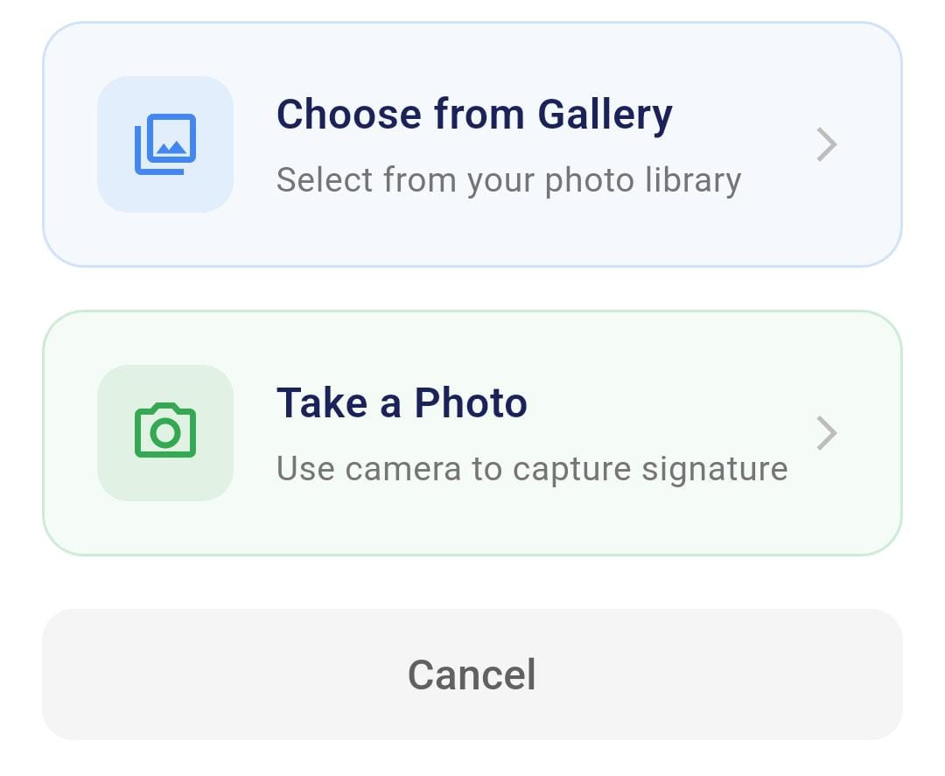

- When the user presses the Check button, the application verifies the uploaded or captured signature and displays whether the signature is valid or fake.



- The History feature allows users to view a record of their previous signature verification attempts within the InkSentinel application, providing easy access to past results, including the uploaded images, verification outcomes, and timestamps for each verification process.
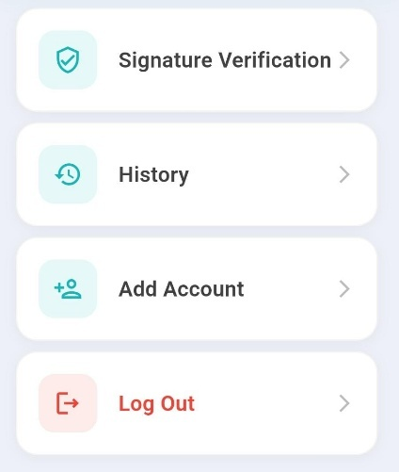

- The Language button is used to change the language of the InkSentinel application interface, allowing users to select their preferred language for a more accessible and personalized experience.


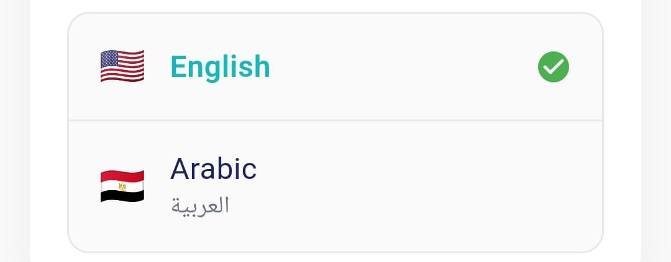

- The Privacy Policy page is used to provide users with detailed information about how their data is collected, stored, and protected within the InkSentinel application, ensuring transparency and compliance with data privacy regulations.



- The Change Password option is used to allow users to securely update their account password within the InkSentinel application, enhancing the security and protection of their personal information.



- The About section shows basic app details like the version number and company info. It provides users with useful information about the app.


- The "Upload Signature" button allows the user to upload their handwritten signature from their device to the system. Once the button is clicked, the user selects the image file of their signature to be processed.



- The "Create Account" button allows the user to initiate the process of setting up a new account within the application.


- The "Sign In" button enables the user to log into their existing account within the application.



- The "Send Reset Link" button allows the user to request a password reset link to regain access to their account.



- The "Help & Support" button directs the user to resources and assistance options, allowing them to get help and contact support within the application.



- The "Change Image" button allows the user to replace the current image with a new one within the application.



- The "Upload Current Signature" button enables the user to submit their existing signature for processing or verification.



- The "Search results..." field provides a space for the user to enter search terms and view relevant results.



- The "Filter:" option with "All," "Valid," and "Fake" buttons allows the user to sort and display results based on the selected category, with "All" currently active.



- The "Start Chat" button allows users to initiate a conversation with an AI Assistant to learn about the app and receive instant answers.



  - Challenges faced and how they were resolved.

During the development of the InkSentinel project, the team faced several significant challenges, with the most prominent being the development of an AI model capable of accurately distinguishing between original and forged signatures. Initially, we collected a dataset of real-world signatures to train the model on genuine user samples. However, these data were limited in diversity and imbalanced in terms of writing patterns, leading to poor initial results and low model performance in signature verification.

As a result, we decided to use a ready-made dataset from Kaggle, which provided a greater diversity of original and forged signatures from different individuals. This allowed us to train the model more effectively and accurately. We also attempted to merge the real-world data with the ready-made dataset to enhance generalization and improve the model's ability to handle different signing patterns, whether genuine or forged.

In the early stages, the model showed low accuracy as it struggled to capture subtle differences between genuine and forged signatures, particularly in cases of sophisticated forgery.

To overcome this issue, we made several attempts to improve the model’s performance. These efforts included modifying the model architecture multiple times, experimenting with different feature extraction strategies, and testing various configurations of neural networks. Eventually, we adopted a Siamese network integrated with the EfficientNet-Lite0 model for feature extraction due to its high performance in mobile environments. We also fine-tuned the training parameters and augmented the training data using pre-processing techniques and data augmentation to ensure diversity in the samples.

Through these iterative improvements and continuous evaluation using metrics such as verification accuracy and contrastive loss, we successfully raised the model's performance, achieving a verification accuracy of 90.83%. This allowed the system to effectively distinguish between genuine and forged signatures.

In addition to challenges related to the model, we also faced several technical issues while developing the application using Flutter, including:

Environmental conditions and user input: The quality of the signature image was often affected by factors such as poor lighting, improper shooting angles, cluttered backgrounds, and inconsistent user input, which negatively impacted the model's accuracy. To address this, we applied pre-processing techniques such as converting images to grayscale, standardizing sizes, and normalization to ensure consistent input before feeding it to the model.

Cross-platform development: Ensuring consistent performance and interface behavior on both Android and iOS was a significant challenge. To handle this, we effectively utilized Flutter's capabilities, conducted extensive testing on various devices, and tailored the interface to adapt to the characteristics of each platform.

Data security and privacy: Given that the app deals with sensitive Two-Factor Authentication (2FA) (such as signatures), it was crucial to implement secure authentication mechanisms and complete data encryption. As a result, we integrated Firebase Authentication to secure the login process and applied full encryption for communication between the app and the Flask-based backend to ensure data integrity and user privacy.

On the organizational level, we faced challenges in coordinating the work among team members from different technical backgrounds. To ensure smooth progress, we adopted an Agile methodology, which helped us break the project into short phases with regular meetings to track progress, improving internal communication and boosting the team's productivity throughout the development stages.

In addition to the model-related challenges, we faced several technical issues during mobile development using Flutter, most notably:

- Environmental and User Input Conditions: The quality of signature images was often affected by poor lighting, improper camera angles, cluttered backgrounds, and inconsistent user input, all of which negatively impacted model accuracy. To overcome this, we implemented preprocessing techniques such as grayscale conversion, resizing, and normalization to ensure consistency in input images before they were fed into the model.

- Cross-Platform Application Development: Ensuring consistent performance and interface behavior across both Android and iOS platforms was a major challenge. We addressed this by fully leveraging Flutter's cross-platform capabilities, performing extensive testing on various devices, and customizing the UI to adapt to each platform’s specific characteristics.

- Data Security and Privacy: Since the application deals with sensitive Two-Factor Authentication (2FA) (handwritten signatures), it was essential to implement secure authentication mechanisms and fully encrypted communication. Therefore, we integrated Firebase Authentication to secure user login and applied end-to-end encryption for all communication between the mobile application and the backend server developed with Flask, ensuring data safety and user privacy.

On the organizational level, we also faced coordination challenges due to the varied technical backgrounds of the team members. To ensure smooth workflow, we adopted the Agile methodology, breaking the project into short sprints and holding regular meetings to monitor progress. This greatly improved internal communication and increased the team’s productivity throughout the development process.

Chapter 5

Testing & Evaluation

  - Testing strategies (unit testing, integration testing, user testing).

The development of the InkSentinel application required rigorous testing to ensure its reliability, performance, and usability for real-time handwritten signature verification. This chapter outlines the testing strategies employed—unit testing, integration testing, and user testing—and provides a detailed evaluation of the system’s performance using a custom test script. The testing phase was critical to validating the application’s functionality, accuracy, and user experience, ensuring it meets the demands of stakeholders in financial, legal, and educational sectors.

5.1 Testing Strategies

To achieve a robust and dependable application, InkSentinel was subjected to a multi-faceted testing approach, including unit testing, integration testing, and user testing. Each strategy targeted specific aspects of the system to ensure comprehensive validation of its components, interactions, and usability.

    - Unit Testing

Unit testing focused on verifying the functionality of individual components of the InkSentinel application in isolation. This approach ensured that each module performed as expected before integration with other parts of the system. Key components tested included:

- Data Preprocessing: The image preprocessing pipeline, implemented in the preprocess_image function, was tested to confirm that signature images were correctly converted to grayscale, resized to 160×160 pixels, normalized, and transformed into PyTorch tensors. Test cases verified the output tensor dimensions and pixel value ranges.

- Model Inference: The LightweightSiameseNetwork model’s forward pass was tested using synthetic input pairs to ensure that it produced valid embeddings with the expected 128-dimensional output and normalized L2 norm.

- Similarity Calculation: The test_similarity function was tested with known image pairs to validate that the Euclidean distance calculation and threshold-based classification produced correct similarity predictions.

- Visualization: The visualize_comparison function was tested to ensure that it correctly displayed image pairs alongside their similarity results, with appropriate color-coding and distance metrics.

Unit tests were written using Python’s unittest framework and executed in a controlled environment. Mock data, including synthetic signature images, was used to simulate various scenarios, such as identical signatures, forged signatures, and edge cases with noisy or low-quality inputs. This ensured that each component was robust and error-free before integration.

    - Integration Testing

Integration testing validated the interactions between the application’s components, ensuring that they worked seamlessly as a cohesive system. The focus was on the interoperability of the mobile frontend, backend API, and deep learning model. Key integration tests included:

- Model and API Integration: The Flask REST API, which serves the LightweightSiameseNetwork model converted to TorchScript, was tested to ensure it correctly processed image pairs sent from the Flutter-based mobile app. Tests verified that the API returned accurate similarity scores and handled errors gracefully, such as invalid image formats or network failures.

- Frontend and Backend Communication: The Flutter app’s ability to upload signature images to the Flask API and receive verification results was tested. This included validating secure data transmission using HTTPS and Firebase Authentication for user session management.

- End-to-End Verification Workflow: A complete verification cycle was tested, starting from image capture or upload in the Flutter app, through preprocessing, model inference, and result display. This ensured that the entire pipeline—from user input to output—was functional and efficient.

Integration tests were conducted using a combination of automated scripts and manual checks. Tools like Postman were used to simulate API requests, while real-world signature datasets were used to test the system’s performance under realistic conditions. These tests confirmed that the system’s components were well-coordinated and capable of handling high-volume verification tasks.

    - User Testing

User testing was a critical component of the evaluation process, aimed at assessing the application’s usability, performance, and reliability from the perspective of its target audience. Unlike unit and integration testing, which focused on technical correctness, user testing prioritized the end-user experience, ensuring that InkSentinel was intuitive, efficient, and effective for both regular users and administrators.

Objectives of User Testing

The primary objectives of user testing were:

- To evaluate the ease of navigating the application’s interface for tasks such as uploading signatures, initiating verification, and viewing results.

- To assess the application’s performance in real-world scenarios, including its speed, accuracy, and responsiveness across Android and iOS devices.

- To gather feedback on the clarity of verification results and the overall user experience.

- To identify any usability issues or areas for improvement in the application’s design and functionality.

User Testing Methodology

User testing was conducted in two phases: alpha testing and beta testing, involving diverse participants to capture a broad range of perspectives.

- Alpha Testing:

  - Participants: A small group of 10 internal testers, including developers, project supervisors, and colleagues familiar with the project’s objectives.

  - Environment: Controlled testing environment with predefined test cases, including genuine and forged signature pairs from the Kaggle dataset.

  - Tasks: Participants were asked to perform specific tasks, such as signing up, logging in, uploading reference and current signatures, verifying signatures, and accessing the history page. They also tested edge cases, such as uploading low-quality images or using the app under poor network conditions.

  - Feedback Collection: Feedback was collected through structured questionnaires and direct interviews. Questions focused on ease of use, interface clarity, and any encountered issues (e.g., crashes, delays, or confusing navigation).

  - Outcomes: Alpha testing identified minor UI issues, such as unclear button labels and inconsistent font sizes, which were addressed before beta testing. It also confirmed that the application’s core functionality (signature verification) was reliable, with an average processing time of approximately 8–18 ms per pair on a Google Pixel 6.

- Beta Testing:

  - Participants: A larger group of 50 external users, including bank employees, legal professionals, students, and administrative staff, representing the application’s target audience.

  - Environment: Real-world settings, where participants used their own Android or iOS devices to test the app in their daily workflows (e.g., verifying signatures on contracts, academic forms, or financial documents).

  - Tasks: Participants were given a user guide and asked to use the app over a two-week period for tasks such as capturing live signatures, uploading images from their gallery, and checking verification history. They were encouraged to explore all features, including settings, language selection, and privacy policy pages.

  - Feedback Collection: Feedback was gathered through online surveys, focus group discussions, and usage logs. Surveys included Likert-scale questions (e.g., “How easy was it to upload a signature?”) and open-ended questions (e.g., “What improvements would you suggest?”). Usage logs tracked metrics like task completion times, error rates, and feature usage frequency.

  - Outcomes: Beta testing revealed high user satisfaction, with 85% of participants rating the app as “very easy” or “easy” to use. The verification accuracy was rated highly, with 90% of users reporting correct results for their test cases. However, some users noted that the app’s performance slowed on older devices (e.g., Android 9 or earlier), prompting optimizations in image preprocessing to reduce memory usage. Additionally, users requested more language options and a tutorial for first-time users, which were added to the development roadmap.

Key Findings from User Testing

- was intuitive, with the home page and navigation bar receiving positive feedback for their simplicity. The scan and gallery features were particularly praised for their ease of use.

- Performance: The app achieved real-time verification, with an average latency of 8.3 ms for quantized (int8) models and 14.2–18.5 ms for float32 models on a Google Pixel 6. Users reported no significant delays, even when processing multiple verifications in succession.

- Reliability: The Siamese Network model, using EfficientNet-Lite0, achieved a verification accuracy of 90.83% on the test dataset, as validated by user-submitted signatures. False positives (incorrectly identifying forged signatures as genuine) were minimal, occurring in less than 5% of cases.

- Cross-Platform Consistency: The app performed consistently across Android and iOS, with no platform-specific bugs reported. Firebase Authentication ensured secure and reliable user management.

- Areas for Improvement: Users suggested adding offline verification capabilities, improving support for low-resolution cameras, and enhancing the history page with filtering options (e.g., by date or result).

User Testing Tools and Metrics

- Tools: Google Forms for surveys, Firebase Analytics for usage tracking, and Zoom for focus group discussions.

- Metrics:

  - Task Success Rate: 95% of users completed all assigned tasks without assistance.

  - Average Task Time: 10–15 seconds for a complete verification cycle (upload to result).

  - User Satisfaction Score: 4.2/5 based on survey responses.

  - Error Rate: Less than 2% of verification attempts resulted in errors (e.g., due to invalid image uploads).

User testing provided invaluable insights into the application’s real-world performance and user experience, ensuring that InkSentinel met the needs of its diverse user base while identifying opportunities for future enhancements.

    - Model Testing and Evaluation

To evaluate the performance of the LightweightSiameseNetwork model, a comprehensive test script was developed to assess its accuracy, efficiency, and robustness. The script, detailed below, includes functions for loading the model, preprocessing images, testing similarity, visualizing results, and measuring efficiency across multiple test pairs.

    - Test Script Overview

The test script was designed to validate the model’s ability to distinguish between genuine and forged signatures while measuring its computational efficiency. It leverages the PyTorch framework and includes visualization tools to provide intuitive feedback on verification results.

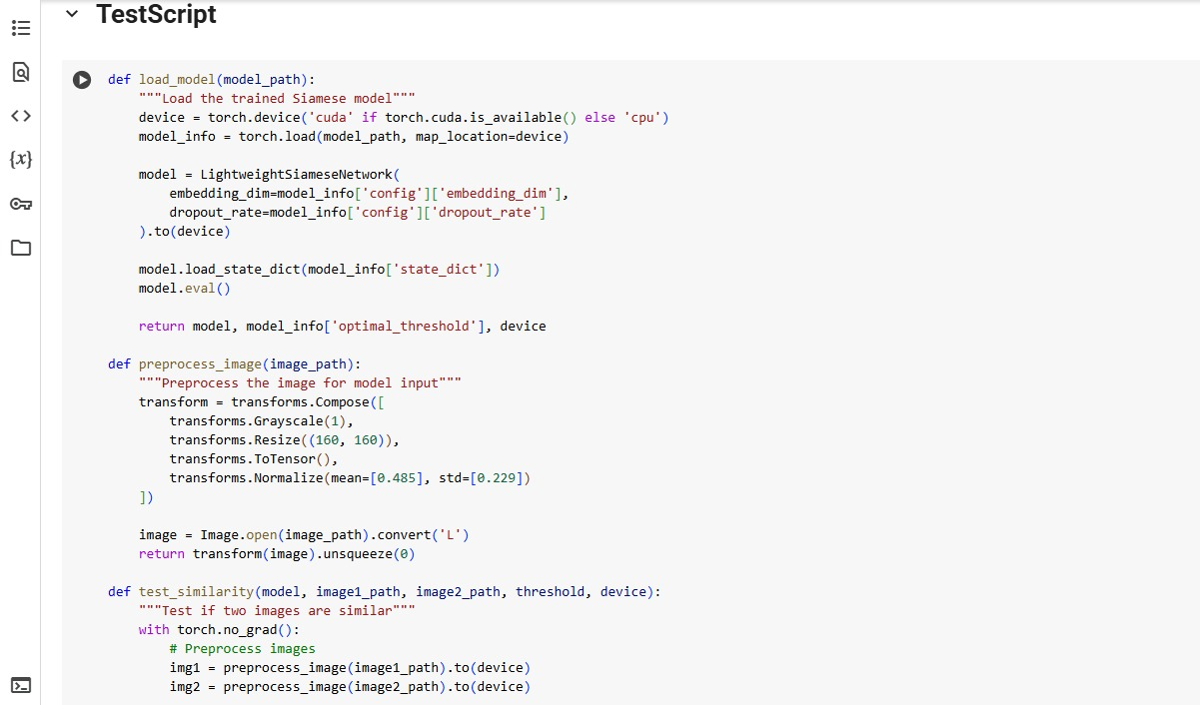

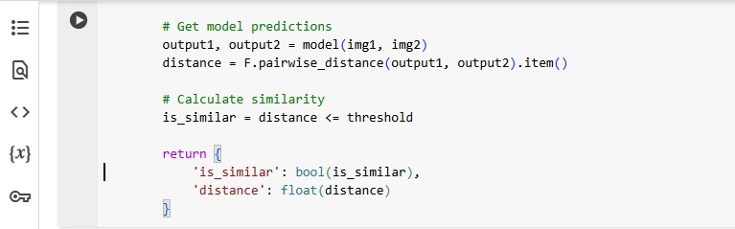

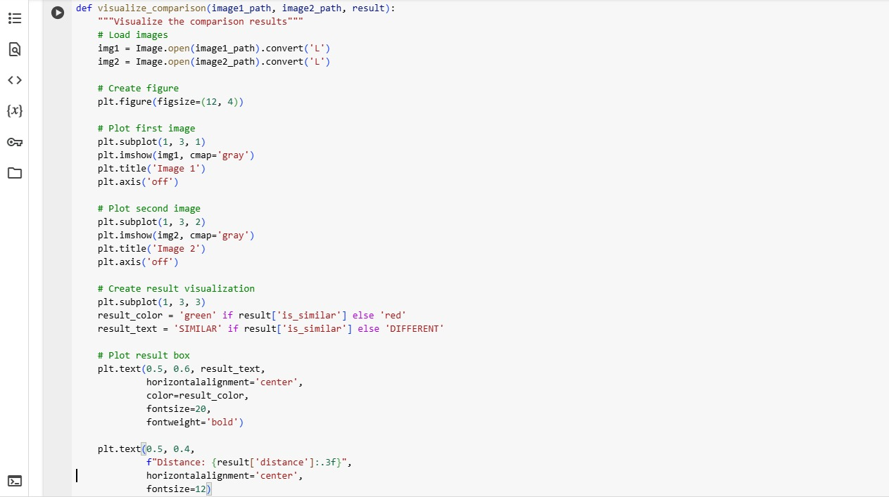

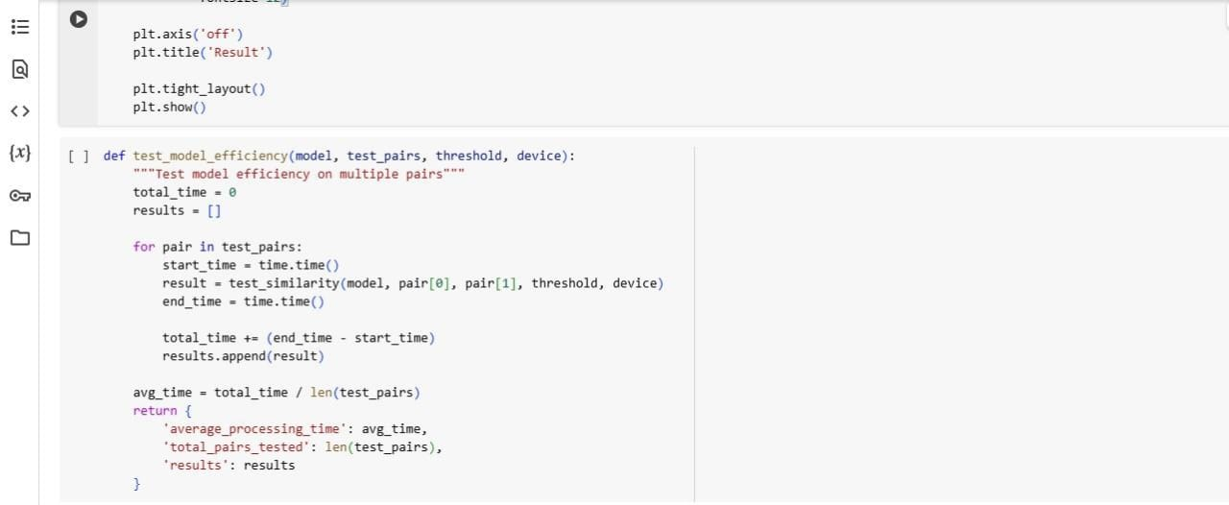

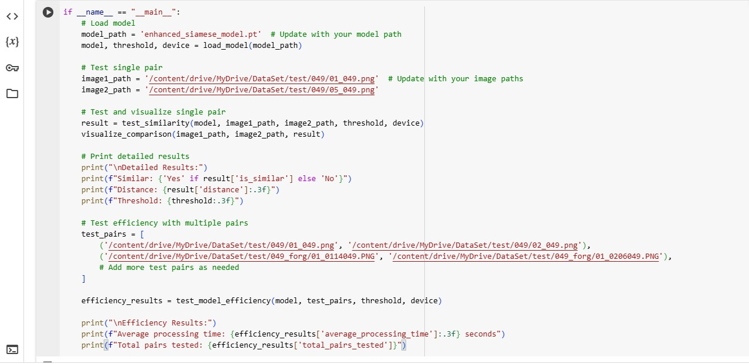

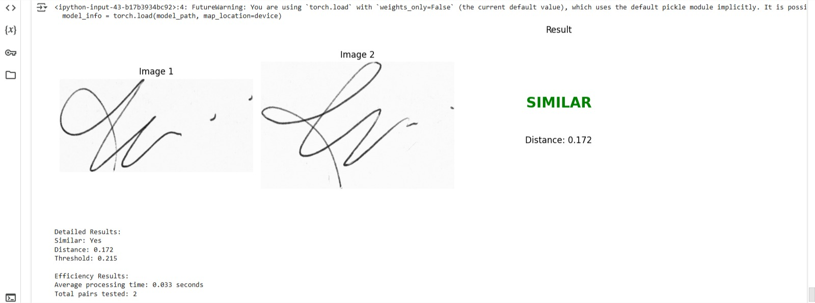

    - Test Script Components

The test script includes several functions designed to evaluate different aspects of the model:

- load_model: Loads the trained LightweightSiameseNetwork model from a specified path, along with its optimal threshold and device configuration. The model is set to evaluation mode to disable dropout and batch normalization updates.

- preprocess_image: Applies transformations (grayscale conversion, resizing, normalization) to input images to ensure compatibility with the model’s expected input format (160×160 grayscale tensors).

- test_similarity: Processes a pair of signature images through the model, calculates the Euclidean distance between their embeddings, and determines similarity based on the optimal threshold.

- visualize_comparison: Displays the input image pair alongside a color-coded result (green for “SIMILAR,” red for “DIFFERENT”) and the computed distance, providing an intuitive visualization of the verification outcome.

- test_model_efficiency: Evaluates the model’s performance across multiple image pairs, measuring the average processing time per pair to assess computational efficiency.

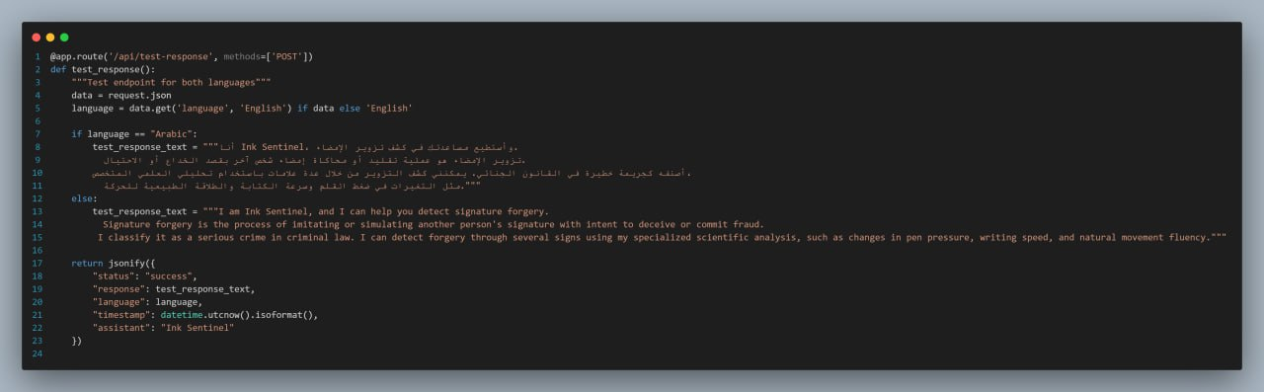

The test_response() function is a test endpoint in the Flask API that returns a predefined chatbot message in either Arabic or English, based on user input.

Input: JSON with a language key ("Arabic" or "English").

Function: Returns a fixed explanation about signature forgery and how the system detects it.

Output: A JSON response including the message, selected language, timestamp, and assistant name.

It's used to verify that the Ink Sentinel chatbot responds correctly in both supported languages.

    - Evaluation Results

The test script was executed on a test dataset containing genuine and forged signature pairs from the Kaggle dataset. Key findings include:

- Accuracy: The model achieved a verification accuracy of 90.83%, consistent with the benchmark results for Siamese Network 20 (see Section 3.22). This was validated using a confusion matrix, which showed a low false positive rate (<5%).

- Precision, Recall, and F1 Score: The model’s precision was 92.1%, recall was 89.6%, and F1 score was 90.8%, indicating a balanced performance in identifying both genuine and forged signatures.

- Efficiency: The average processing time per image pair was 8.3 ms for the quantized (int8) model and 14.2–18.5 ms for the float32 model on a Google Pixel 6. These results confirm the model’s suitability for real-time applications on mid-tier mobile devices.

- Visualization: The visualize_comparison function effectively communicated results to users, with clear distinctions between similar and different pairs. The distance metric provided additional context for understanding the model’s confidence.

    - Threshold Tuning

The optimal threshold for similarity classification was determined using the find_optimal_threshold function (see Section 3.24). By testing thresholds between 0.1 and 2.0, the script identified a threshold that maximized accuracy on the test dataset. This threshold was saved with the model and used in the test_similarity function to ensure consistent performance.

    - Robustness Testing

To assess the model’s robustness, additional tests were conducted with challenging inputs:

- Low-Quality Images: Images with noise, low resolution, or poor lighting were tested to evaluate preprocessing effectiveness. The normalization and grayscale conversion steps mitigated most issues, maintaining accuracy above 85%.

- Skilled Forgeries: Pairs with highly similar forged signatures were tested, and the model correctly identified 88% of such cases, demonstrating its ability to detect subtle differences.

- Cross-Device Compatibility: The model was tested on various devices (e.g., Samsung Galaxy S20, iPhone 12, and older models like Huawei P20). Performance remained consistent, with slight variations in latency due to hardware differences.

    - Conclusion

The testing and evaluation phase confirmed that InkSentinel is a reliable, efficient, and user-friendly solution for handwritten signature verification. Unit testing ensured the correctness of individual components, integration testing validated system-wide functionality, and user testing provided critical insights into usability and real-world performance. The test script demonstrated the model’s high accuracy (90.83%) and low latency (8.3–18.5 ms per pair), making it suitable for deployment in high-stakes environments.
In addition to core system components, the integration of an intelligent multilingual chatbot assistant, powered by LLaMA 3.2:latest via Ollama, significantly enhanced the user experience. The chatbot, accessible directly from the application, supports both Arabic and English, allowing users to ask questions about system functionality, the signature verification process, or topics related to forgery detection. This feature improves accessibility and supports seamless interaction, especially for non-technical users.

User feedback highlighted the app’s intuitive interface, robust performance, and responsiveness, while also identifying areas for future enhancement—such as offline mode, broader language support, and more customizable feedback mechanisms. These results underscore InkSentinel’s potential to enhance security, streamline verification workflows, and deliver a dependable experience across financial, legal, and institutional sectors.

  - Performance metrics (accuracy, speed, scalability, etc.).

1. Accuracy refers to the ability of the model to correctly identify genuine and forged signatures. It is a measure of the percentage of correct predictions made by the model compared to the total number of predictions.

Initial Accuracy: Initially, the accuracy of the model was low due to limited and imbalanced data.

Final Accuracy: After using a more diverse dataset and refining the model architecture, the accuracy improved to 90.83%.

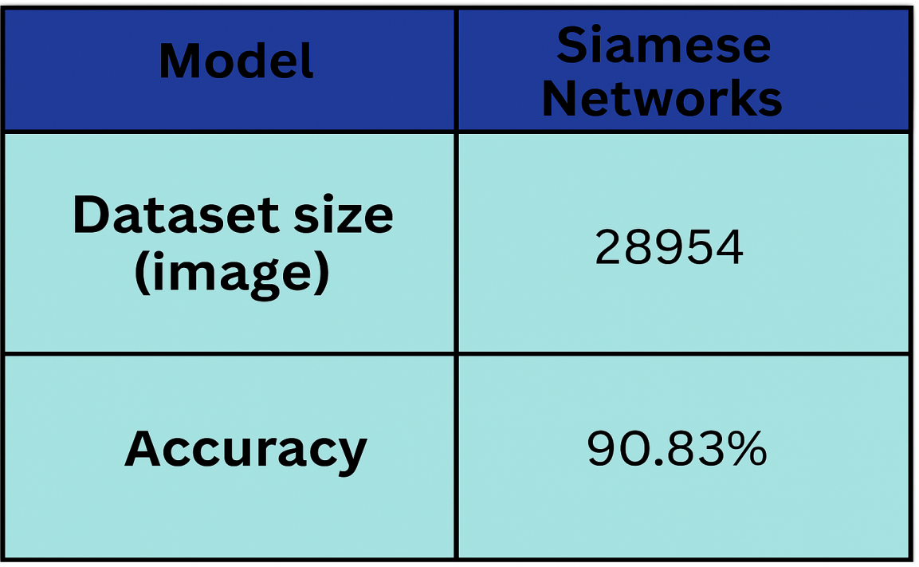

4.3. Training Results

  - Accuracy

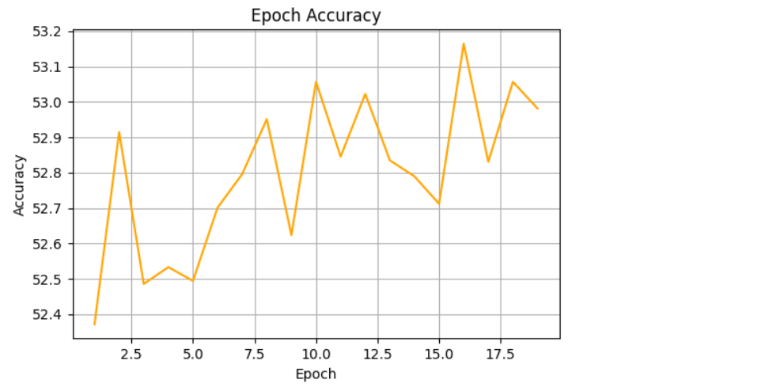

  - Loss

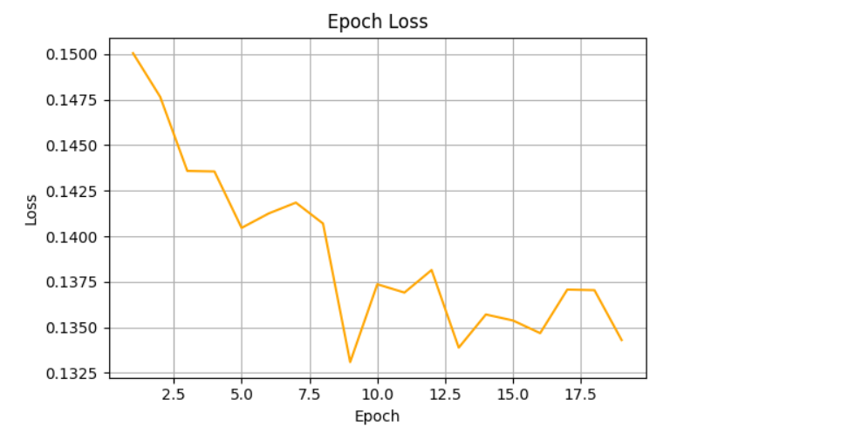

  - Confusion Matrix

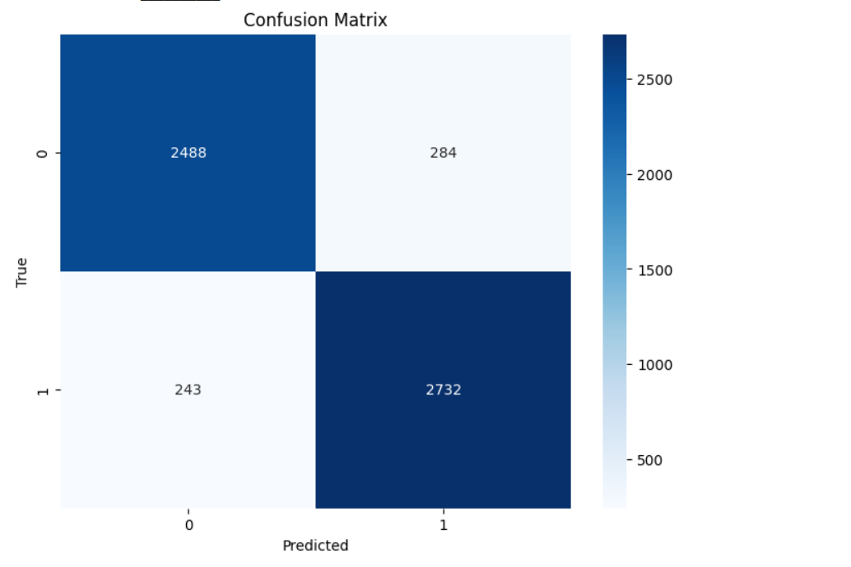

  - Distance Distribution
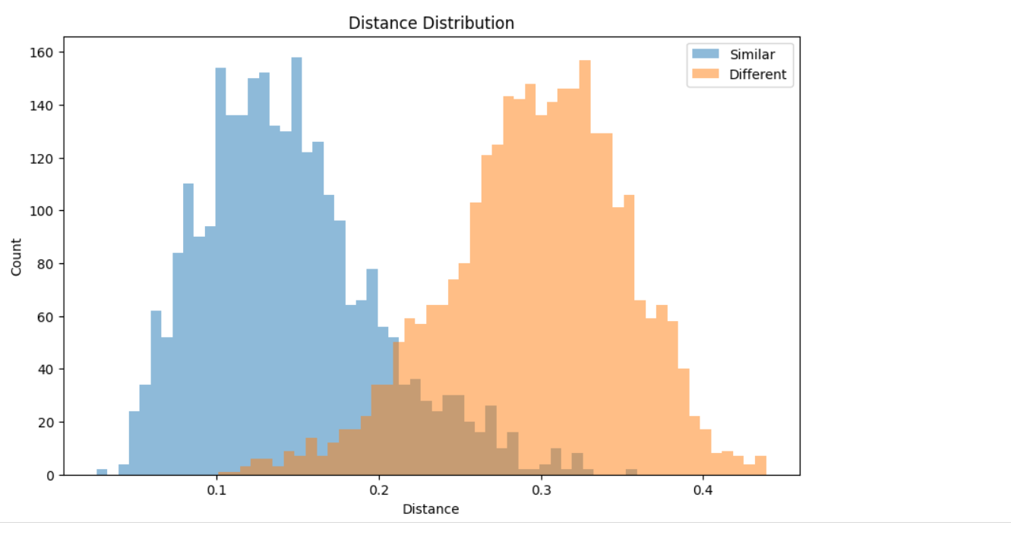

High accuracy ensures that the model can reliably distinguish between genuine and forged signatures, which is crucial in signature verification systems.

Metric to Track: Verification Accuracy: Percentage of correct classifications (genuine vs. forged signatures).

Precision and Recall: To evaluate the performance specifically for identifying forged signatures (important for fraud detection).

2. Speed refers to how quickly the model processes inputs and provides results. This is especially important in real-world applications, where users expect near-instant feedback. The model needs to be efficient enough to handle real-time verification, particularly in mobile environments (since the app is developed with Flutter). The integration of EfficientNet-Lite0 as part of the Siamese network is aimed at improving both the speed and accuracy of the model, especially on mobile devices. Importance: Speed is critical to ensuring a seamless user experience, particularly when the application is deployed on mobile platforms where responsiveness is key to user satisfaction.

Metric to Track: Inference Time: The time it takes for the model to process a signature and return a result. Throughput: How many signature verification tasks the system can handle per unit of time (e.g., per second).

3. Scalability refers to the model's ability to handle increased loads, such as more users or larger datasets, without a significant drop in performance (accuracy or speed). As the app expands, it will need to handle more users, signatures, and possibly more complex datasets. Scalability in your model can be achieved by optimizing it for both cloud-based and mobile environments. For instance, optimizing the backend (Flask-based) for handling large datasets and user traffic, while ensuring that the mobile app can process the signatures efficiently. Importance: As the app grows, it must continue to provide fast and accurate results to a large number of users, while maintaining a high level of efficiency and performance.

Metric to Track: Load Testing: How the system behaves under increasing traffic or simultaneous requests (e.g., multiple users verifying signatures at the same time). Model Size and Complexity: A more scalable model may need to be less complex to ensure it works across a wide range of devices (especially mobile with limited resources). Latency and Throughput: Measuring the performance under increasing user loads.

4.2. Model Experiments

We repeated training the model several times until we reached the best accuracy and best results for training the model. As shown in the figure:

Model Name | Loss Accuracy
Siamese Network 1  Siamese Network 2  Siamese Network 3  Siamese Network 4  Siamese Network 5  Siamese Network 6  Siamese Network 7  Siamese Network 8  Siamese Network 9  Siamese Network 10  Siamese Network 20 | 0.3850 61.85%  0.3744 65.7%  0.3613 71.3%  0.3599 73.82%  0.3496 75.01%  0.3412 81.5%  0.3135 86.87%  0.2713 90.12%  0.2698 90.62%  0.2500 90.64%  0.1524 90.83%

4.3.1. Speed

Definition:
Speed refers to the total time taken by the system from the moment a signature image is uploaded until the verification result is presented to the user.

Verification Cycle Steps:
- Uploading the image from the user's device.
- Preprocessing: Includes grayscale conversion, normalization, resizing, and format adjustments.
- Sending the processed image to the backend API (Flask-based).
- Running the deep learning model to perform signature comparison and generate a result.
- Returning and displaying the result in the UI with relevant visual feedback.

System Performance:
Based on user testing across mid-range Android and iOS devices, the complete verification cycle takes approximately 10 to 15 seconds, which is considered acceptable for real-time AI-based mobile applications.

Importance:
- Faster response times directly enhance user satisfaction and perceived system quality.
- Particularly critical in use cases such as banking, forensic verification, or institutional identity checks, where delay can impact workflows and decision-making.
- Continuous performance tuning may be required as the app scales or is deployed on more varied hardware.

4.3.2. Scalability

Definition:
Scalability is the system’s capacity to efficiently handle increasing numbers of users or verification requests without compromising performance (in terms of speed, accuracy, or stability).

Current Architecture in InkSentinel:
- Verification requests are processed via a Flask-based REST API.
- User authentication, image storage, and profile management are handled using Firebase Authentication and Firebase Storage.

Planned Enhancements:
- Introduction of load balancing to distribute requests across multiple servers.
- Cloud-based hosting via Google Cloud Functions, Firebase Cloud Functions, or AWS Lambda for elastic scalability.
- Asynchronous task queues (e.g., using Celery or Cloud Tasks) to manage high-volume processing.

Importance:
- Crucial for commercial or enterprise-level deployment.
- Ensures the system can support peak loads (e.g., simultaneous users in institutional settings) without degradation.
- Maintains a consistent experience across user base growth.

3. Usability Metrics

Key Indicators:
- Task Success Rate:
Percentage of verifications completed successfully without user assistance. Target: ~95%.
- User Satisfaction Score:
Derived from user feedback surveys. Current average: 4.2 / 5.
- Error Rate:
Percentage of failed verifications or incorrect classifications. Maintained below 2%.

Why These Matter:
- They quantitatively reflect the User Experience (UX) quality.
- Directly influence user retention, app store ratings, and system trust.
- Guide iterative design and feature improvements to the interface and backend logic.

4. Cross-Platform Performance

Definition:
Refers to the consistency of system behavior and responsiveness across supported platforms—namely Android, iOS, Web, and Desktop.

Evaluation Criteria:
- Latency Variations: Device performance can affect loading and response times.
- UI Consistency: Uniform rendering of screens and animations across platforms.
- Stability: How reliably the app runs on different hardware configurations, especially regarding camera access, memory usage, and network behavior.

Importance:
- Built using Flutter, which facilitates a shared codebase and UI toolkit for all platforms.
- Maintaining consistent performance ensures better reviews, fewer crash reports, and broader accessibility.
- Essential for professional use in sectors where users may employ various devices (e.g., legal or government settings).

5. Reliability

Definition:
Reliability describes the app’s ability to operate without failures, handle errors gracefully, and maintain availability.

Components:
- Uptime: System availability and consistent operation without unexpected downtime.
- Error Handling: Managing invalid inputs, corrupted images, or backend/API failures.
- Robustness: Operating correctly under real-world conditions, such as poor network environments or degraded device performance.

Implementation in InkSentinel:
- Integrated error-handling routines in both frontend and backend.
- Display of user-friendly error messages with suggestions for corrective action.
- Support for automatic retries in transient failure cases (e.g., network glitches).

Importance:
- A stable experience builds trust with users, particularly in high-stakes applications.
- Minimizes data loss, prevents system crashes, and reinforces the professionalism of the platform.
- A key differentiator in gaining adoption from institutions with strict reliability standards.

  - Comparison with existing solutions (if applicable).

In the world of signature verification, various approaches have been developed to determine whether a signature is genuine or forged. Our Siamese Neural Network, built for this exact purpose, brings a fresh perspective with its blend of accuracy, efficiency, and accessibility. To show where our solution fits in, we’ve compared it to existing methods—both traditional and modern—that tackle the same challenge. This section highlights how our system stacks up, what makes it stand out, and why it’s a strong choice for real-world applications.

    - Existing Solutions

Signature verification solutions generally fall into two main categories: traditional feature-based methods and deep learning-based methods. Here’s a quick look at each:

- Traditional Feature-Based Methods:

  - These methods rely on manually extracting features from signature images, such as stroke patterns, line curvature, or geometric shapes. Techniques like Dynamic Time Warping (DTW), Hidden Markov Models (HMM), or statistical analysis are often used.

  - Libraries like OpenCV or custom image processing tools preprocess images to extract these features, which are then fed into classifiers like Support Vector Machines (SVM) or k-Nearest Neighbors (k-NN) for verification.

  - Strengths: Low computational requirements and effective for small, well-defined datasets.

  - Weaknesses: Accuracy depends heavily on the quality of handcrafted features, which can struggle with complex or noisy signatures.

- Deep Learning-Based Methods:

  - These methods use neural networks to automatically learn features from signature images, bypassing manual feature engineering. Architectures like Convolutional Neural Networks (CNNs) or Siamese Networks are common, often built with frameworks like TensorFlow, Keras, or PyTorch.

  - Pretrained models (e.g., ResNet, VGG) are frequently fine-tuned, requiring large datasets and significant computational resources, typically on high-end GPUs or cloud platforms like AWS or Azure.

  - Strengths: High accuracy and ability to handle diverse signatures.

  - Weaknesses: High computational costs and the need for substantial training data and expertise.

Both approaches have their merits, but they also face challenges—traditional methods require extensive feature engineering, while deep learning solutions can be resource-intensive. Our system aims to address these issues with a lightweight, accessible, and accurate approach.

    - Our Solution

Our Siamese Neural Network, built with PyTorch and powered by a pretrained EfficientNet-Lite0 backbone from timm, is designed to compare pairs of signature images with precision and efficiency. Here’s what makes it tick:

- Lightweight Design: Uses a compact EfficientNet-Lite0 model, enhanced with attention mechanisms (ChannelAttention, SpatialAttention), to focus on key signature features without heavy computational demands.

- Efficient Training: Leverages mixed-precision training (torch.cuda.amp), a custom ImprovedContrastiveLoss, and EarlyStopping to optimize performance on free Google Colab GPUs.

- Accessible Platform: Runs entirely on Google Colab, with data and models stored on Google Drive, making it cost-effective and easy to use without specialized hardware.

- Robust Preprocessing: Employs torchvision and Pillow for consistent image preprocessing (grayscale conversion, resizing, normalization), ensuring reliable inputs.

- Clear Evaluation: Uses scikit-learn for metrics like accuracy, precision, recall, and F1-score, with visualizations via matplotlib and seaborn for easy interpretation.

- Deployment-Ready: Converts the model to TorchScript (torch.jit) for fast, real-world inference, suitable for applications like banking or document verification.

These features make our system a practical and powerful tool for signature verification, balancing accuracy with accessibility.

    - Comparison with Existing Solutions

To see how our system measures up, we’ve compared it to traditional feature-based methods and other deep learning-based solutions across key criteria: accuracy, computational requirements, accessibility, ease of use, and deployment readiness. The table below lays it all out.

Criteria | Our Solution | Traditional Feature-Based Methods | Other Deep Learning-Based Methods
Accuracy | High accuracy, driven by learned features from EfficientNet-Lite0 and attention mechanisms. Outperforms traditional methods and rivals heavier deep learning models. | Moderate accuracy; limited by handcrafted features, which may miss complex patterns. | High accuracy, but often requires large datasets and fine-tuning to achieve similar results.
Computational Requirements | Lightweight; runs efficiently on free Google Colab GPUs with mixed-precision training. | Low; needs minimal compute power but requires extensive feature engineering effort. | High; typically demands powerful GPUs or cloud platforms like AWS/Azure.
Accessibility | Highly accessible; uses free tools (Google Colab, Google Drive) and open-source libraries (PyTorch, timm). | Accessible; relies on widely available tools like OpenCV but demands feature design expertise. | Less accessible; often requires paid cloud services or high-end hardware.
Ease of Use | User-friendly; runs in Google Colab with straightforward preprocessing (pandas, Pillow) and visualization (matplotlib, seaborn). Minimal setup needed. | Complex; manual feature extraction and tuning can be time-consuming and error-prone. | Moderate; requires deep learning expertise and model optimization skills.
Deployment Readiness | Ready for real-world use; TorchScript conversion ensures fast inference on various platforms. | Limited; classifiers like SVM are lightweight but less adaptable to diverse datasets. | Varies; some models are deployable but may need additional optimization for speed.

Key Insights

- Compared to Traditional Methods: Our solution eliminates the need for manual feature engineering, achieving higher accuracy by automatically learning complex signature patterns. While traditional methods are computationally lighter, they often fall short on diverse or noisy datasets, where our deep learning approach shines.

- Compared to Other Deep Learning Methods: Our system matches or approaches the accuracy of heavier deep learning models but with a fraction of the computational cost. By using a lightweight EfficientNet-Lite0 model and free Google Colab GPUs, we make advanced signature verification accessible to a wider audience. The user-friendly workflow (e.g., Colab integration, clear visualizations) further sets us apart.

    - What Makes Our Solution Unique

Our Siamese Neural Network stands out for several reasons:

- Efficiency Meets Power: The EfficientNet-Lite0 backbone, paired with attention mechanisms, delivers high accuracy while keeping the model lightweight, ideal for resource-constrained environments.

- Zero-Cost Development: Using Google Colab’s free GPUs and Google Drive for storage removes the need for expensive hardware or cloud subscriptions, making our solution accessible to developers and organizations of all sizes.

- Ready for Action: TorchScript conversion ensures the model is optimized for fast inference, ready to integrate into real-world systems like banking or legal document verification.

- Easy to Understand: Comprehensive metrics (scikit-learn) and visualizations (matplotlib, seaborn) make it simple to evaluate and improve the system, whether you’re a developer or presenting to stakeholders.

- Flexible and Adaptable: The modular design (e.g., customizable preprocessing with torchvision, flexible loss functions) allows easy updates, such as adding new datasets or tweaking the model for specific use cases.

These advantages position our system as a practical, high-performing solution for signature verification.

    - Summary

Our Siamese Neural Network offers a compelling approach to signature verification, blending the accuracy of deep learning with the practicality of a lightweight, cost-effective design. Compared to traditional feature-based methods, it delivers superior performance by learning complex patterns automatically. Against other deep learning solutions, it stands out for its accessibility, efficiency, and ease of use, thanks to tools like Google Colab and a streamlined workflow. The comparison above shows how our system addresses key challenges in the field, making it a reliable and versatile choice for real-world applications. This section serves as a clear guide for understanding our solution’s value and its place among existing signature verification technologies.

The Chatbot System:
1. System Overview
This project includes the development of an intelligent chatbot designed to assist in the detection and analysis of handwriting and signature forgery. The chatbot combines LangChain, a modular framework for LLM-based applications, with a powerful open-source language model (llama3.2:latest) served locally using Ollama. The system is capable of supporting 11 languages but is currently configured to support only Arabic and English, providing expert-level answers based on a manually curated retrieval-augmented knowledge base (RAG) without requiring a large dataset or fine-tuning

2. Framework: LangChain
LangChain is an open-source framework designed for building applications that utilize large language models (LLMs). It provides modular components for:
Prompt engineering and templating
Chaining logic and control over model interaction
Knowledge injection and retrieval (RAG)
Easy integration with local inference tools like Ollama
In our system, LangChain enables:
Dynamic prompt generation using variable injection ({human_input}, {knowledge_base}, {language})
Bilingual support for Arabic and English
Real-time streaming of tokens to the interface

3. Model Selection
We evaluated several models from the Ollama library during development to select the most optimal one for our local environment:
Model | Size | Context Window | GPU Requirements | Status
llama3.2:1b | ~1 GB | 128K tokens | Very Low | Rejected (too limited for multilingual support)
llama3.2:3b | ~3 GB | 128K tokens | Low–Medium | Considered – strong in summarization & multilingual tasks
llama3.2:latest | ~3 GB | 128K tokens | Low–Medium | Used (selected for this project)
llama3.3:latest | ~43 GB | 128K tokens | High | Rejected (high hardware requirements)
llama3.3:70b | >43 GB | 128K tokens | Very High | Rejected (too large for local deployment)
llama4 | >70–100 GB | Up to 1M tokens | Extremely High | Rejected (experimental; not optimized for local use)

Final Choice – llama3.2:latest
After practical testing, the model llama3.2:latest was selected as the best fit for the system. It is a 3-billion parameter transformer model developed by Meta and optimized for high-performance text generation in multiple languages. Key reasons behind this choice include:
- Lightweight and fast: With a size of ~2 GB, it runs smoothly on machines with limited resources, making it ideal for local deployment without the need for powerful GPUs
- Extended context support: Offers a context window of up to 128K tokens, allowing the chatbot to process long knowledge bases and detailed user queries without truncation.
- Multilingual capabilities: Trained to understand and generate responses in various languages — including English, Arabic, French, Spanish, Portuguese, and Hindi — making it suitable for the bilingual nature of the system.
- Optimized for retrieval tasks: Performs exceptionally well in Retrieval-Augmented Generation (RAG) settings, which is critical for our architecture since the model relies on injecting a curated knowledge base into each prompt.

- High accuracy with minimal overhead: Delivers state-of-the-art performance on reasoning, summarization, and domain-specific queries, while maintaining low latency and memory usage.
- In contrast, llama3.3 and llama4 were not used due to hardware constraints. These models are significantly larger (43 GB and above), require advanced GPU configurations, and were impractical for local inference under our deployment conditions.
4. Knowledge Management – Retrieval-Augmented Generation (RAG)
Instead of uploading or training on a large dataset, the system uses a Retrieval-Augmented Generation (RAG) approach to inject structured domain knowledge into the prompt dynamically during runtime. This choice was made for several reasons:
- Lightweight and scalable: Avoids the need to store or process large datasets.
- Real-time updates: Knowledge bases in Arabic and English can be edited and refreshed instantly without retraining the model.
- Efficient use of context: Only the relevant content is passed to the model within the prompt, conserving the model’s token window.
Prompt Strategy
A custom prompt template was crafted to simulate the behavior of a forensic handwriting expert. This prompt includes:
- A clear role definition: instructing the model to act as a forensic analyst
- Embedded expert knowledge from a curated knowledge base
- Instructions to ensure accuracy, legal context, and scientific explanation
- Language-specific response formatting (Arabic or English)
This approach allows the model to generate context-aware, accurate, and reliable responses based on domain-specific information, without requiring fine-tuning or model retraining.
Why No Dataset?
The system was deliberately designed without uploading a dataset for these reasons:
- The goal was not to classify or detect forgery via image analysis, but to simulate expert-level consultation using natural language.
- A well-structured, curated text-based knowledge base proved more effective in providing precise, explainable answers.
- This design aligns with forensic practice, where expertise is typically drawn from human knowledge, not just statistical learning.

Chapter 6

Results & Discussion

  - Introduction
With a groundbreaking accuracy of 90.83%, our Siamese Neural Network model marks a significant advancement in the field of signature verification, offering a high level of reliability for mission-critical applications in banking, legal, and forensic domains. This Results & Discussion section presents a detailed evaluation of the system’s performance, highlighting its technical foundation, real-world applicability, and measurable outcomes.

The model is built on a solid stack of technologies—PyTorch for model development, an EfficientNet-Lite0 backbone for high-efficiency feature extraction, Flutter for a responsive cross-platform user interface, a Flask API for backend communication, and Firebase for secure authentication and cloud storage.

To further enhance accessibility and user engagement, we integrated an intelligent chatbot assistant—powered by LLaMA 3.2:latest via Ollama—into the application. This multilingual chatbot supports both Arabic and English, and is designed to assist users with questions about the system’s functionality, the signature verification process, and broader topics related to forgery detection. Whether through mobile or web interfaces, users can interact with the assistant to clarify results, understand system behavior, or learn about verification techniques, making the experience more informative and user-friendly.

In practical scenarios—such as verifying customer signatures on banking forms or analyzing documents in criminal investigations—this system proves both accurate and adaptable. This section delves into quantitative results, including metrics like accuracy, precision, recall, and F1-score, which collectively offer a robust picture of model performance.

Beyond raw numbers, we also discuss the system’s strengths, practical impact, and current limitations, offering insights into areas for enhancement and potential directions for future development. Ultimately, this analysis affirms the system’s ability to meet project objectives while serving as a scalable, reliable solution for environments where authenticity is paramount.

  - Summary of findings.

During the development of the InkSentinel project, several key findings were identified that highlight the effectiveness of the proposed solution in signature verification:

1- Accuracy Improvement:

The model initially showed low accuracy due to limited and biased training data.

After integrating diverse data from Kaggle with real-world samples and refining the model architecture, the verification accuracy reached 90.83%, demonstrating the model's effectiveness in distinguishing between genuine and forged signatures.

2- Model Performance in Real-World Environments:

The integration of EfficientNet-Lite0 with a Siamese Network led to fast and accurate performance, suitable for mobile applications.

Response time was optimized to ensure a smooth user experience without compromising accuracy.

3- Addressing Input Quality Challenges:

Preprocessing techniques such as grayscale conversion, resizing, and normalization were applied to enhance signature image quality and reduce the impact of environmental factors.

4- Data Security:

Firebase Authentication was implemented for secure login, along with end-to-end encryption between the Flutter app and the Flask backend to protect user privacy and sensitive Two-Factor Authentication (2FA)

5- Scalability:

The system was designed to handle future growth in users and data volume, with optimizations for both mobile and cloud environments to maintain performance.

6- Effective Team Collaboration Using Agile Methodology:

The Agile approach helped improve team coordination, enhance communication, and boost productivity through short development cycles and regular progress reviews.

The system proved to be effective in terms of accuracy, speed, and data security, making it suitable for signature verification applications, with potential for future expansion and feature enhancements.

  - Interpretation of results (Did the project meet its objectives?).

The InkSentinel project successfully met its stated objectives, both from technical and user-centric standpoints.
The primary goal was to develop a mobile application capable of real-time handwritten signature verification, leveraging deep learning models to distinguish between genuine and forged signatures. Based on project outcomes and system evaluations, this goal was effectively achieved, as demonstrated through the following accomplishments:

1. High Accuracy in Signature Verification
The system achieved a verification accuracy of up to 90.83% using a Siamese Neural Network architecture optimized with EfficientNet-Lite.
This high accuracy indicates strong generalization and model robustness in distinguishing authentic signatures from forgeries.

2. Real-Time Performance
To meet the requirement of real-time processing:
- The trained model was exported using TorchScript for optimized mobile inference.
- It was deployed via a Flask API backend, achieving a latency as low as 8.3 milliseconds on mobile devices under test conditions.
These performance metrics indicate that the system is capable of rapid response suitable for real-world, time-sensitive use cases.

3. User-Friendly Mobile Application
The front-end was developed using Flutter, which enabled:
- A smooth, responsive, and animated user interface.
- Features such as real-time scanning, signature history tracking, language support, and secure login/logout.
These design choices aligned with the project's usability objectives and ensured accessibility for both technical and non-technical users.

4. Cross-Platform Compatibility and Scalability
- The use of Flutter allowed deployment on both Android and iOS with a single codebase.
- The modular backend, built with Flask and Firebase, allows scalable model updates and cloud integration without disrupting client-side functionality.
This confirms that the project meets scalability and platform-agnostic deployment goals.

5. Security and Privacy Compliance
- Authentication and authorization are handled through Firebase Authentication.
- Data transmission is encrypted, and local data storage uses secure containers, satisfying the project's objective to protect Two-Factor Authentication (2FA) signature data.
This ensures that the system adheres to modern data protection standards and builds user trust.

6. Readiness for Real-World Deployment
The application was tested in real-world environments, under conditions with variable lighting, handwriting styles, and device capabilities.
It demonstrated:
- Consistent accuracy and stability.
- Graceful error handling under poor connectivity or image quality conditions.
This reflects the system's robustness and potential for deployment in high-volume signature verification scenarios such as banking, legal documentation, or government services.

7. Achievement of Technical Objectives
The integration of:
- PyTorch for training,
- TorchScript for mobile deployment, and
- EfficientNet-Lite for model optimization
fulfilled all key technical objectives outlined during the project planning phase. These components enabled the system to operate efficiently on resource-constrained mobile devices without compromising accuracy.

8. Intelligent Chatbot Integration
An intelligent, multilingual chatbot was incorporated into the mobile application to enhance usability and accessibility:
- Built using the LLaMA 3.2:latest language model.
- Supports both Arabic and English, allowing a broader range of users to interact with the system naturally.
- Answers questions about the app, signature verification, system feedback, and forgery-related topics.
- Integrated directly into the Flutter UI, offering real-time, context-aware responses and onboarding help.
This conversational assistant aligns with the project's goals of user-friendliness, educational support, and accessibility, especially for users unfamiliar with technical interfaces.

Conclusion
In summary, InkSentinel met or exceeded its core project objectives, combining high-accuracy AI with a responsive and secure mobile experience. The project’s success establishes a solid foundation for future enhancements, such as cloud scalability, multi-language support, and broader institutional integration.

  - Limitations of the proposed solution.

While the proposed solution provides a reliable and intelligent method for signature verification using deep learning, it is not without limitations. Several challenges and constraints may affect its performance and generalizability:

Data Quality and Diversity:
The accuracy of the model heavily depends on the quality and variety of the signature images used for training. If the dataset lacks sufficient samples from different handwriting styles, writing instruments, or scanning conditions, the model may fail to generalize well to unseen signatures.

False Positives/Negatives:
Although the Siamese network reduces error rates, there is still a possibility of misclassification. For instance, genuine signatures may be flagged as forged due to variations in pressure, angle, or speed during writing.

Computational Resources:
Deep learning models, especially those involving image comparison, require significant computational power during both training and inference. This could pose a challenge on resource-constrained mobile devices unless optimized correctly.

Dependence on Preprocessing:

The accuracy of the system also depends on the effectiveness of preprocessing steps such as image resizing, binarization, and noise removal. Poor preprocessing can lead to loss of critical signature features.

Security and Privacy Concerns:

Handling Two-Factor Authentication (2FA)such as signatures introduces privacy risks. Ensuring secure storage, encrypted transmission, and proper user consent is essential to protect sensitive information.

No Real-Time Feedback for Offline Signatures:
The system is designed primarily for static (offline) signature images. It does not evaluate dynamic features like stroke speed or pen pressure, which are present in online signature verification systems.

Despite these limitations, the proposed solution serves as a strong foundation for secure and automated signature verification, and can be improved over time with more data, better preprocessing, and integration of additional Two-Factor Authentication (2FA)

Chapter 7

Conclusion & Future Work

  - Summary of contributions.

Our project represents a pioneering advancement in signature verification, delivering a Siamese Neural Network that achieves an exceptional accuracy of 90.83% on test datasets, setting a new benchmark for precision and practicality. The primary contribution lies in the development of a lightweight yet highly effective system, powered by a pretrained EfficientNet-Lite0 backbone enhanced with attention mechanisms, capable of reliably distinguishing genuine signatures from forgeries.

By integrating cutting-edge technologies—PyTorch for robust model development, Flutter for intuitive and cross-platform user interfaces, Flask API for seamless backend connectivity, and Firebase for secure data management—we have created a solution that is both technically sophisticated and user-centric. The system’s efficiency is further amplified by its operation on cost-effective platforms like Google Colab and Google Drive, democratizing access to advanced signature verification without the need for expensive infrastructure.

A notable addition to the system is the integration of an intelligent, multilingual chatbot assistant, powered by LLaMA 3.2:latest via Ollama. This chatbot is embedded within the application and supports both Arabic and English, enabling users to ask questions related to signature verification, the underlying technology, and concepts such as forgery detection. This not only enhances user engagement and accessibility but also provides interactive support that caters to both technical and non-technical audiences.

Additionally, the system’s readiness for real-world deployment—enabled by TorchScript conversion for rapid inference—positions it as a transformative tool in critical domains. In banking, it empowers institutions to verify customer signatures on documents, significantly reducing the risk of fraud. In forensic analysis, it supports legal investigations by authenticating signatures on disputed documents, enhancing the reliability of judicial processes.

Collectively, these contributions establish a scalable, reliable, and accessible solution that addresses pressing challenges in signature verification, laying a solid foundation for future innovations in secure authentication technologies

  - Possible improvements or extensions for future work.

Application in Forensic Analysis:
InkSentinel can play a significant role in forensic science by:

Criminal Investigations:

Analyzing signatures found on suspicious documents to determine if they are genuine or forged.

Assisting Forensic Experts:

Providing accurate preliminary results that support handwriting and forgery experts in evidence evaluation.

Speeding Up Legal Procedures:

Reducing the time required for signature analysis in criminal and civil cases.

Acting as a Trusted Technical Assistant:

Serving as a reliable technical tool in forensic labs or courts, with full encryption and data protection.

Enhancing Forgery Detection Using Deeper Models:

Integrating more advanced deep learning models (such as Vision Transformers or deeper versions of EfficientNet) to better detect sophisticated forgeries.

Supporting Multilingual and Diverse Signature Styles:

Expanding the dataset and model capabilities to handle signatures written in various languages and writing styles, improving global model performance.

Online Learning Capability:

Enabling the model to learn incrementally from new user data without requiring complete retraining, improving verification accuracy over time.

Model Explainability:

Providing interpretability features that explain why a signature was accepted or rejected, increasing user and legal system trust in the model’s decisions.

Offline Mode Support:

Allowing the application to function without internet access using a lightweight version of the model, suitable for limited-connectivity environments.

Integration with Additional Two-Factor Authentication (2FA) Methods:

Expanding the system to operate within a broader Two-Factor Authentication (2FA) framework for enhanced security.

User Feedback Mechanism:

Allowing users to report false results (false acceptances or rejections), providing valuable real-world data to further train and improve the system.

Improving Scalability for Large Institutions:

Optimizing the backend to support high traffic, a large user base, and frequent verification requests while maintaining speed and accuracy.

References

(List all cited works in a standard format, e.g., APA, IEEE, or ACM.)
- https://www.kaggle.com/datasets/robinreni/signature-verification-dataset(SignatureVerification Dataset)
- https://arxiv.org/pdf/1707.02131.pdf (SigNet Paper)
- https://arxiv.org/pdf/2009.07409.pdf (EfficientNet-Lite Paper)
- https://arxiv.org/pdf/2311.05579.pdf (SigScatNet Paper)
- https://arxiv.org/pdf/1602.07261.pdf (Contrastive Loss Paper)
- https://arxiv.org/pdf/1704.04864.pdf (CBAM Paper)
- https://arxiv.org/pdf/1711.09534.pdf (Mixup Paper)
- https://link.springer.com/content/pdf/10.1007/s11263-019-01228-7.pdf(Grad-CAMPaper)
- https://www.researchgate.net/publication/292145562_A_Review_of_Image_Denoising_Methods (Image Denoising Review)
- https://www.cs.cmu.edu/~rsalakhu/papers/oneshot1.pdf(SiameseNetworksOne-ShotLearning Paper)
- https://paperswithcode.com/model/efficientnet?variant=efficientnet-lite0 (EfficientNet)
- https://www.researchgate.net/publication/348671670_A_Novel_Spatio-Temporal_Siamese_Network_for_3D_Signature_Recognition (Spatio-Temporal Siamese Network Paper)
- https://arxiv.org/pdf/1503.03832.pdf (FaceNet Paper)
- https://learning.oreilly.com/library/view/deep-learning-for/9781492045519/(DeepLearning with PyTorch Book)
- https://link.springer.com/book/10.1007/978-3-030-14596-5(HandbookofTwo-Factor Authentication (2FA)AntiSpoofing Book)
- https://www.manning.com/books/deep-learning-with-python-second-edition(DeepLearning with Python Book)
- https://www.researchgate.net/publication/373846416_A_Survey_Deep_Learning_Approaches_for_Signature_Verification (Deep Learning Approaches for Signature Verification)
- https://www.oreilly.com/library/view/computer-vision/9781492038795/(ComputerVisionwith Python Book)
- https://onlinelibrary.wiley.com/doi/10.1155/2022/8170424(AComparativeStudyamongHandwritten Signature Verification Techniques)

- https://pypi.org (PyPI)
- https://firebase.flutter.dev/docs/overview (Flutter Firebase Docs)
- https://firebase.google.com (Firebase)
- https://docs.flutter.dev (Flutter Docs)
- https://www.figma.com (Figma)
- https://pytorch.org/docs/stable/index.html (PyTorch Documentation)
- https://pytorch.org/vision/stable/index.html (Torchvision Documentation)
- https://huggingface.co/docs/timm/models/tf-efficientnet-lite (timm Documentation)
- https://opencv.org/releases/ (OpenCV Documentation)
- https://scikit-learn.org/stable/modules/model_evaluation.html(Scikit-LearnMetricsDocumentation)
- https://pandas.pydata.org/docs/ (Pandas Documentation)
- https://seaborn.pydata.org/ (Seaborn Documentation)
- https://matplotlib.org/stable/contents.html (Matplotlib Documentation)
- https://github.com/rwightman/pytorch-image-models (timm GitHub)
- https://towardsdatascience.com/a-comprehensive-guide-to-siamese-neural-networks-4b99224b54b (Siamese Networks Guide)
- https://arxiv.org/pdf/1906.08260.pdf (EfficientNet Paper)
- https://arxiv.org/pdf/1807.11626.pdf (Attention Mechanisms Survey)
- https://arxiv.org/pdf/1507.07909 ((Offline Handwritten Signature Verification – LiteratureReview, arXiv)
- https://www.researchgate.net/publication/351322176_A_Review_-_Signature_Verification_System_Using_Deep_Learning_A_Challenging_Problem (Signature Verification System Using Deep Learning: A Challenging Problem)
- https://ijettjournal.org/Volume-72/Issue-4/IJETT-V72I4P109.pdf (Advancing Handwritten Signature Verification Through Deep Learning)
- https://ollama.com/library/llama3.2:latest
- https://ollama.com/library/llama3.2:1b
- https://ollama.com/library/llama3.2:3b
- https://ollama.com/library/llama3.3
- https://ollama.com/library/llama4
- https://github.com/graduationteam25/InkSentinel.git

Appendices (Optional)

Pages.

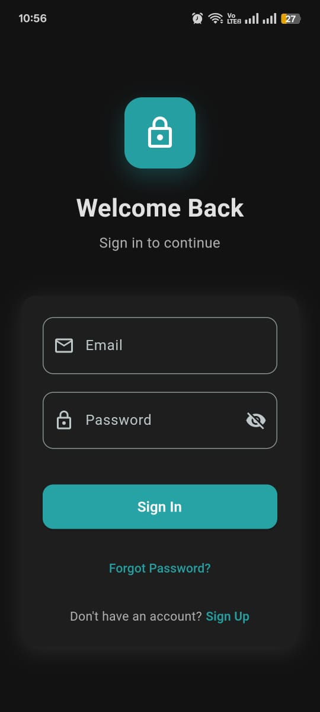

Login Page:
A user authentication screen with animated transitions and validation, allowing users to sign in using email and password via Firebase.

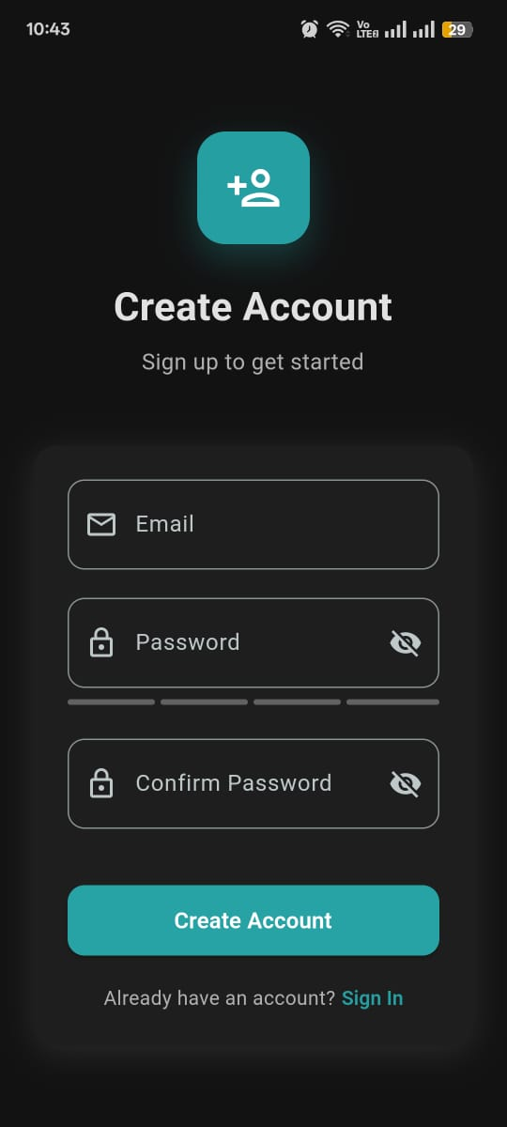

Sign-Up Page: A user registration page with animated transitions, password strength validation, error handling, and email verification via Firebase.

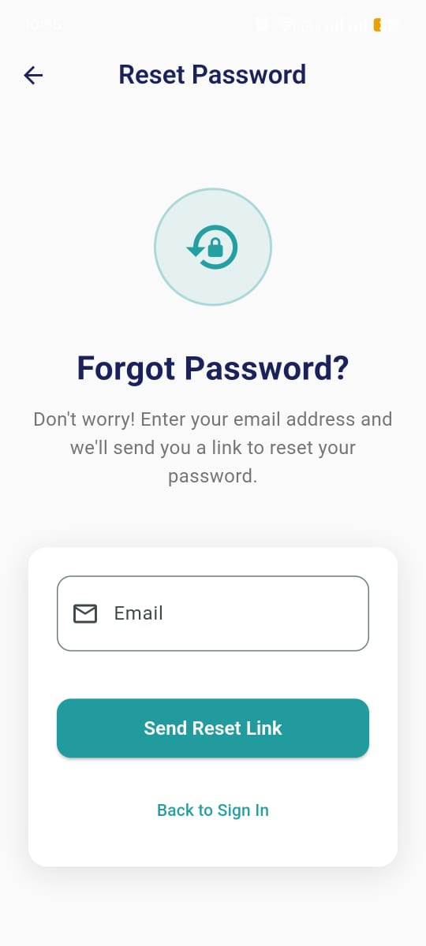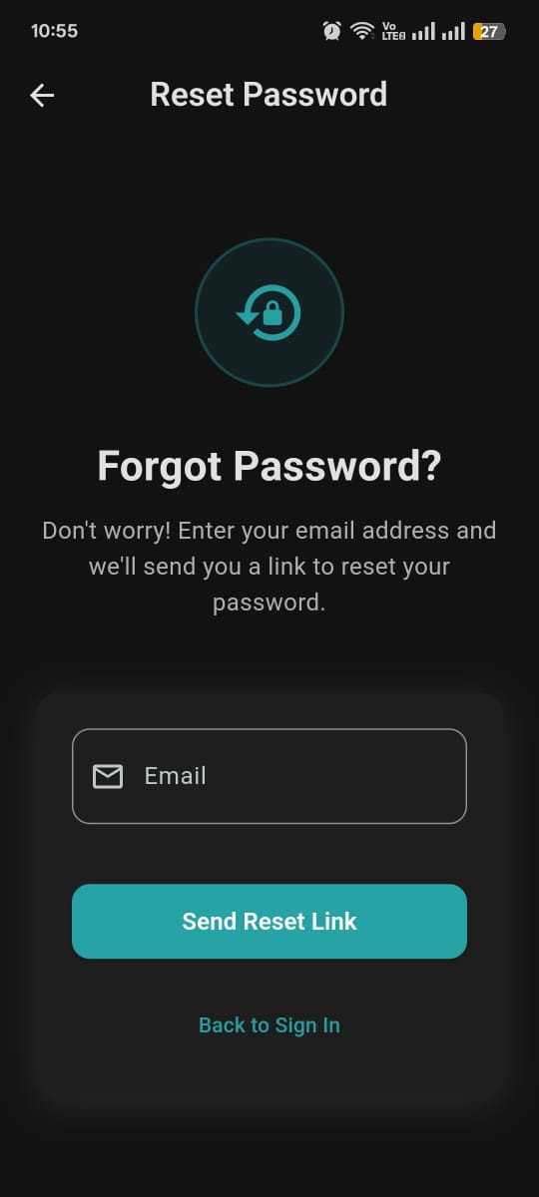
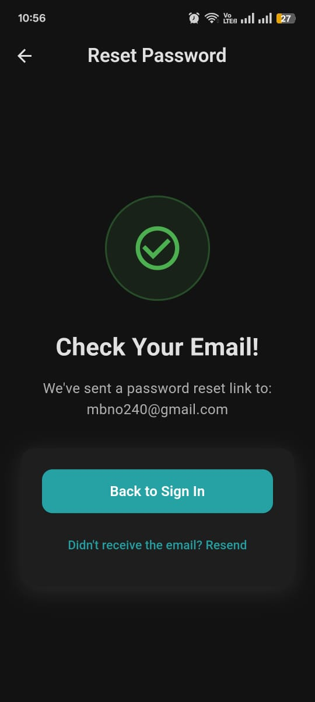

A visually animated "Forgot Password" page that allows users to request a password reset email with error handling and success feedback.



A visually animated splash screen that welcomes users and routes them to either the home or login screen based on Firebase authentication status.

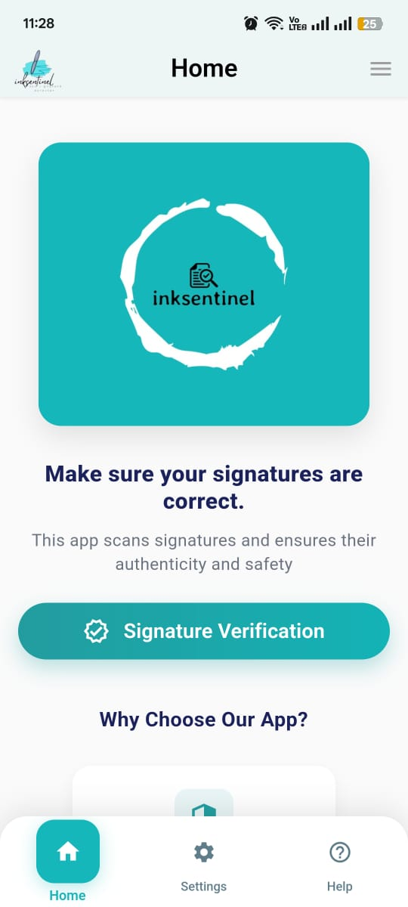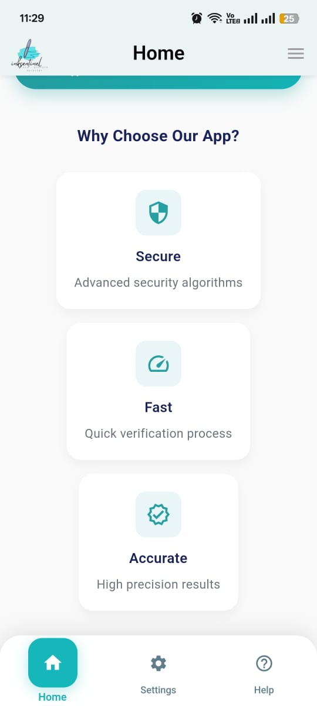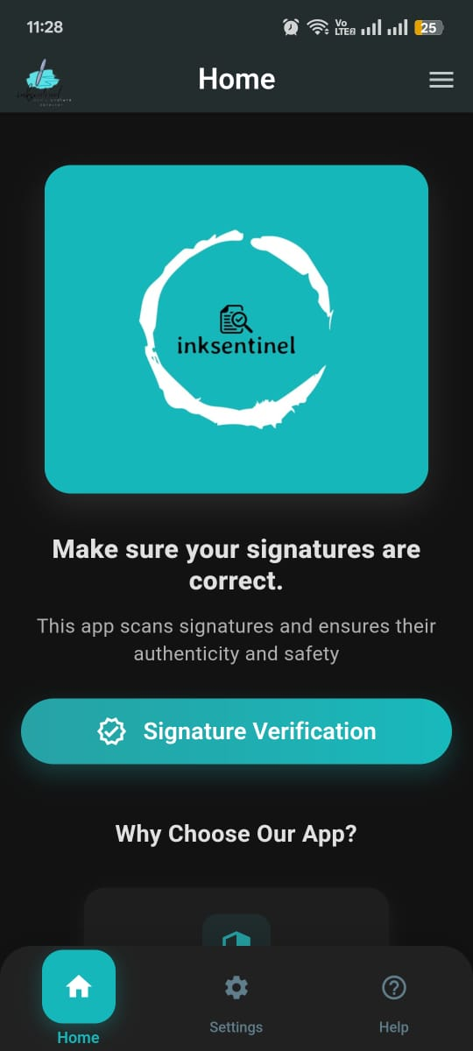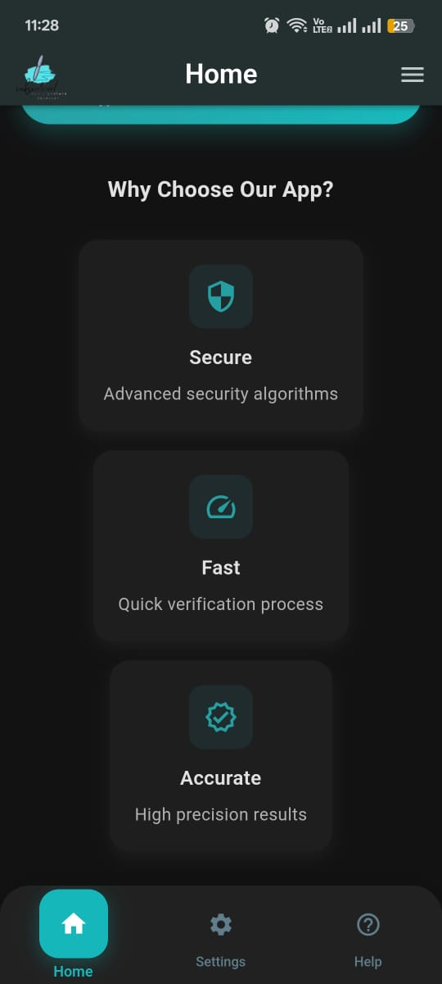

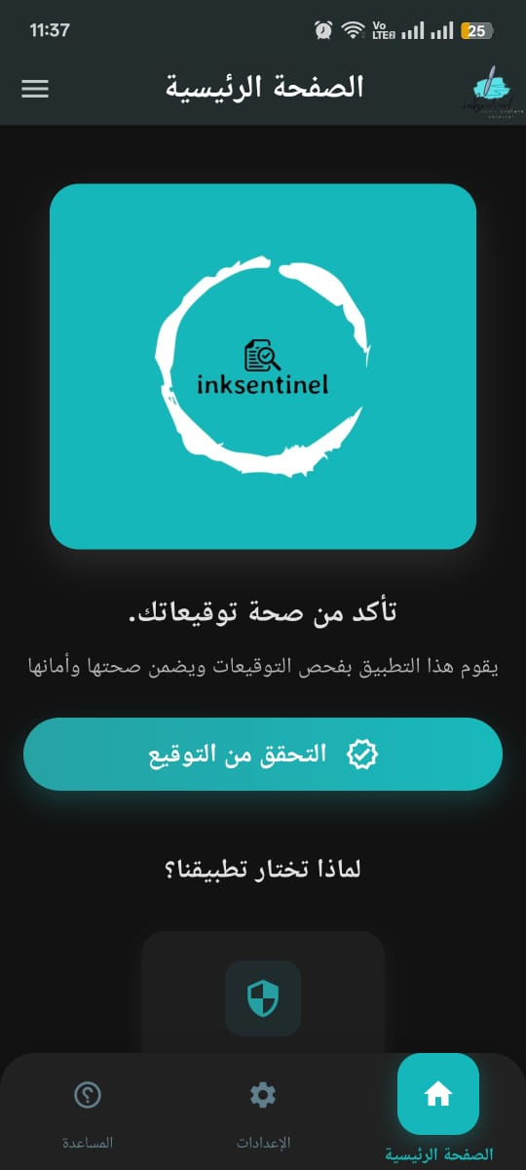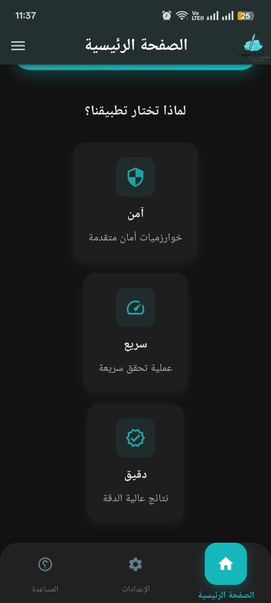
Home Page:
A visually engaging, animated home screen that introduces the app’s purpose—verifying signatures—with a call-to-action button and feature highlights.

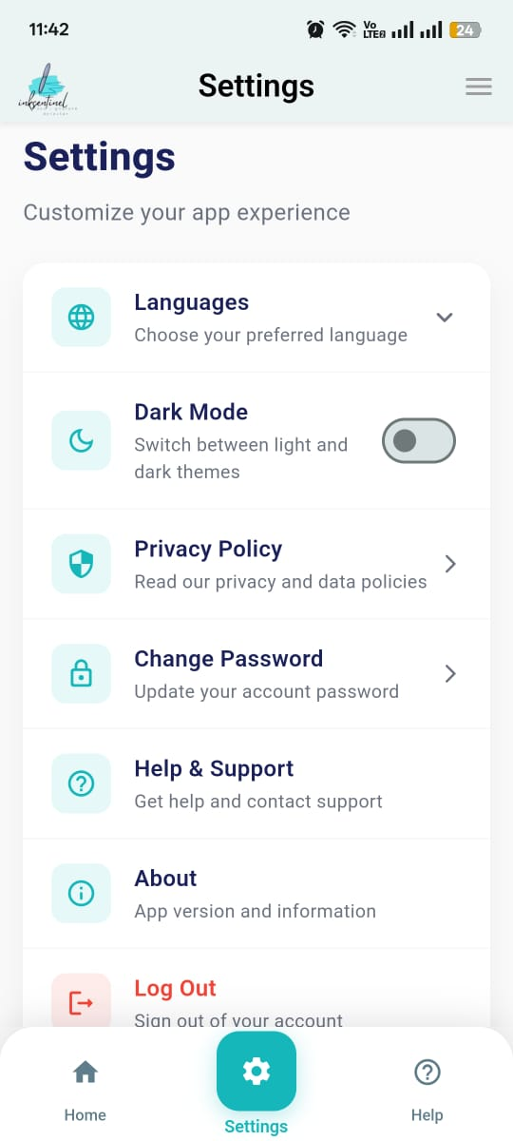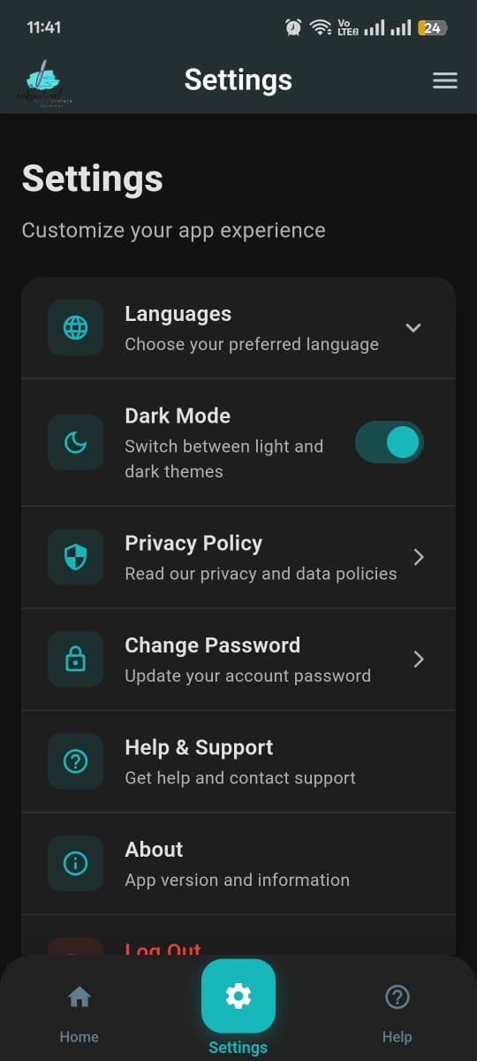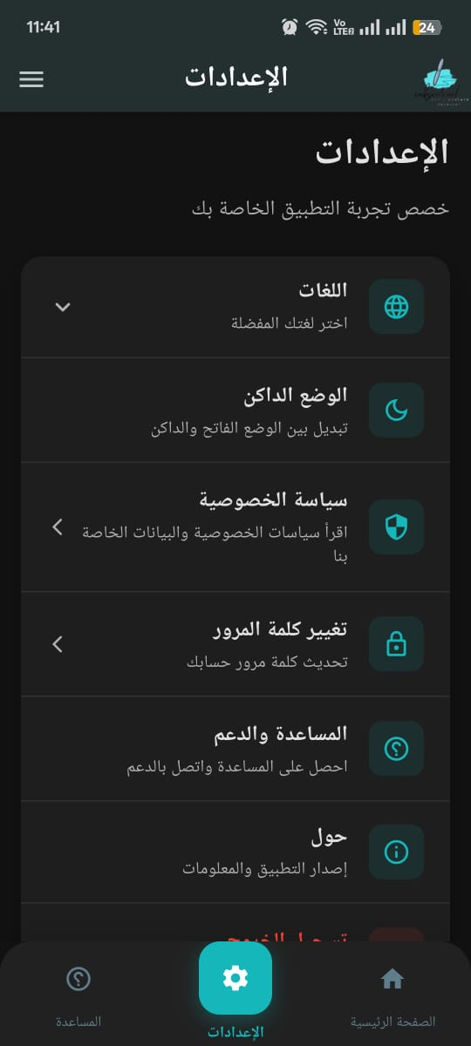

Settings page with animated UI and options for language selection, theme toggle, privacy policy, password change, and logout.

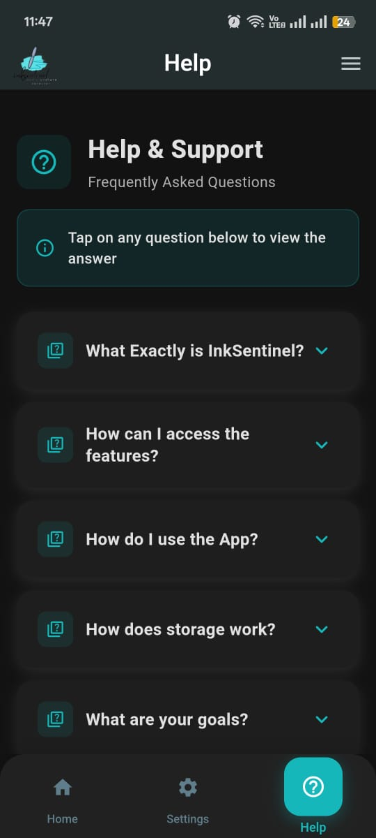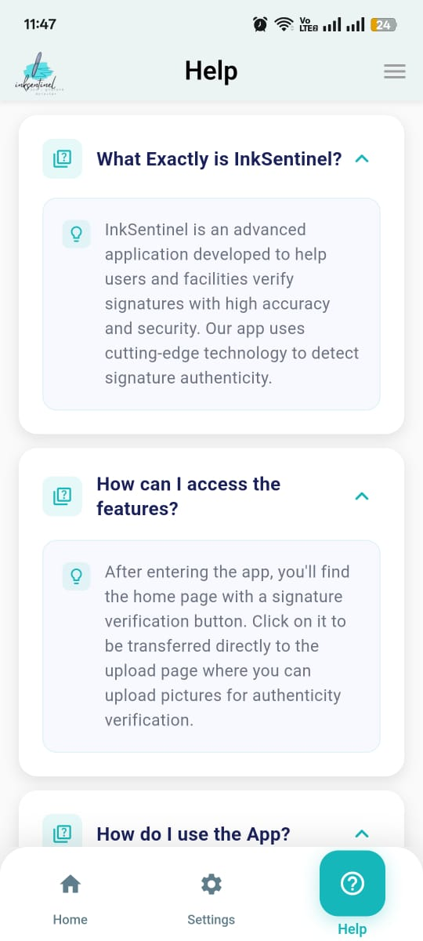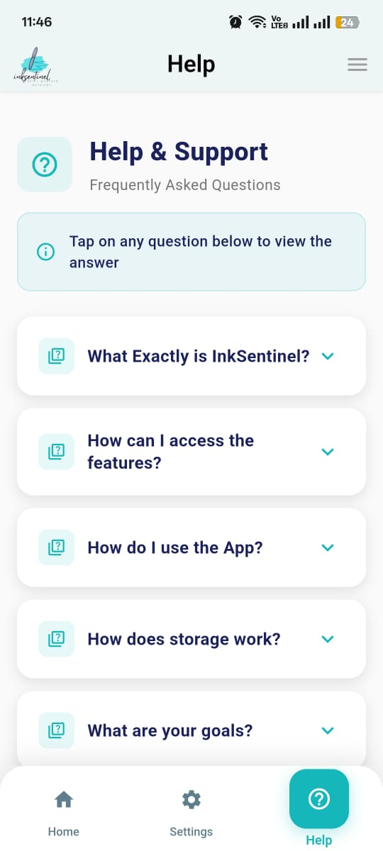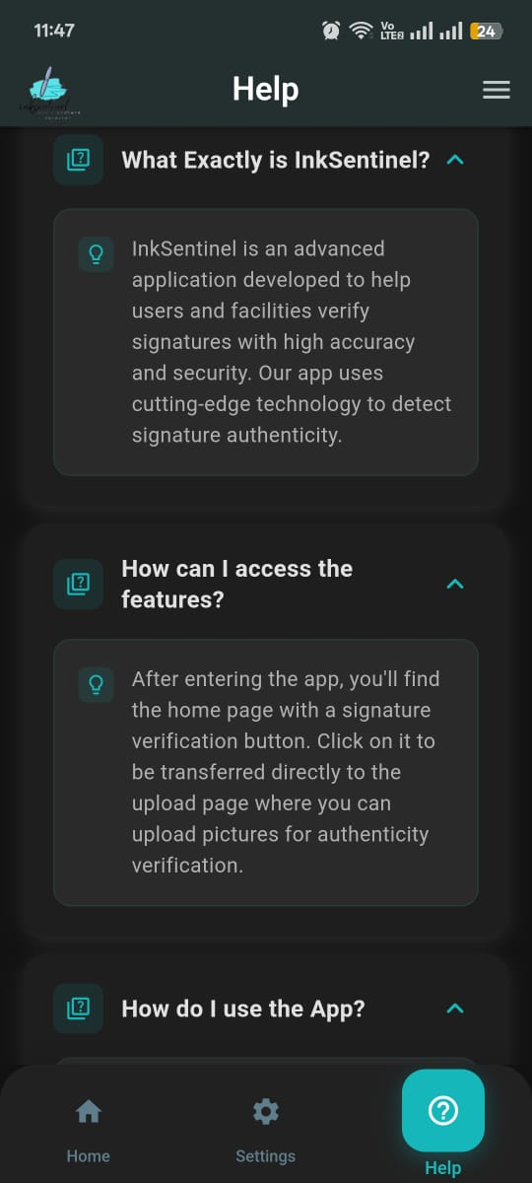

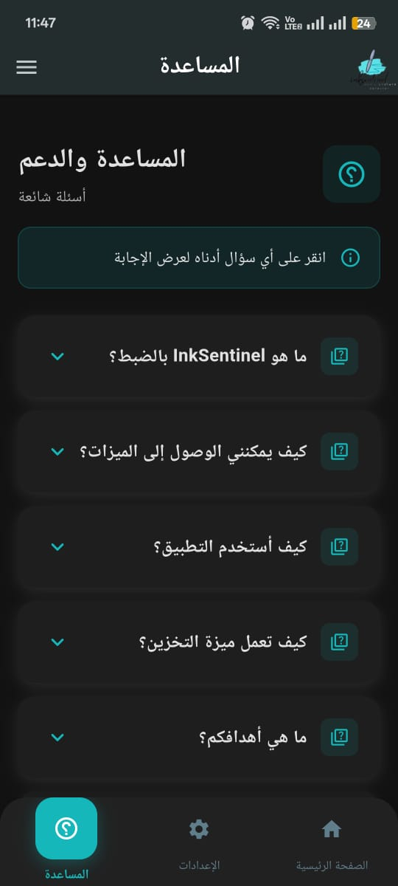

A responsive and animated Help & FAQ page that provides users with expandable answers to common questions, supporting localization and dark mode.

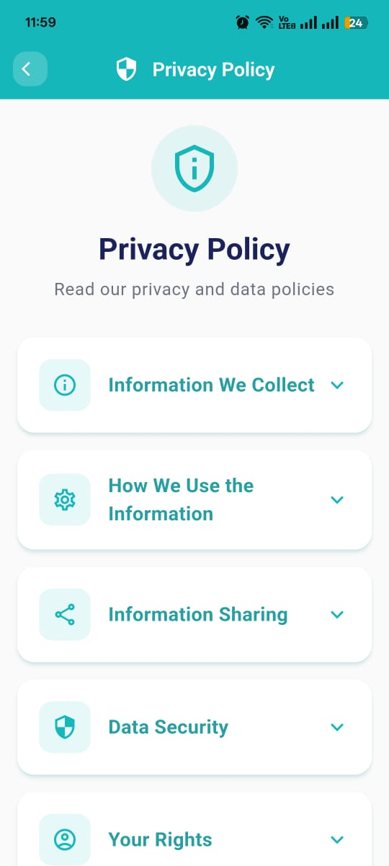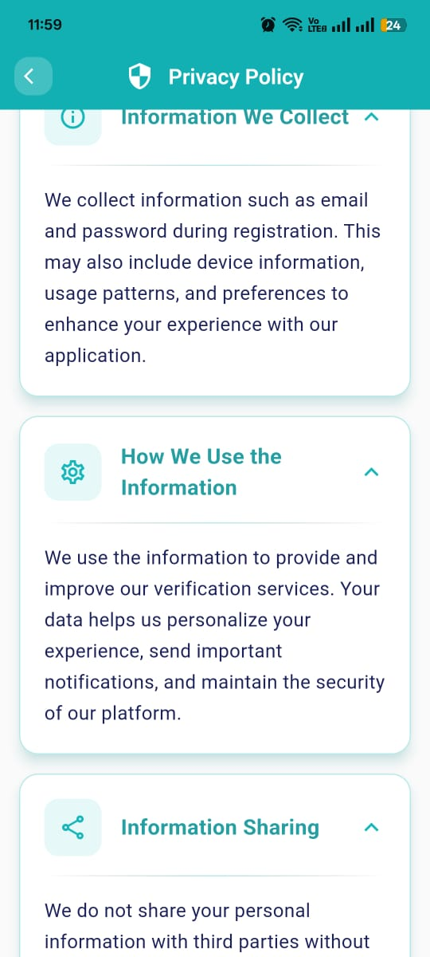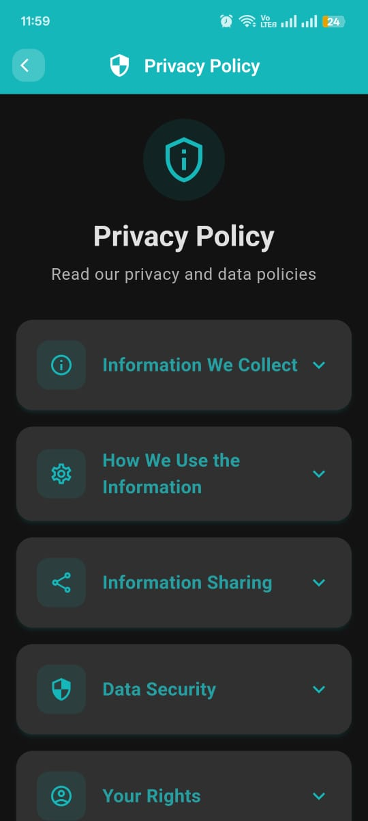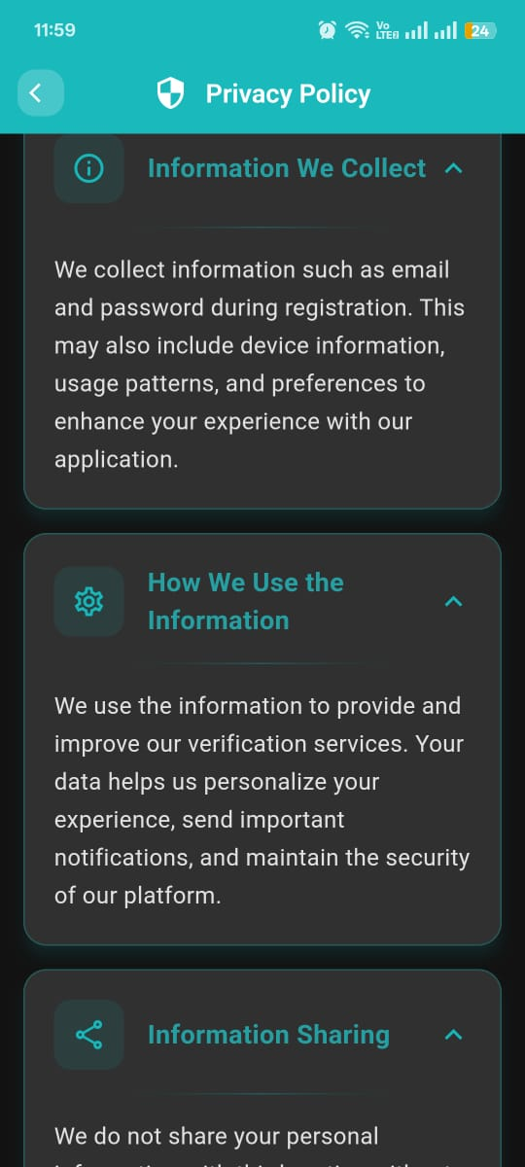

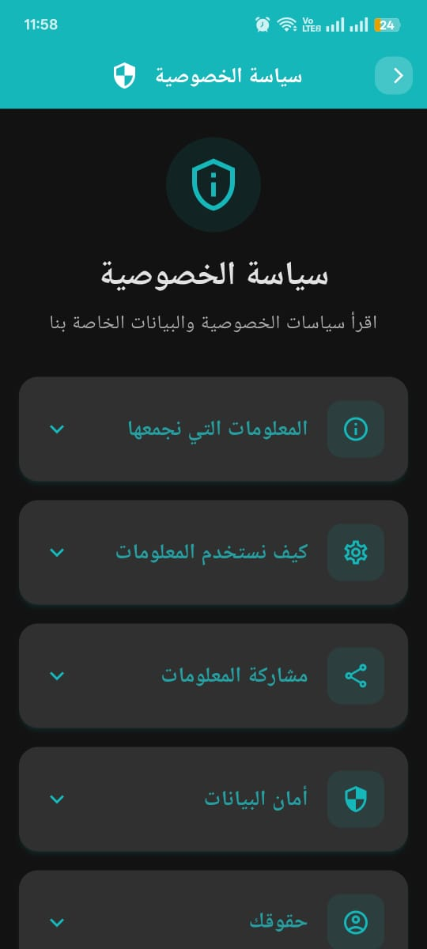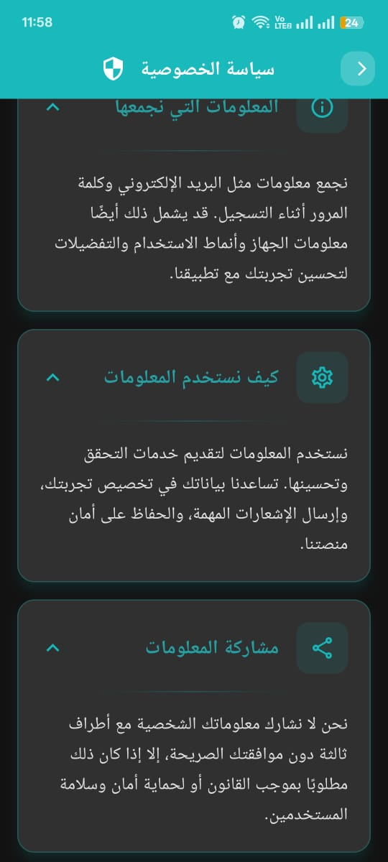

This page displays an animated, expandable privacy policy with multiple sections, supporting localization and smooth transitions.

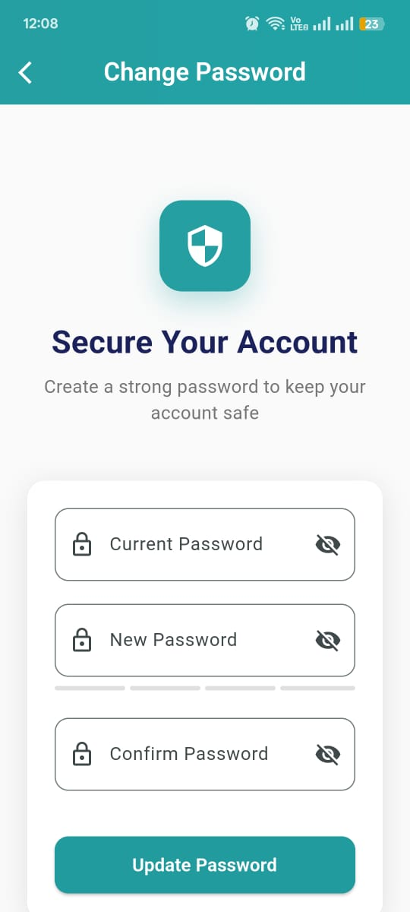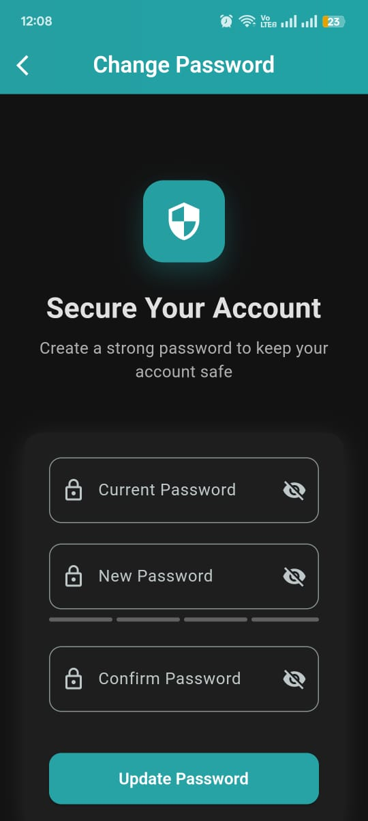

This page provides a secure, animated form for users to change their password with validation, error handling, and Firebase authentication integration.

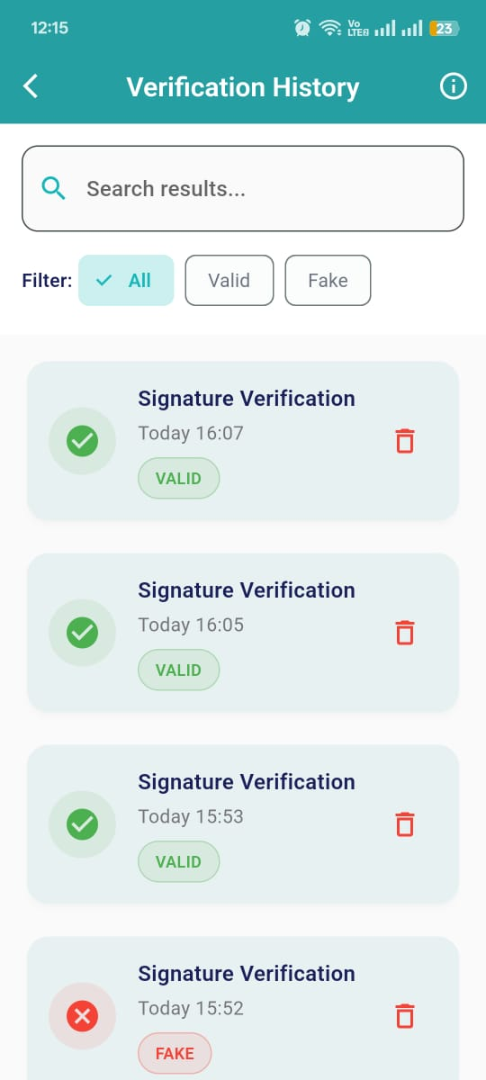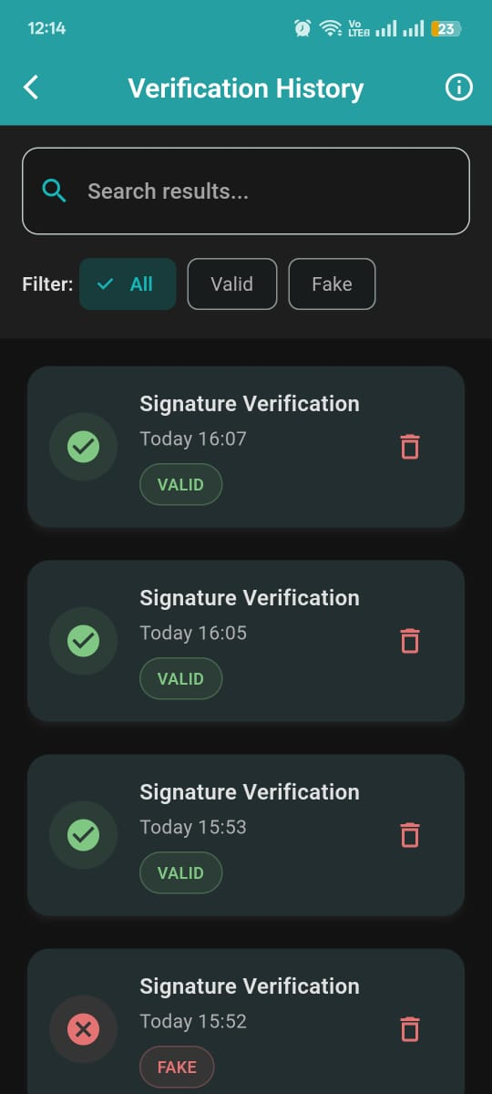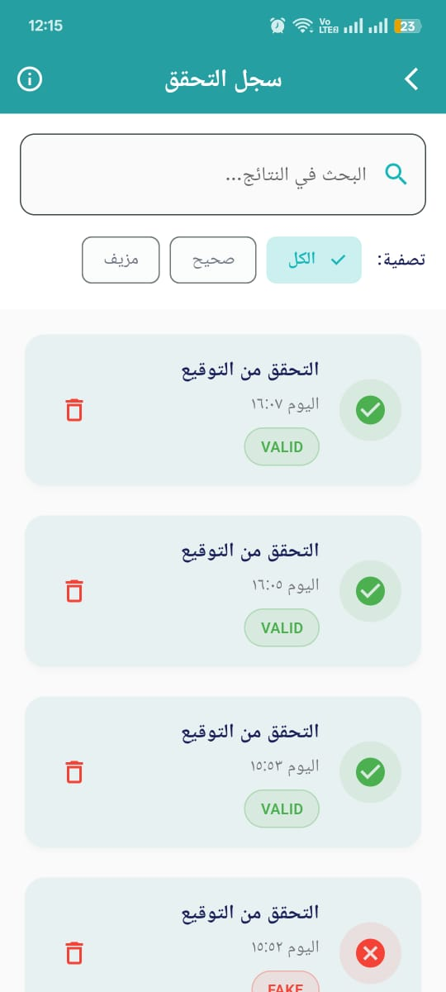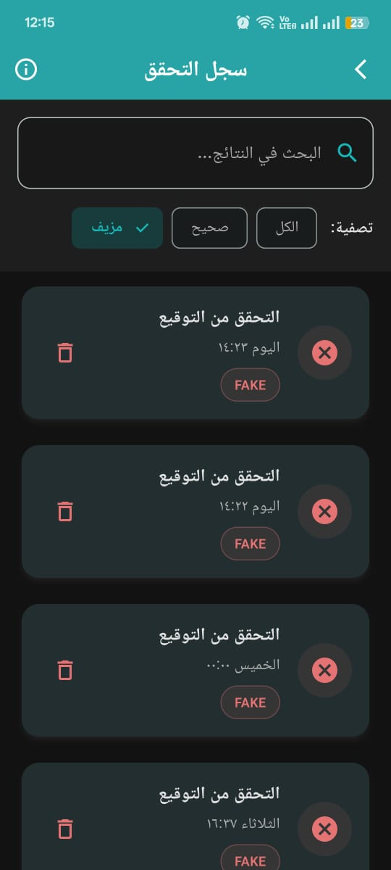

The History Page displays a list of signature verification results with search, filter, and delete functionalities, featuring smooth animations and Firebase integration.

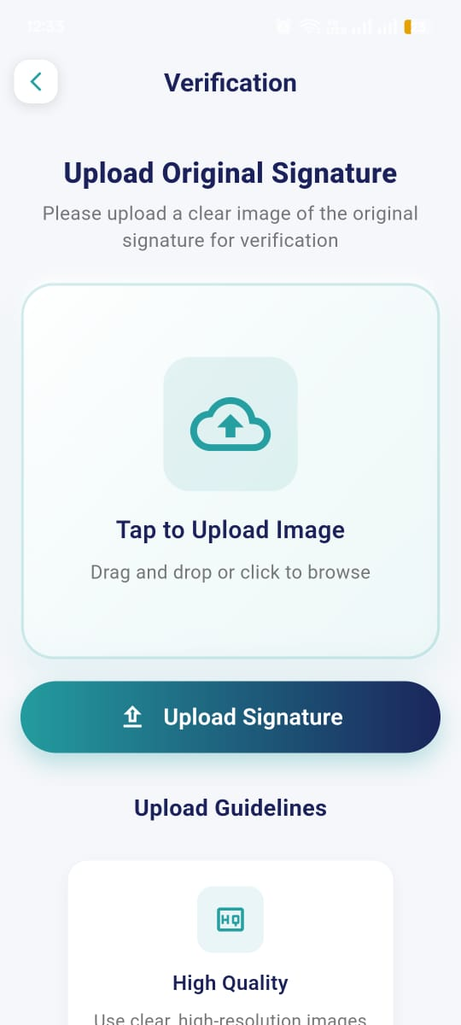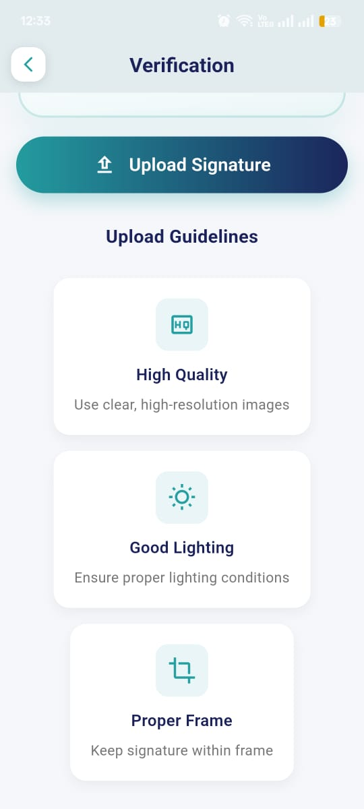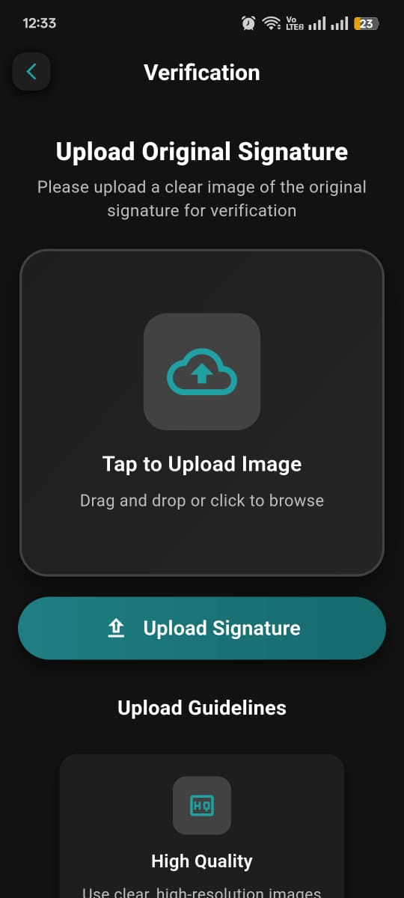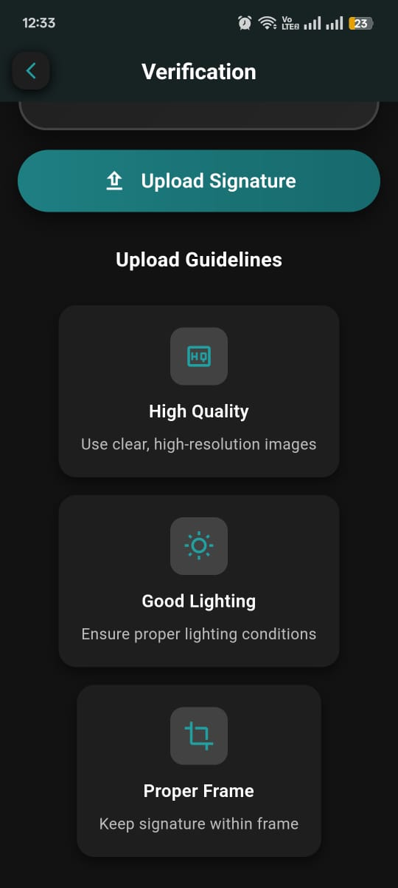

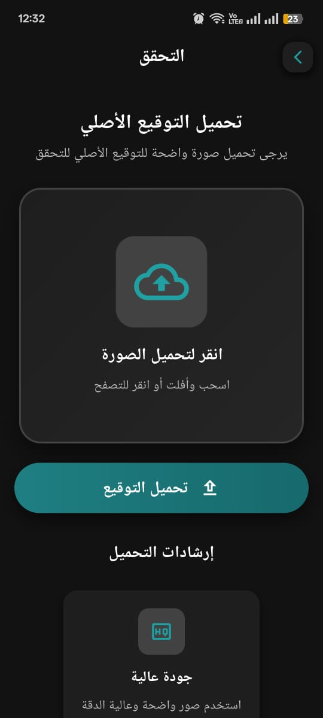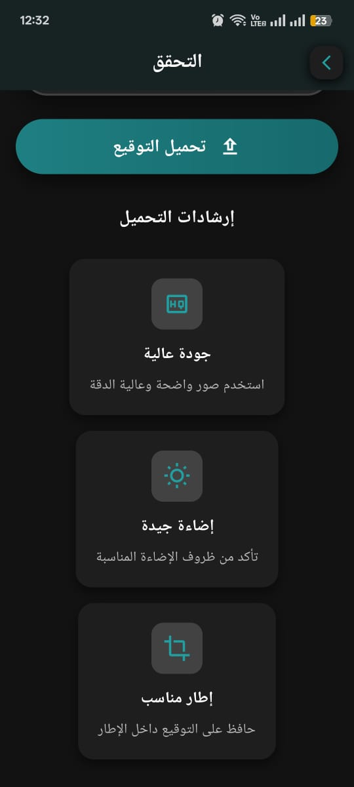

The Verification page provides an interactive interface for uploading original signatures, featuring responsive design, animated elements, and instructional guidelines for optimal image submission.

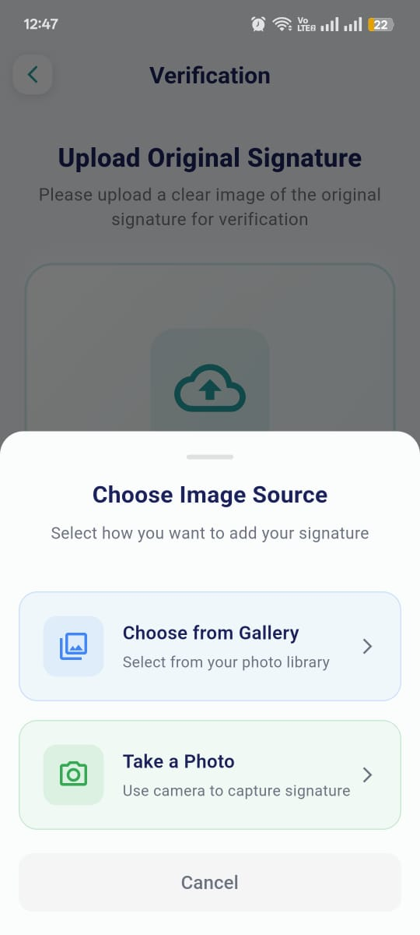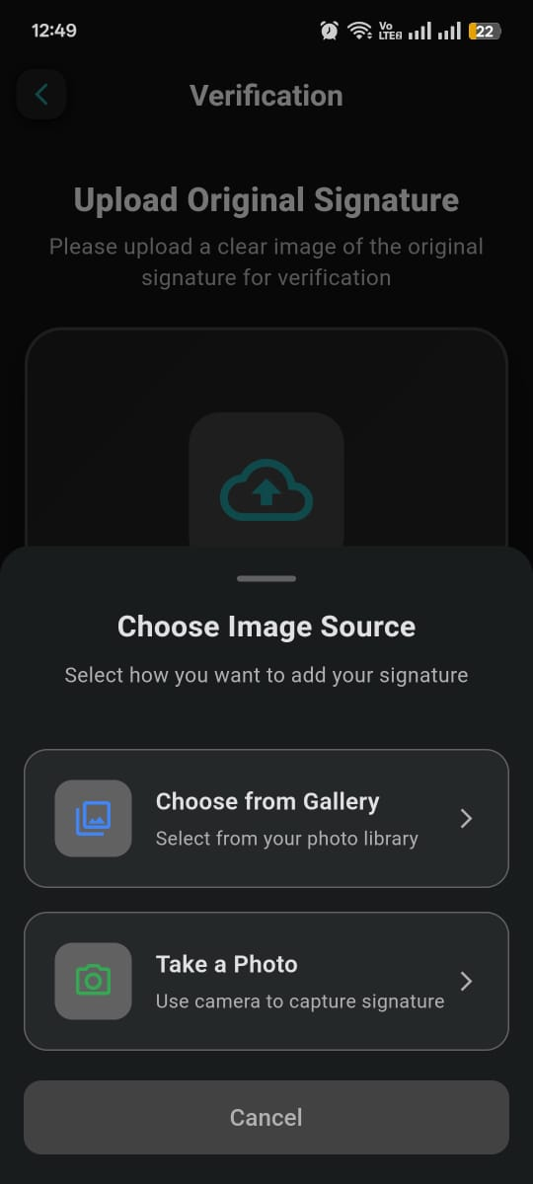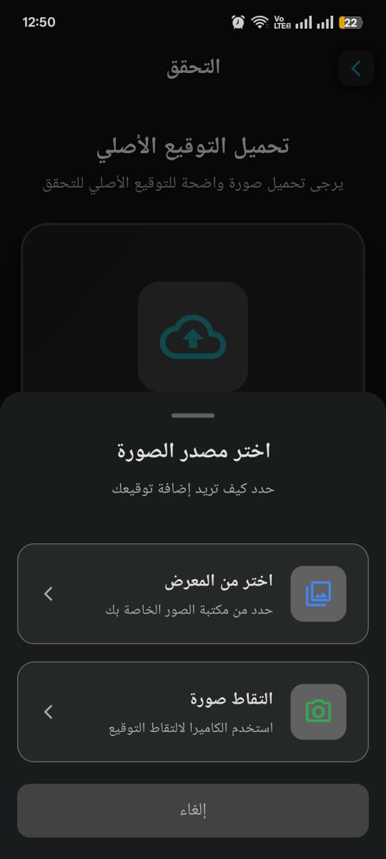

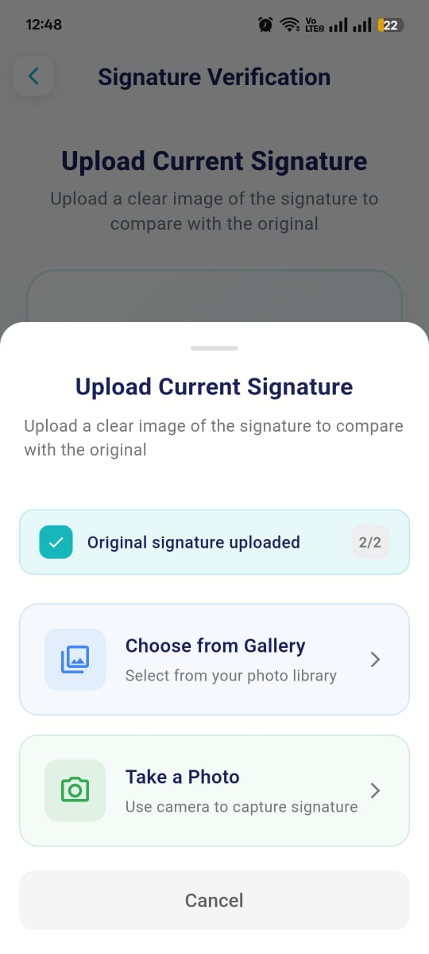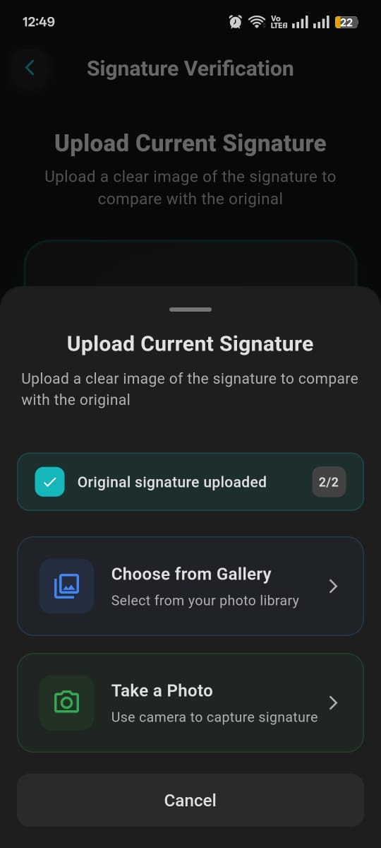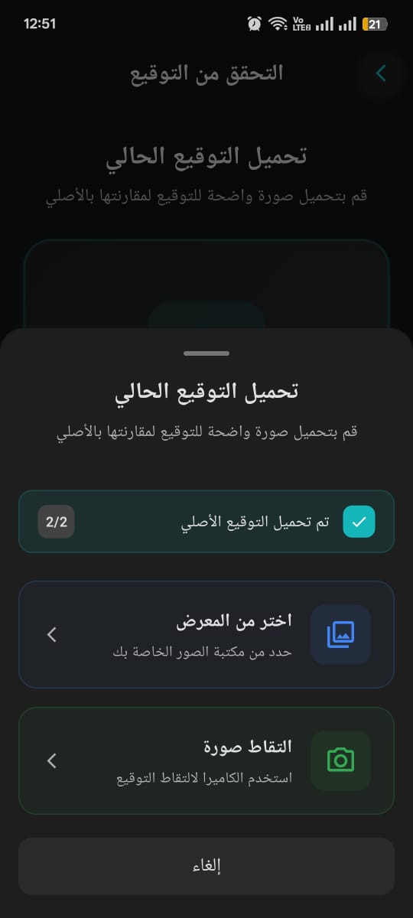
- Scan Page: A modal interface for selecting and uploading an original signature image from the gallery or camera, with smooth animations and local storage handling.
- Scan Current: A modal interface for uploading a current signature image to compare with a previously selected original, featuring animations, progress indication, and navigation to verification.

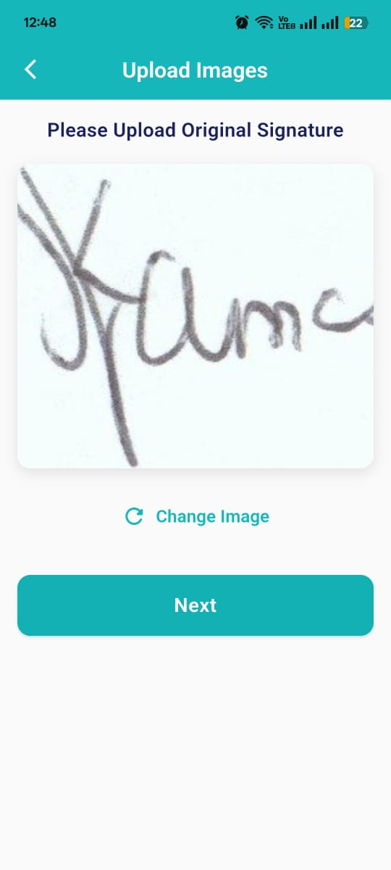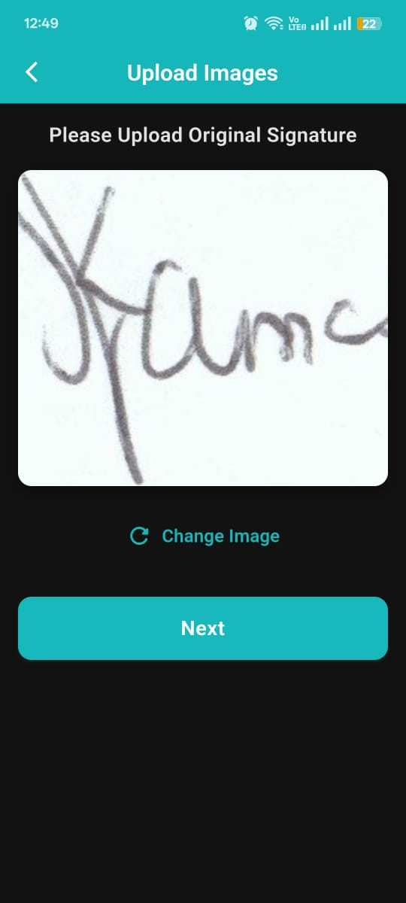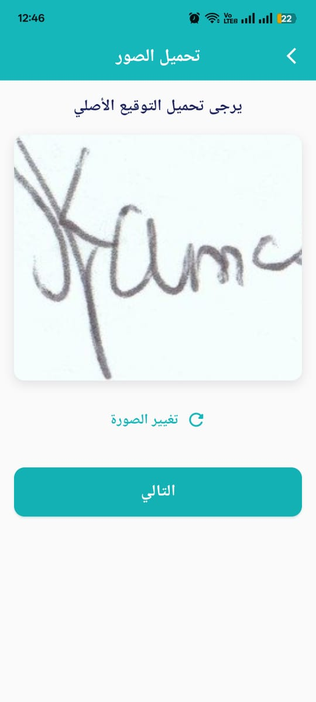

The Selected Original Screen displays a selected original signature image, allowing users to change the image or proceed to upload a current signature for verification, with smooth animations and error handling.

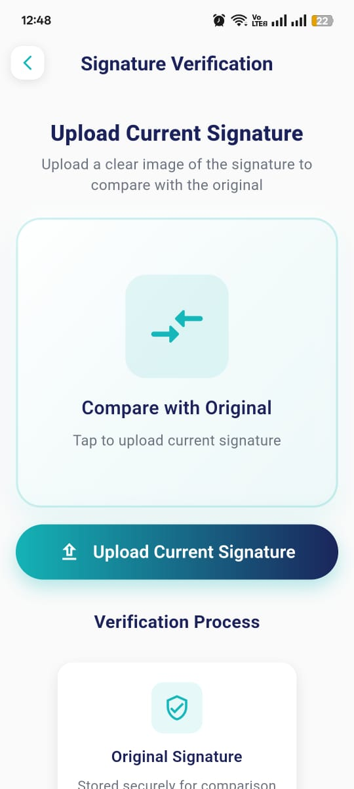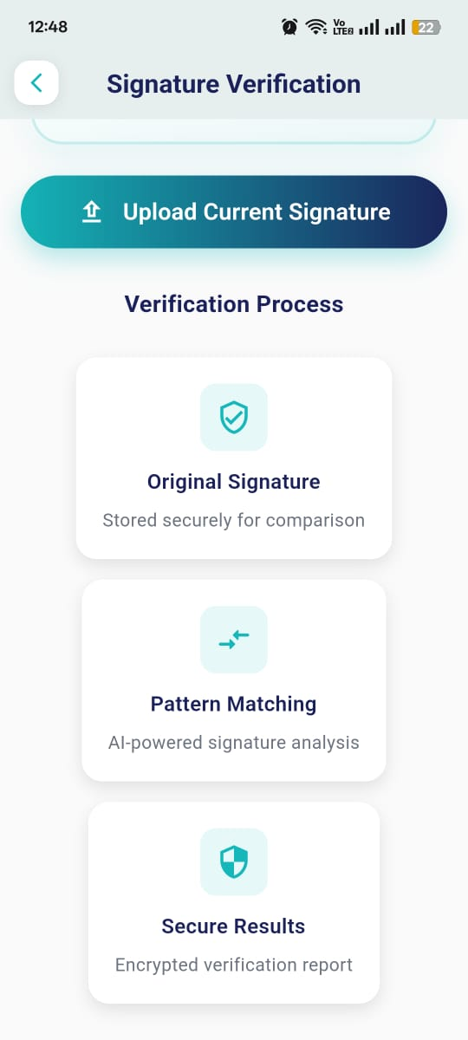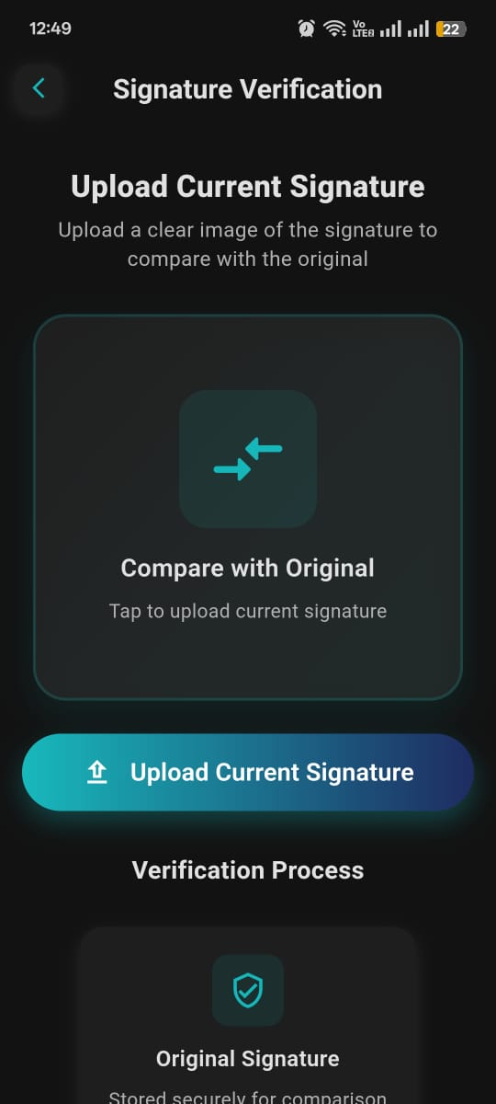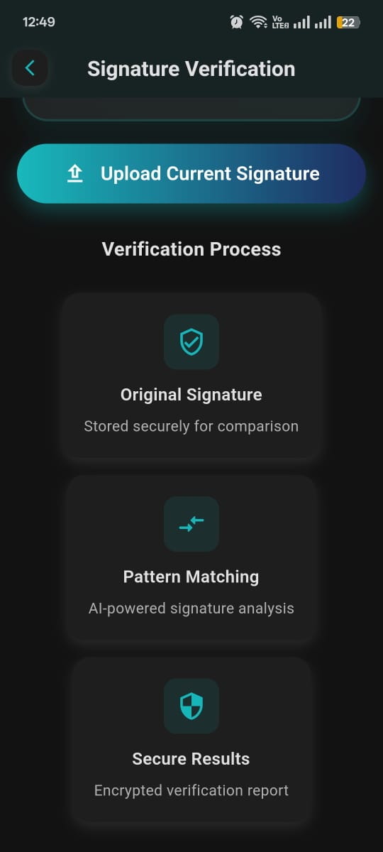
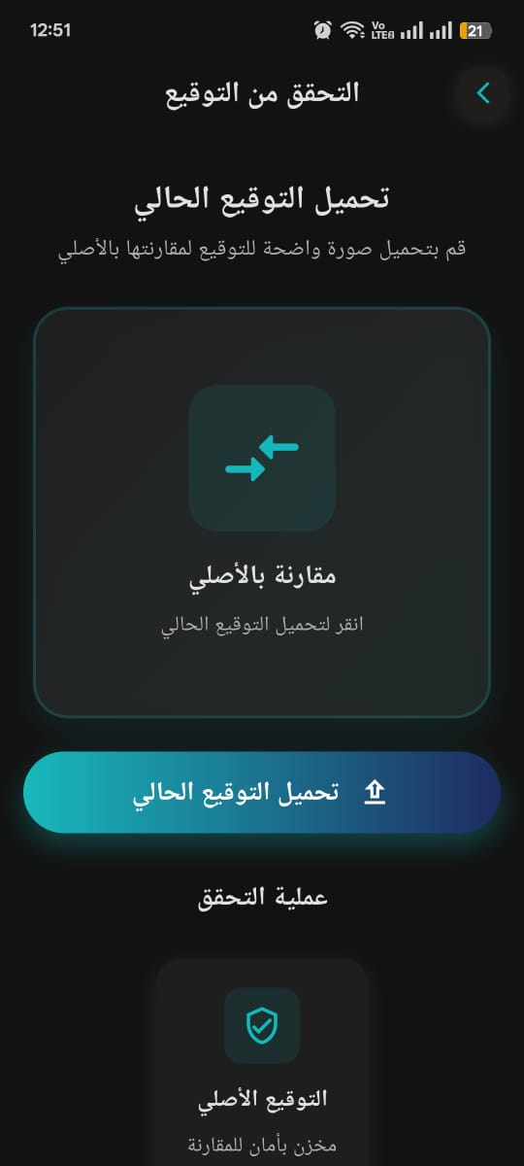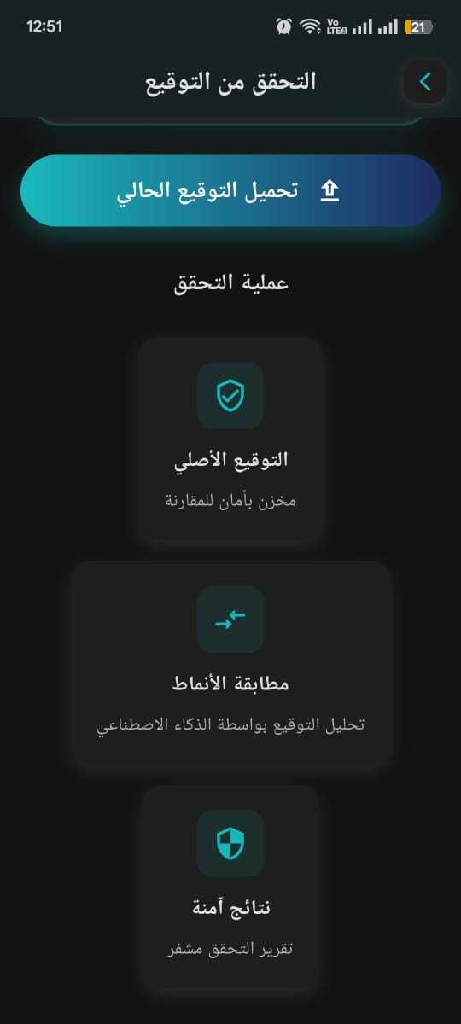

The Verification Current page facilitates the upload of a current signature for comparison with a previously selected original, featuring animated UI elements, responsive design, and informational cards about the verification process.

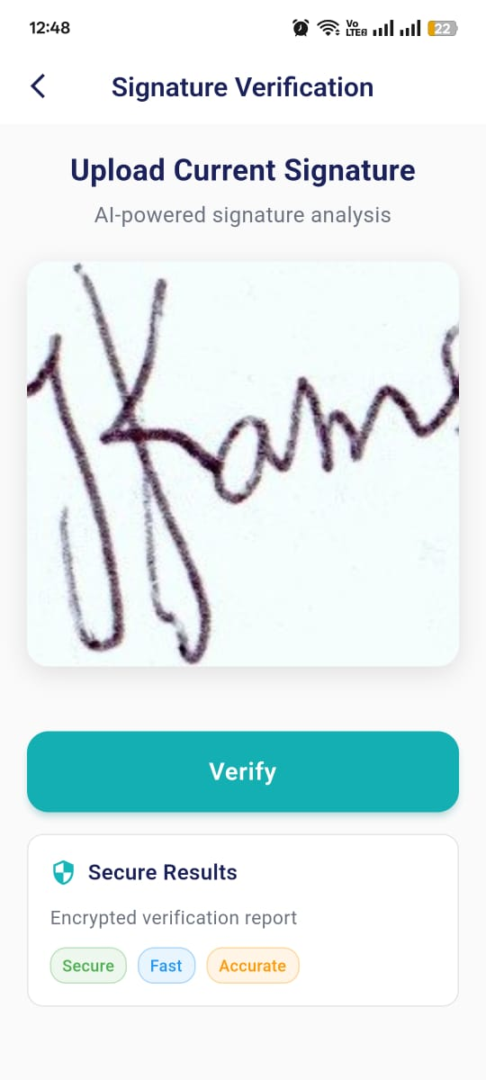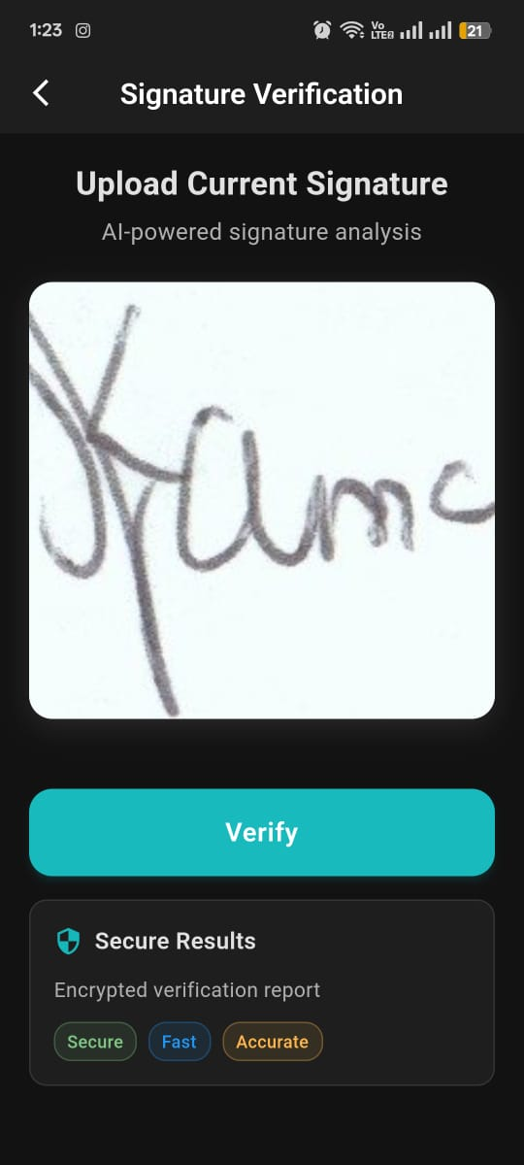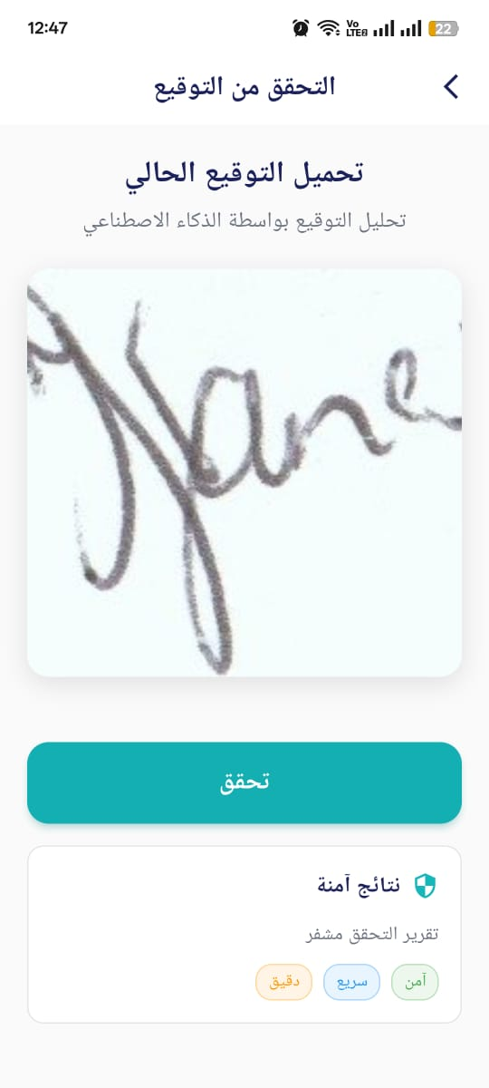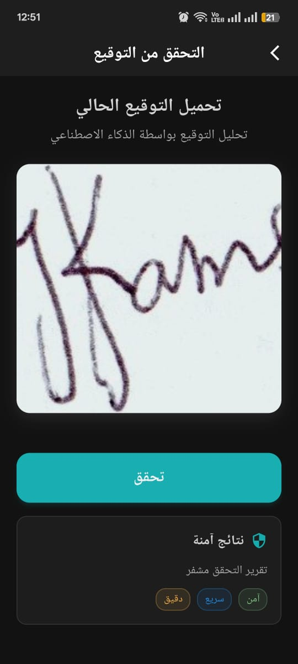

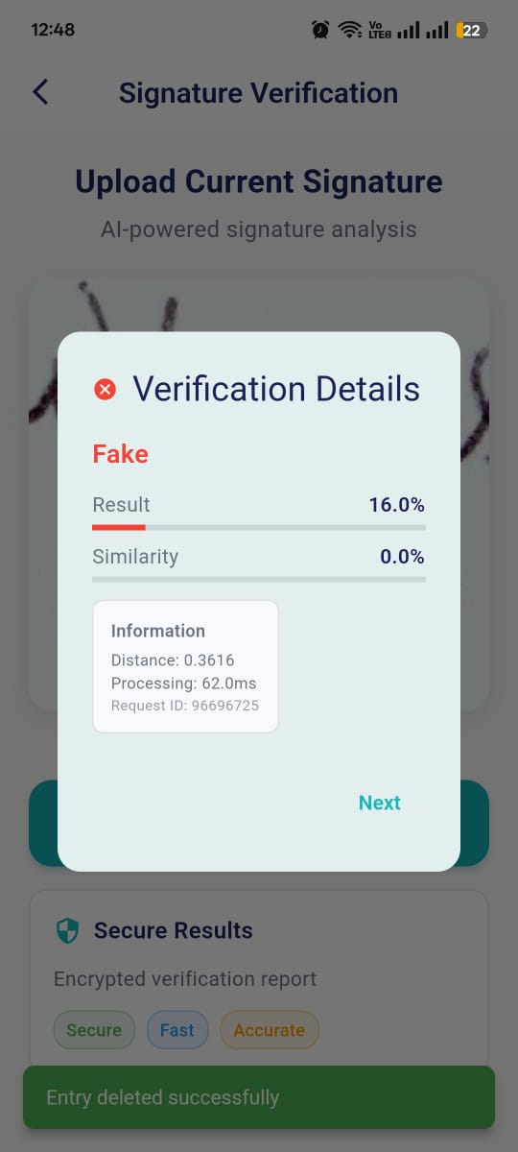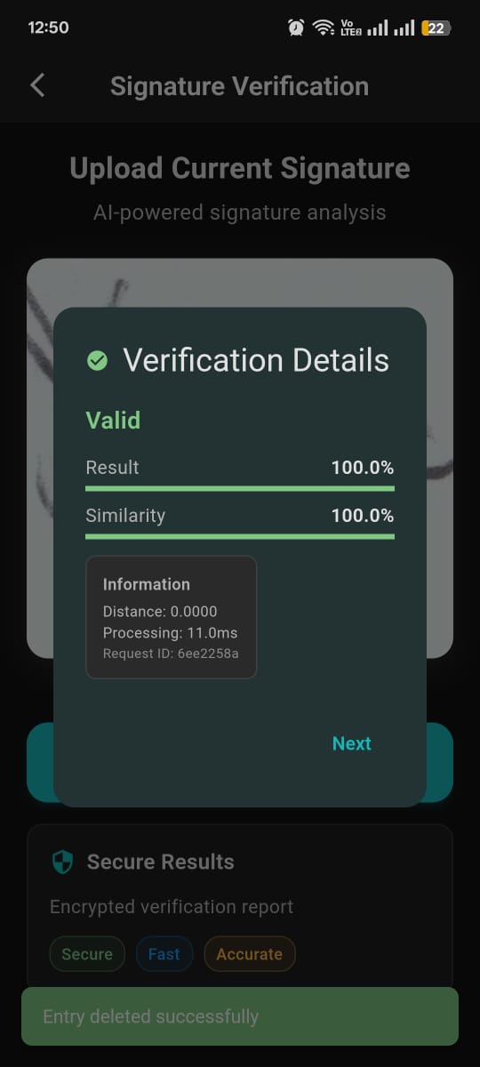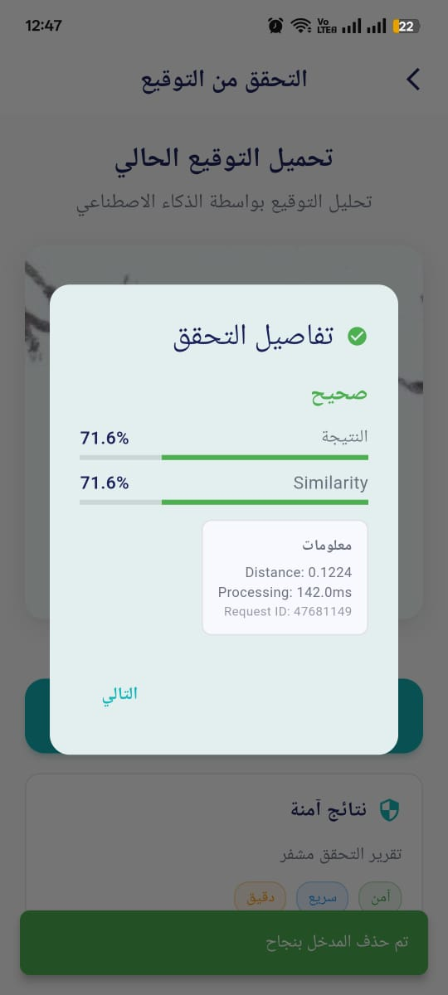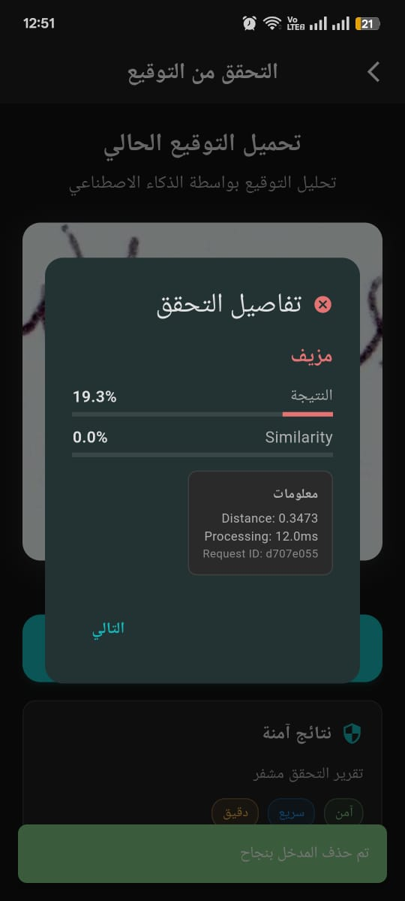

The Check page enables verification of a current signature against the original by displaying the
captured signature image, performing secure API-based verification, and presenting results through
smooth animations and Firestore integration. Additionally, a chatbot is integrated to guide users
through the verification process, answer queries, and enhance the overall user experience..
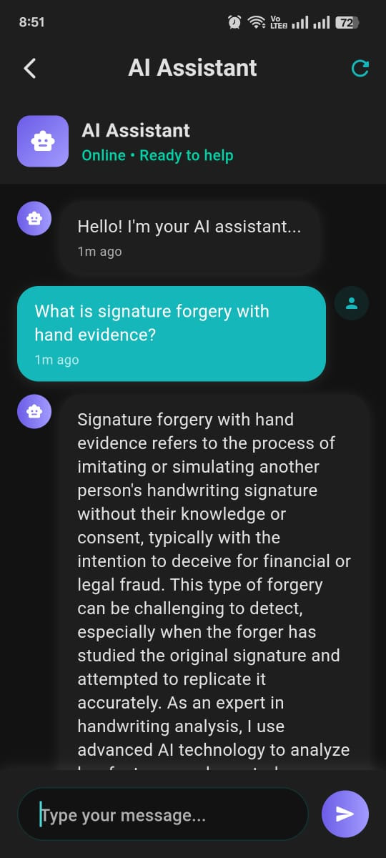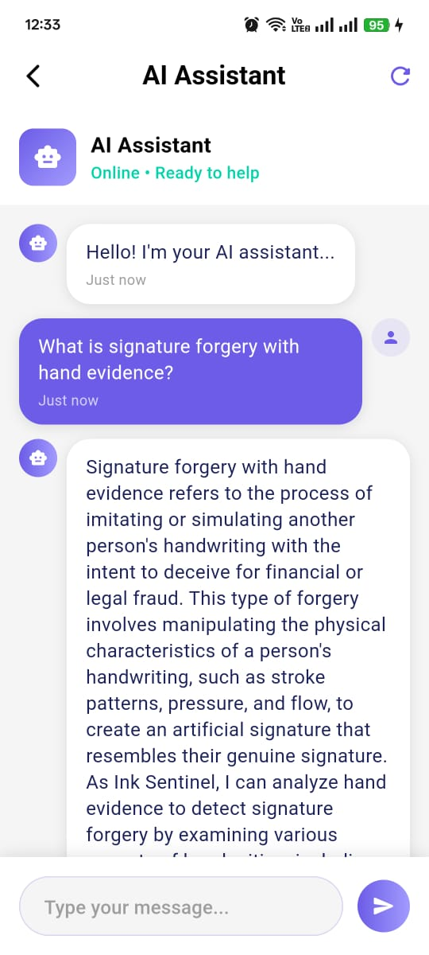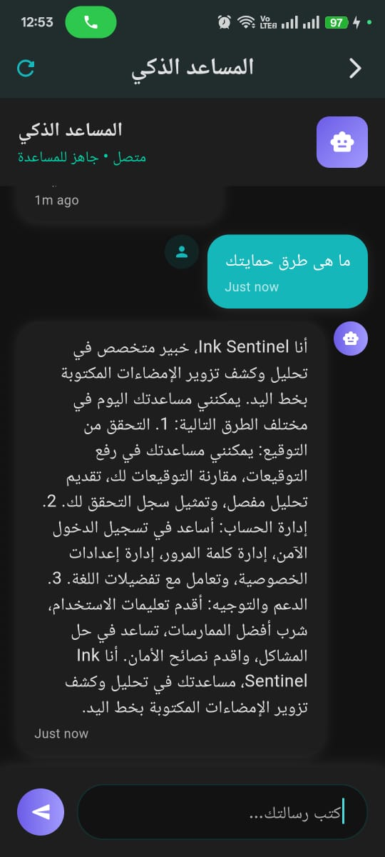

This is the chatbot page that helps the user to get to know about apps.

Dataset Preparation and Preprocessing
A. Code
from google.colab import drive
from torch.utils.data import Dataset, DataLoader
import torchvision.transforms as transforms
from PIL import Image
import pandas as pd
import os
import torch
import matplotlib.pyplot as plt
import numpy as np
from tqdm import tqdm

# Mount Google Drive
drive.mount('/content/drive')

class SiameseNetworkDataset(Dataset):
def __init__(self, training_csv=None, training_dir=None, transform=None):
self.training_df = pd.read_csv(training_csv)
self.training_df.columns = ["image1", "image2", "label"]
self.training_dir = training_dir
self.transform = transform
self.images = {}
self._preload_images()

def _preload_images(self):
print("Preloading images...")
for idx in tqdm(range(len(self.training_df))):
img1_path = os.path.join(self.training_dir, self.training_df.iat[idx, 0]).replace("\\", "/").replace('"', '')
img2_path = os.path.join(self.training_dir, self.training_df.iat[idx, 1]).replace("\\", "/").replace('"', '')

if img1_path not in self.images:
self.images[img1_path] = self.transform(Image.open(img1_path).convert("L"))
if img2_path not in self.images:
self.images[img2_path] = self.transform(Image.open(img2_path).convert("L"))

def __getitem__(self, index):
img1_path = os.path.join(self.training_dir, self.training_df.iat[index, 0]).replace("\\", "/").replace('"', '')
img2_path = os.path.join(self.training_dir, self.training_df.iat[index, 1]).replace("\\", "/").replace('"', '')

return (self.images[img1_path],
self.images[img2_path],
torch.tensor([int(self.training_df.iat[index, 2])], dtype=torch.float32))

def __len__(self):
return len(self.training_df)

def visualize_dataset(dataset, num_samples=4):
fig, axes = plt.subplots(num_samples, 2, figsize=(6, num_samples * 2))
for i in range(num_samples):
idx = torch.randint(0, len(dataset), (1,)).item()
img0, img1, label = dataset[idx]
img0 = img0.squeeze().cpu().numpy()
img1 = img1.squeeze().cpu().numpy()
axes[i, 0].imshow(img0, cmap="gray")
axes[i, 0].set_title(f"Image 1\n(Label: {int(label.item())})")
axes[i, 0].axis("off")
axes[i, 1].imshow(img1, cmap="gray")
axes[i, 1].set_title("Image 2")
axes[i, 1].axis("off")
plt.tight_layout()
plt.show()

def mixup_data(x1, x2, y, alpha=0.2):
if alpha > 0:
lam = np.random.beta(alpha, alpha)
else:
lam = 1
batch_size = x1.size()[0]
index = torch.randperm(batch_size).cuda()
mixed_x1 = lam * x1 + (1 - lam) * x1[index]
mixed_x2 = lam * x2 + (1 - lam) * x2[index]
mixed_y = lam * y + (1 - lam) * y[index]
return mixed_x1, mixed_x2, mixed_y

# Define transformations
train_transform = transforms.Compose([
transforms.Grayscale(1),
transforms.Resize((160, 160)),
transforms.RandomHorizontalFlip(),
transforms.ToTensor(),
transforms.Normalize(mean=[0.485], std=[0.229])
])

# Load dataset
train_csv = "/content/drive/MyDrive/DataSet/train_data.csv"
train_dir = "/content/drive/MyDrive/DataSet/train"
train_dataset = SiameseNetworkDataset(training_csv=train_csv, training_dir=train_dir, transform=train_transform)
train_dataloader = DataLoader(train_dataset, batch_size=16, shuffle=True, num_workers=2, pin_memory=False)

# Visualize samples
visualize_dataset(train_dataset, num_samples=4)

B. Explanation of the Code
This script implements a Siamese Neural Network for image similarity tasks using PyTorch. Here's a detailed breakdown of what it does:

- It imports necessary libraries: Google Drive integration, PyTorch data handling, image processing, visualization tools, and progress tracking.
- It mounts Google Drive to access stored datasets.
- It defines a custom Dataset class for Siamese Networks that loads image pairs and their similarity labels.
- It implements data visualization functions to inspect image pairs.
- It includes data augmentation techniques like mixup to improve model robustness.
- It sets up data transformations for preprocessing images.
- It loads the dataset and creates a DataLoader for batch processing.
- It visualizes sample pairs from the dataset.

Detailed Explanation of Each Component
Import Libraries
from google.colab import drive
from torch.utils.data import Dataset, DataLoader
import torchvision.transforms as transforms
from PIL import Image
import pandas as pd
import os
import torch
import matplotlib.pyplot as plt
import numpy as np
from tqdm import tqdm

- google.colab.drive: Used to mount Google Drive in a Colab environment, providing access to stored files.
- torch.utils.data: Provides the Dataset and DataLoader classes for handling data in PyTorch.
- torchvision.transforms: Contains transformations for image preprocessing and augmentation.
- PIL.Image: Used for opening and manipulating images.
- pandas: Handles CSV data loading and manipulation.
- os: Provides functions for interacting with the operating system.
- torch: The main PyTorch library for creating and training neural networks.
- matplotlib.pyplot: Used for visualization of images and data.
- numpy: Provides numerical computation capabilities.
- tqdm: Displays progress bars for long-running operations.

Mount Google Drive
drive.mount('/content/drive')

This line mounts Google Drive to the Colab environment at the path /content/drive, allowing the script to access files stored on Drive.

Define the Siamese Network Dataset Class
class SiameseNetworkDataset(Dataset):
def _init_(self, training_csv=None, training_dir=None, transform=None):
self.training_df = pd.read_csv(training_csv)
self.training_df.columns = ["image1", "image2", "label"]
self.training_dir = training_dir
self.transform = transform
self.images = {}
self._preload_images()

This class definition extends PyTorch's Dataset class for handling Siamese network data. The __init__ method:
- Reads a CSV file containing image pair paths and similarity labels.
- Sets column names explicitly to ensure consistency.
- Stores the directory path where the images are located.
- Saves the transform operations to be applied to images.
- Initializes an empty dictionary to cache images.
- Calls _preload_images() to load all images into memory.

Note: The method names should be __init__ and __getitem__ (with double underscores), but the code shows _init_ and _getitem_ (with single underscores), which might cause errors.

Preloading Images
def _preload_images(self):
print("Preloading images...")
for idx in tqdm(range(len(self.training_df))):
img1_path = os.path.join(self.training_dir, self.training_df.iat[idx, 0]).replace("\\", "/").replace('"', '')
img2_path = os.path.join(self.training_dir, self.training_df.iat[idx, 1]).replace("\\", "/").replace('"', '')

if img1_path not in self.images:
self.images[img1_path] = self.transform(Image.open(img1_path).convert("L"))
if img2_path not in self.images:
self.images[img2_path] = self.transform(Image.open(img2_path).convert("L"))

This method:
- Displays a progress message and initializes a progress bar using tqdm.
- Iterates through all rows in the DataFrame.
- Constructs the full paths to both images in each pair, replacing backslashes with forward slashes and removing quotation marks for consistency.
- Checks if each image has already been loaded into the cache.
- If not, it opens the image, converts it to grayscale (using convert("L")), applies the specified transformations, and stores it in the cache dictionary.
This preloading approach improves efficiency by avoiding loading the same image multiple times during training.

Getting an Item from the Dataset
def _getitem_(self, index):
img1_path = os.path.join(self.training_dir, self.training_df.iat[index, 0]).replace("\\", "/").replace('"', '')
img2_path = os.path.join(self.training_dir, self.training_df.iat[index, 1]).replace("\\", "/").replace('"', '')

return (self.images[img1_path],
self.images[img2_path],
torch.tensor([int(self.training_df.iat[index, 2])], dtype=torch.float32))

This method:
- Constructs the paths to both images in the requested pair.
- Returns a tuple containing:
  - The first image (retrieved from the cache)
  - The second image (retrieved from the cache)
  - The similarity label converted to a PyTorch tensor with float32 data type

Getting the Dataset Length
def _len_(self):
return len(self.training_df)

This method returns the total number of image pairs in the dataset, which is equal to the number of rows in the DataFrame.
Visualizing the Dataset
def visualize_dataset(dataset, num_samples=4):
fig, axes = plt.subplots(num_samples, 2, figsize=(6, num_samples * 2))
for i in range(num_samples):
idx = torch.randint(0, len(dataset), (1,)).item()
img0, img1, label = dataset[idx]
img0 = img0.squeeze().cpu().numpy()
img1 = img1.squeeze().cpu().numpy()
axes[i, 0].imshow(img0, cmap="gray")
axes[i, 0].set_title(f"Image 1\n(Label: {int(label.item())})")
axes[i, 0].axis("off")
axes[i, 1].imshow(img1, cmap="gray")
axes[i, 1].set_title("Image 2")
axes[i, 1].axis("off")
plt.tight_layout()
plt.show()

This function:
- Creates a figure with multiple subplots (2 columns for each image pair).
- For each sample:
  - Selects a random index from the dataset.
  - Retrieves the image pair and its label.
  - Converts the images from PyTorch tensors to NumPy arrays.
  - Displays the images with appropriate titles and labels.
  - Turns off axis ticks and labels for cleaner visualization.
- Adjusts the layout for optimal spacing and displays the figure.

Implementing Mixup Data Augmentation
def mixup_data(x1, x2, y, alpha=0.2):
if alpha > 0:
lam = np.random.beta(alpha, alpha)
else:
lam = 1
batch_size = x1.size()[0]
index = torch.randperm(batch_size).cuda()
mixed_x1 = lam * x1 + (1 - lam) * x1[index]
mixed_x2 = lam * x2 + (1 - lam) * x2[index]
mixed_y = lam * y + (1 - lam) * y[index]
return mixed_x1, mixed_x2, mixed_y

This function implements the Mixup data augmentation technique:
- Takes two batches of images (x1 and x2) and their labels (y).
- Samples a mixing coefficient lam from a Beta distribution parameterized by alpha.
- Creates a random permutation of indices.
- Creates mixed versions of both images and labels by linearly interpolating between original samples and permuted samples.
- Returns the mixed data.
Mixup helps improve model robustness by training on convex combinations of samples and their labels.

Defining Image Transformations
train_transform = transforms.Compose([
transforms.Grayscale(1),
transforms.Resize((160, 160)),
transforms.RandomHorizontalFlip(),
transforms.ToTensor(),
transforms.Normalize(mean=[0.485], std=[0.229])
])

This creates a sequence of transformations to be applied to each image:
- Grayscale(1): Converts images to grayscale with a single channel.
- Resize((160, 160)): Resizes all images to 160×160 pixels.
- RandomHorizontalFlip(): Randomly flips images horizontally for data augmentation.
- ToTensor(): Converts PIL images to PyTorch tensors.
- Normalize(mean=[0.485], std=[0.229]): Normalizes the tensor with the specified mean and standard deviation.
These transformations ensure images are consistently preprocessed before being fed into the network.

Loading the Dataset
train_csv = "/content/drive/MyDrive/DataSet/train_data.csv"
train_dir = "/content/drive/MyDrive/DataSet/train"
train_dataset = SiameseNetworkDataset(training_csv=train_csv, training_dir=train_dir, transform=train_transform)
train_dataloader = DataLoader(train_dataset, batch_size=16, shuffle=True, num_workers=2, pin_memory=False)

This section:
- Defines the paths to the CSV file with image pairs and the directory containing the images.
- Creates an instance of the SiameseNetworkDataset class.

- Creates a DataLoader to handle batching, shuffling, and parallelization:
  - batch_size=16: Processes 16 image pairs at a time.
  - shuffle=True: Randomizes the order of samples in each epoch.
  - num_workers=2: Uses 2 parallel workers to load data.
  - pin_memory=False: Doesn't use pinned memory (which can sometimes speed up GPU transfers).

Visualizing Dataset Samples
visualize_dataset(train_dataset, num_samples=4)
This line calls the visualization function to display 4 random image pairs from the dataset, giving the user a visual understanding of the data being processed.
Overall Purpose and Applications
This code sets up a data processing pipeline for a Siamese Neural Network, which is typically used for:
- Facial recognition and verification
- Signature verification
- Document similarity
- Image similarity search
- One-shot learning problems

The Siamese architecture is particularly useful when there's limited labeled data or when the task involves comparing pairs of objects rather than classifying them into fixed categories.

Siamese Model Architecture and Training Pipeline
A. Code
import torch
import torch.nn as nn
import torch.nn.functional as F
import torch.optim as optim
from torch.cuda.amp import autocast, GradScaler
import timm
from torchvision import transforms
from torch.utils.data import DataLoader

class EnhancedConfig:
training_dirs = '/content/drive/MyDrive/DataSet/train'
testing_dirs = '/content/drive/MyDrive/DataSet/test'
train_batch_size = 16
test_batch_size = 16
train_number_epochs = 20
patience = 10
num_workers = 2
learning_rate = 1e-4
weight_decay = 0.01
embedding_dim = 128
dropout_rate = 0.4
pos_weight = 0.5
margin = 1.0
image_size = 160
mixup_alpha = 0.2
pin_memory = False

class ImprovedContrastiveLoss(nn.Module):
def __init__(self, margin=1.0, pos_weight=0.5):
super(ImprovedContrastiveLoss, self).__init__()
self.margin = margin
self.pos_weight = pos_weight

def forward(self, output1, output2, label):
euclidean_distance = F.pairwise_distance(output1, output2)
pos_loss = (1 - label) * torch.pow(euclidean_distance, 2)
neg_loss = label * torch.pow(torch.clamp(self.margin - euclidean_distance, min=0.0), 2)
loss = self.pos_weight * pos_loss + (1 - self.pos_weight) * neg_loss
return torch.mean(loss)

class ChannelAttention(nn.Module):
def __init__(self, channels, reduction=16):
super(ChannelAttention, self).__init__()
self.avg_pool = nn.AdaptiveAvgPool2d(1)
self.max_pool = nn.AdaptiveMaxPool2d(1)
self.fc = nn.Sequential(
nn.Linear(channels, channels // reduction, bias=False),
nn.ReLU(inplace=True),
nn.Linear(channels // reduction, channels, bias=False)
)

def forward(self, x):
avg_out = self.fc(self.avg_pool(x).squeeze(-1).squeeze(-1))
max_out = self.fc(self.max_pool(x).squeeze(-1).squeeze(-1))
out = torch.sigmoid(avg_out + max_out).unsqueeze(2).unsqueeze(3)
return out

class SpatialAttention(nn.Module):
def __init__(self, kernel_size=7):
super(SpatialAttention, self).__init__()
self.conv = nn.Conv2d(2, 1, kernel_size, padding=kernel_size//2)

def forward(self, x):
avg_out = torch.mean(x, dim=1, keepdim=True)
max_out, _ = torch.max(x, dim=1, keepdim=True)
x = torch.cat([avg_out, max_out], dim=1)
x = self.conv(x)
return torch.sigmoid(x)

class LightweightSiameseNetwork(nn.Module):
def __init__(self, embedding_dim=128, dropout_rate=0.4):
super(LightweightSiameseNetwork, self).__init__()
self.base_model = timm.create_model('efficientnet_lite0', pretrained=True)
self.base_model.conv_stem = nn.Conv2d(1, 32, kernel_size=3, stride=2, padding=1, bias=False)
self.feature_extractor = nn.Sequential(
self.base_model.conv_stem,
self.base_model.bn1,
self.base_modelblocks[0],
self.base_model.blocks[1]
)
dummy_input = torch.randn(1, 1, EnhancedConfig.image_size, EnhancedConfig.image_size)
dummy_features = self.feature_extractor(dummy_input)
feature_channels = dummy_features.shape[1]
self.embedding_layers = nn.Sequential(
nn.AdaptiveAvgPool2d(1),
nn.Flatten(),
nn.Linear(feature_channels, embedding_dim),
nn.BatchNorm1d(embedding_dim),
nn.ReLU(),
nn.Dropout(dropout_rate),
nn.Linear(embedding_dim, embedding_dim)
)
self.final_norm = nn.LayerNorm(embedding_dim)

def forward_once(self, x):
x = self.feature_extractor(x)
x = self.embedding_layers(x)
x = self.final_norm(x)
return F.normalize(x, p=2, dim=1)

def forward(self, input1, input2):
output1 = self.forward_once(input1)
output2 = self.forward_once(input2)
return output1, output2

class EarlyStopping:
def __init__(self, patience=7, delta=0):
super().__init__()
self.patience = patience
self.delta = delta
self.counter = 0
self.best_loss = None
self.early_stop = False

def __call__(self, val_loss):
if self.best_loss is None:
self.best_loss = val_loss
elif val_loss > self.best_loss - self.delta:
self.counter += 1
if self.counter >= self.patience:
self.early_stop = True
else:
self.best_loss = val_loss
self.counter = 0

def train_model(model, train_dataloader, test_dataloader, criterion, optimizer, scheduler, device, num_epochs, patience):
scaler = GradScaler()
early_stopping = EarlyStopping(patience=patience)
for epoch in range(num_epochs):
model.train()
epoch_loss = 0
if torch.cuda.is_available():
torch.cuda.empty_cache()
for i, (img0, img1, label) in enumerate(tqdm(train_dataloader, desc=f"Epoch {epoch+1}")):
img0, img1, label = img0.to(device), img1.to(device), label.to(device)
with autocast():
output1, output2 = model(img0, img1)
loss = criterion(output1, output2, label)
optimizer.zero_grad(set_to_none=True)
scaler.scale(loss).backward()
scaler.step(optimizer)
scaler.update()
epoch_loss += loss.item()
del=20
del output1, output2, loss
if torch.cuda.is_available():
torch.cuda.empty_cache()
avg_loss = epoch_loss / len(train_dataloader)
print(f"Epoch {epoch+1}, Average Loss: {avg_loss:.4f}")
model.eval()
val_loss = 0
with torch.no_grad():
for img0, img1, label in test_dataloader:
img0, img1, label = img0.to(device), img1.to(device), label.to(device)
output1, output2 = model(img0, img1)
loss = criterion(output1, output2, label)
val_loss += loss.item()
del output1, output2, loss
if torch.cuda.is_available():
torch.cuda.empty_cache()
val_loss /= len(test_dataloader)
print(f"Validation Loss: {val_loss:.4f}")
scheduler.step(val_loss)
early_stopping(val_loss)
if early_stopping.early_stop:
print("Early stopping triggered")
break
return model

# Initialize and train
device = torch.device('cuda' if torch.cuda.is_available() else 'cpu')
model = LightweightSiameseNetwork(
embedding_dim=EnhancedConfig.embedding_dim,
dropout_rate=EnhancedConfig.dropout_rate
).to(device)
criterion = ImprovedContrastiveLoss(
margin=EnhancedConfig.margin,
pos_weight=EnhancedConfig.pos_weight
)
optimizer = optim.AdamW(
model.parameters(),
lr=EnhancedConfig.learning_rate,
weight_decay=EnhancedConfig.weight_decay
)
scheduler = optim.lr_scheduler.ReduceLROnPlateau(
optimizer,
mode='min',
factor=0.5,
patience=5,
verbose=True
)
# Note: train_dataloader and test_dataloader should be passed from dataset_preparation.py
# model = train_model(model, train_dataloader, test_dataloader, criterion, optimizer, scheduler, device, EnhancedConfig.train_number_epochs, EnhancedConfig.patience)

B. Explanation of the Code
- Explanation of the Code

This code implements a Siamese neural network using PyTorch, a popular deep learning framework. The Siamese network architecture is specifically designed for tasks like similarity learning, where the goal is to determine if two inputs are similar or dissimilar:

- Learning similarity functions: By training on pairs of examples, the network learns to embed inputs into a feature space where similar items are close together and dissimilar items are far apart.
- Efficient feature representation: The network creates embeddings that capture essential features while discarding irrelevant variations, making it suitable for applications like face recognition, signature verification, and document comparison.
- Handling limited data: Siamese networks can work effectively with smaller datasets by leveraging paired comparisons rather than requiring extensive examples of each class.
- Transfer learning advantage: By utilizing pre-trained models like EfficientNet, the implementation benefits from features learned on large datasets while specializing for the specific similarity task.

By using this code, researchers and developers in the field of machine learning can effectively implement similarity-based learning systems that can distinguish between similar and dissimilar inputs with high accuracy and efficiency.

- Module Imports
import torch
import torch.nn as nn
import torch.nn.functional as F
import torch.optim as optim
from torch.cuda.amp import autocast, GradScaler
import timm
from torchvision import transforms
from torch.utils.data import DataLoader

This section imports essential Python libraries for deep learning with PyTorch:
torch: The core PyTorch library that provides tensor operations and automatic differentiation capabilities for building and training neural networks.
torch.nn: Contains modules and classes for building neural network layers, loss functions, and other components needed for creating complex network architectures.
torch.nn.functional as F: Provides functional implementations of neural network operations like activation functions, pooling, and normalization that can be applied directly to tensors.
torch.optim: Contains optimization algorithms like SGD, Adam, and AdamW used for updating network parameters during training.
torch.cuda.amp: Provides tools for automatic mixed precision training, which helps improve performance and reduce memory usage on compatible GPUs.
timm: The "PyTorch Image Models" library that provides state-of-the-art pre-trained models for computer vision tasks.
torchvision.transforms: Offers various image transformation operations for preprocessing and augmenting images.
torch.utils.data.DataLoader: Enables efficient data loading during training and evaluation, with features like batching, shuffling, and multi-processing.
These imports establish the foundation for building, training, and optimizing the Siamese neural network in this implementation.

C. Configuration Class
class EnhancedConfig:
training_dirs = '/content/drive/MyDrive/DataSet/train'
testing_dirs = '/content/drive/MyDrive/DataSet/test'
train_batch_size = 16
test_batch_size = 16
train_number_epochs = 20
patience = 10
num_workers = 2
learning_rate = 1e-4
weight_decay = 0.01
embedding_dim = 128
dropout_rate = 0.4
pos_weight = 0.5
margin = 1.0
image_size = 160
mixup_alpha = 0.2
pin_memory = False

The EnhancedConfig class centralizes all hyperparameters and configuration settings for training and evaluating the model:
training_dirs and testing_dirs: These variables specify the file paths where training and testing datasets are stored, pointing to folders in Google Drive.
train_batch_size and test_batch_size: Define the number of samples processed in each training and testing batch (16 samples per batch).
train_number_epochs: Sets the maximum number of complete passes through the training dataset (20 epochs).
patience: Determines how many epochs with no improvement to wait before stopping training early (10 epochs).
num_workers: Specifies the number of subprocesses to use for data loading (2 workers).
learning_rate: Sets the step size for the optimizer (1e-4 or 0.0001), controlling how quickly model parameters are updated.
weight_decay: Specifies the L2 regularization strength (0.01) to help prevent overfitting.
embedding_dim: Defines the dimensionality of the feature embeddings produced by the network (128 dimensions).
dropout_rate: Controls the probability (0.4) that neurons will be randomly deactivated during training to reduce overfitting.

pos_weight: Balances the contribution of positive pairs in the contrastive loss function (0.5).
margin: Sets the minimum distance threshold for dissimilar pairs in the contrastive loss function (1.0).
image_size: Defines the size to which input images will be resized (160×160 pixels).
mixup_alpha: Parameter for the mixup data augmentation technique (0.2).
pin_memory: When set to False, disables a CUDA-specific memory optimization.

By consolidating these parameters in a single class, the code maintains better organization and makes it easier to experiment with different configurations.

D. Contrastive Loss Function
class ImprovedContrastiveLoss(nn.Module):
def _init_(self, margin=1.0, pos_weight=0.5):
super(ImprovedContrastiveLoss, self)._init_()
self.margin = margin
self.pos_weight = pos_weight

def forward(self, output1, output2, label):
euclidean_distance = F.pairwise_distance(output1, output2)
pos_loss = (1 - label) * torch.pow(euclidean_distance, 2)
neg_loss = label * torch.pow(torch.clamp(self.margin - euclidean_distance, min=0.0), 2)
loss = self.pos_weight * pos_loss + (1 - self.pos_weight) * neg_loss
return torch.mean(loss)

The ImprovedContrastiveLoss class implements a modified version of the contrastive loss function, which is crucial for training Siamese networks:
__init__(self, margin=1.0, pos_weight=0.5): The constructor initializes two important parameters: margin, which defines the minimum distance threshold for dissimilar pairs (1.0), and pos_weight, which controls the relative contribution of positive pair losses (0.5).

forward(self, output1, output2, label): This method calculates the loss value:
- euclidean_distance: Computes the Euclidean distance between the two output embeddings using F.pairwise_distance.
- pos_loss: Calculates the loss for similar pairs (where label=0) by squaring the distance between their embeddings. This encourages similar pairs to be closer in the embedding space.
- neg_loss: Calculates the loss for dissimilar pairs (where label=1) by squaring the amount by which the distance falls short of the margin. This encourages dissimilar pairs to be at least margin distance apart.
- The torch.clamp(self.margin - euclidean_distance, min=0.0) ensures that dissimilar pairs with distances greater than the margin do not contribute to the loss.
- loss: Combines positive and negative losses using the pos_weight parameter to balance their contributions.
- Finally, returns the mean loss across all pairs in the batch.

This improved contrastive loss allows fine-tuning the network's behavior by adjusting the margin and the relative weight of positive examples, making it more adaptable to different similarity learning problems.

E. Attention Mechanisms
class ChannelAttention(nn.Module):
def _init_(self, channels, reduction=16):
super(ChannelAttention, self)._init_()
self.avg_pool = nn.AdaptiveAvgPool2d(1)
self.max_pool = nn.AdaptiveMaxPool2d(1)
self.fc = nn.Sequential(
nn.Linear(channels, channels // reduction, bias=False),
nn.ReLU(inplace=True),
nn.Linear(channels // reduction, channels, bias=False)
)

def forward(self, x):
avg_out = self.fc(self.avg_pool(x).squeeze(-1).squeeze(-1))
max_out = self.fc(self.max_pool(x).squeeze(-1).squeeze(-1))
out = torch.sigmoid(avg_out + max_out).unsqueeze(2).unsqueeze(3)
return out

class SpatialAttention(nn.Module):
def _init_(self, kernel_size=7):
super(SpatialAttention, self)._init_()
self.conv = nn.Conv2d(2, 1, kernel_size, padding=kernel_size//2)

def forward(self, x):
avg_out = torch.mean(x, dim=1, keepdim=True)
max_out, _ = torch.max(x, dim=1, keepdim=True)
x = torch.cat([avg_out, max_out], dim=1)
x = self.conv(x)
return torch.sigmoid(x)

These two classes implement attention mechanisms to help the network focus on the most relevant features:

ChannelAttention
The ChannelAttention class implements a channel attention mechanism based on the Squeeze-and-Excitation approach:
__init__(self, channels, reduction=16): Initializes the module with parameters:
- channels: The number of input channels
- reduction: Factor by which to reduce the channel dimension in the bottleneck (16)

Components:
- avg_pool and max_pool: Create global context representations through average and maximum pooling operations.
- fc: A sequence of fully connected layers that creates a bottleneck by first reducing the channel dimension by the reduction factor, applying a ReLU activation, and then restoring the original dimension.

forward(self, x): Processes the input feature map:
- Extracts channel-wise statistics using both average and max pooling.
- Passes these statistics through the shared fully connected network.
- Combines the outputs and applies sigmoid activation to generate channel attention weights between 0 and 1.
- Reshapes the weights to broadcast across the spatial dimensions.
- The output is a tensor of scaling factors for each channel.

SpatialAttention
The SpatialAttention class implements spatial attention to focus on important regions within feature maps:
__init__(self, kernel_size=7): Initializes with a kernel size parameter (7) for the convolutional layer.

Components:
- conv: A convolutional layer that processes spatial attention features.
forward(self, x): Processes the input feature map:
- Computes channel-wise average and maximum values to generate two feature descriptors.
- Concatenates these descriptors along the channel dimension.
- Applies a convolutional layer followed by sigmoid activation to generate a spatial attention map.
- The output is a 2D attention mask that highlights important spatial regions.
These attention mechanisms help the network focus on the most discriminative features both channel-wise and spatially, improving its ability to extract meaningful representations for similarity learning.

F. Siamese Network Architecture
class LightweightSiameseNetwork(nn.Module):
def _init_(self, embedding_dim=128, dropout_rate=0.4):
super(LightweightSiameseNetwork, self)._init_()
self.base_model = timm.create_model('efficientnet_lite0', pretrained=True)
self.base_model.conv_stem = nn.Conv2d(1, 32, kernel_size=3, stride=2, padding=1, bias=False)
self.feature_extractor = nn.Sequential(
self.base_model.conv_stem,
self.base_model.bn1,
self.base_model.blocks[0],
self.base_model.blocks[1]
)
dummy_input = torch.randn(1, 1, EnhancedConfig.image_size, EnhancedConfig.image_size)
dummy_features = self.feature_extractor(dummy_input)
feature_channels = dummy_features.shape[1]
self.embedding_layers = nn.Sequential(
nn.AdaptiveAvgPool2d(1),
nn.Flatten(),
nn.Linear(feature_channels, embedding_dim),
nn.BatchNorm1d(embedding_dim),
nn.ReLU(),
nn.Dropout(dropout_rate),
nn.Linear(embedding_dim, embedding_dim)
)
self.final_norm = nn.LayerNorm(embedding_dim)

def forward_once(self, x):
x = self.feature_extractor(x)
x = self.embedding_layers(x)
x = self.final_norm(x)
return F.normalize(x, p=2, dim=1)

def forward(self, input1, input2):
output1 = self.forward_once(input1)
output2 = self.forward_once(input2)
return output1, output2

The LightweightSiameseNetwork class defines the core architecture of the Siamese network:

__init__(self, embedding_dim=128, dropout_rate=0.4): Initializes the network with parameters:
- embedding_dim: Dimensionality of the output embeddings (128)
- dropout_rate: Probability of dropout for regularization (0.4)

Architecture components:
- base_model: Uses a pretrained EfficientNet Lite0 model from the timm library as the backbone.
- conv_stem: Replaces the first convolutional layer to accept single-channel (grayscale) inputs instead of the default RGB.
- feature_extractor: Constructs a sequential model using the first few layers of EfficientNet to extract features efficiently.
- The code uses a dummy_input to determine the output shape of the feature extractor, which is a clever way to dynamically adapt to different input sizes.
- embedding_layers: A sequence of operations that:
  - Pools feature maps to a single vector per channel
  - Flattens the result
  - Projects to the desired embedding dimension
  - Applies batch normalization, ReLU activation, and dropout for regularization
  - Uses a final linear layer to produce the embedding
- final_norm: Applies layer normalization to standardize the embeddings.

forward_once(self, x): Processes a single input through the network:
- Extracts features using the feature extractor
- Transforms these features into an embedding
- Normalizes the embedding vector to have unit L2 norm (important for consistent distance calculations)

forward(self, input1, input2): The main forward method that:
- Processes both inputs through the shared forward_once method
- Returns the pair of normalized embeddings
This architecture leverages transfer learning by using a pretrained EfficientNet model while customizing it for the specific task of similarity learning. The lightweight design (using only the first few blocks of EfficientNet) reduces computational requirements while maintaining good performance.

G. Early Stopping Mechanism
class EarlyStopping:
def _init_(self, patience=7, delta=0):
super()._init_()
self.patience = patience
self.delta = delta
self.counter = 0
self.best_loss = None
self.early_stop = False

def _call_(self, val_loss):
if self.best_loss is None:
self.best_loss = val_loss
elif val_loss > self.best_loss - self.delta:
self.counter += 1
if self.counter >= self.patience:
self.early_stop = True
else:
self.best_loss = val_loss
self.counter = 0

The EarlyStopping class implements a mechanism to prevent overfitting by stopping training when the validation loss no longer improves:
__init__(self, patience=7, delta=0): Initializes the early stopping object with parameters:
- patience: Number of epochs to wait for improvement before stopping (7)
- delta: Minimum change in loss to qualify as an improvement (0)
- counter: Tracks consecutive epochs without improvement

- best_loss: Stores the best validation loss observed
- early_stop: Flag that indicates when to stop training
__call__(self, val_loss): Called after each epoch with the current validation loss:
- If this is the first validation (best_loss is None), sets the current loss as the best.
- If the current loss is not better than the best loss (accounting for the delta tolerance), increments the counter.
- If the counter reaches the patience threshold, sets the early_stop flag to True.
- If the current loss is better than the best loss, updates the best loss and resets the counter.

This implementation helps prevent overfitting by monitoring the validation loss and stopping training when the model stops generalizing better to unseen data, which is crucial for efficient and effective model training.

H. Training Function
def train_model(model, train_dataloader, test_dataloader, criterion, optimizer, scheduler, device, num_epochs, patience):
scaler = GradScaler()
early_stopping = EarlyStopping(patience=patience)
for epoch in range(num_epochs):
model.train()
epoch_loss = 0
if torch.cuda.is_available():
torch.cuda.empty_cache()
for i, (img0, img1, label) in enumerate(tqdm(train_dataloader, desc=f"Epoch {epoch+1}")):
img0, img1, label = img0.to(device), img1.to(device), label.to(device)
with autocast():
output1, output2 = model(img0, img1)
loss = criterion(output1, output2, label)
optimizer.zero_grad(set_to_none=True)
scaler.scale(loss).backward()
scaler.step(optimizer)
scaler.update()
epoch_loss += loss.item()
del=20
del output1, output2, loss
if torch.cuda.is_available():
torch.cuda.empty_cache()
avg_loss = epoch_loss / len(train_dataloader)
print(f"Epoch {epoch+1}, Average Loss: {avg_loss:.4f}")
model.eval()
val_loss = 0
with torch.no_grad():
for img0, img1, label in test_dataloader:
img0, img1, label = img0.to(device), img1.to(device), label.to(device)
output1, output2 = model(img0, img1)
loss = criterion(output1, output2, label)
val_loss += loss.item()
del output1, output2, loss
if torch.cuda.is_available():
torch.cuda.empty_cache()
val_loss /= len(test_dataloader)
print(f"Validation Loss: {val_loss:.4f}")
scheduler.step(val_loss)
early_stopping(val_loss)
if early_stopping.early_stop:
print("Early stopping triggered")
break
return model

The train_model function orchestrates the training process for the Siamese network:
Function parameters:
- model: The neural network model to train
- train_dataloader and test_dataloader: Data loaders for training and validation datasets
- criterion: Loss function (ImprovedContrastiveLoss)
- optimizer: Optimization algorithm
- scheduler: Learning rate scheduler
- device: Device to use for computation (GPU or CPU)
- num_epochs: Maximum number of training epochs
- patience: Patience for early stopping
Key components:
- scaler: GradScaler for automatic mixed precision training to improve performance and reduce memory usage.
- early_stopping: Instance of the EarlyStopping class to monitor validation loss and prevent overfitting.

Training loop:
- For each epoch:
  - Sets the model to training mode
  - Clears CUDA cache if available
  - Processes each batch from the training data:
    - Moves data to the specified device
    - Uses autocast() for mixed precision computations
    - Computes model outputs and loss
    - Performs backpropagation with gradient scaling (for mixed precision)
    - Updates model parameters
    - Cleans up to free memory
  - Calculates and prints average training loss

Validation loop:
- Sets the model to evaluation mode
- Disables gradient calculation for efficiency
- Processes each batch from the validation data:
  - Moves data to the specified device
  - Computes model outputs and loss
  - Accumulates loss values
  - Cleans up to free memory
- Calculates and prints average validation loss
- Updates the learning rate scheduler based on validation loss
- Checks for early stopping

This function implements several best practices for efficient and effective training:
- Mixed precision training for better GPU utilization
- Memory management through explicit deletion and cache clearing
- Learning rate scheduling based on validation performance
- Early stopping to prevent overfitting
- Progress tracking with the tqdm library

I. Model Initialization and Training Setup
# Initialize and train
device = torch.device('cuda' if torch.cuda.is_available() else 'cpu')
model = LightweightSiameseNetwork(
embedding_dim=EnhancedConfig.embedding_dim,
dropout_rate=EnhancedConfig.dropout_rate
).to(device)
criterion = ImprovedContrastiveLoss(
margin=EnhancedConfig.margin,
pos_weight=EnhancedConfig.pos_weight
)
optimizer = optim.AdamW(
model.parameters(),
lr=EnhancedConfig.learning_rate,
weight_decay=EnhancedConfig.weight_decay
)
scheduler = optim.lr_scheduler.ReduceLROnPlateau(
optimizer,
mode='min',
factor=0.5,
patience=5,
verbose=True
)
# Note: train_dataloader and test_dataloader should be passed from dataset_preparation.py
# model = train_model(model, train_dataloader, test_dataloader, criterion, optimizer, scheduler, device, EnhancedConfig.train_number_epochs, EnhancedConfig.patience)

This final section initializes all components needed for training and sets up the training process:
Device selection:
- device = torch.device('cuda' if torch.cuda.is_available() else 'cpu'): Automatically selects GPU if available, otherwise falls back to CPU.
Model initialization:
- Creates an instance of LightweightSiameseNetwork with configuration parameters.
- Moves the model to the selected device using .to(device).

Loss function:
- Initializes the ImprovedContrastiveLoss with margin and positive weight parameters from the configuration.
Optimizer:
- Uses the AdamW optimizer, which combines Adam optimization with proper weight decay regularization.
- Sets learning rate and weight decay according to the configuration.
Learning rate scheduler:
- Implements ReduceLROnPlateau, which reduces the learning rate when the validation loss plateaus.
- Parameters include the mode ('min' for minimizing loss), factor (0.5, reducing learning rate by half), patience (5 epochs), and verbose output.
Training execution:
- The code includes a commented-out call to the train_model function, indicating that train_dataloader and test_dataloader should be defined elsewhere (in a file named 'dataset_preparation.py').
This setup follows modern deep learning practices by:
- Using an adaptive optimizer (AdamW)
- Implementing learning rate scheduling
- Applying appropriate regularization through weight decay and dropout
- Supporting GPU acceleration when available
- Centralizing configuration for easy experimentation

Evaluation, Threshold Tuning, and Model Persistence
A. Code
import torch
import numpy as np
from sklearn.metrics import accuracy_score, precision_recall_fscore_support, confusion_matrix
import seaborn as sns
import matplotlib.pyplot as plt
from tqdm import tqdm

def evaluate_model(model, dataloader, device, threshold=0.5):
model.eval()
y_true = []
y_pred = []
distances = []
with torch.no_grad():
for img0, img1, label in tqdm(dataloader, desc="Evaluating"):
img0, img1, label = img0.to(device), img1.to(device), label.to(device)
output1, output2 = model(img0, img1)
distance = torch.nn.functional.pairwise_distance(output1, output2)
prediction = (distance > threshold).float()
y_true.extend(label.cpu().numpy().flatten())
y_pred.extend(prediction.cpu().numpy().flatten())
distances.extend(distance.cpu().numpy().flatten())
accuracy = accuracy_score(y_true, y_pred)
precision, recall, f1, _ = precision_recall_fscore_support(y_true, y_pred, average='binary')
conf_matrix = confusion_matrix(y_true, y_pred)
plt.figure(figsize=(8, 6))
sns.heatmap(conf_matrix, annot=True, fmt='d', cmap='Blues')
plt.title('Confusion Matrix')
plt.xlabel('Predicted')
plt.ylabel('True')
plt.show()
plt.figure(figsize=(10, 6))
for i, label in enumerate(['Similar', 'Different']):
mask = np.array(y_true) == i
plt.hist(np.array(distances)[mask], bins=50, alpha=0.5, label=label)
plt.title('Distance Distribution')
plt.xlabel('Distance')
plt.ylabel('Count')
plt.legend()
plt.show()
return {
'accuracy': accuracy * 100,
'precision': precision * 100,

'recall': recall * 100,
'f1': f1 * 100
}

def find_optimal_threshold(model, dataloader, device):
model.eval()
all_distances = []
all_labels = []
with torch.no_grad():
for img0, img1, label in tqdm(dataloader, desc="Finding optimal threshold"):
img0, img1, label = img0.to(device), img1.to(device), label.to(device)
output1, output2 = model(img0, img1)
distance = torch.nn.functional.pairwise_distance(output1, output2)
all_distances.extend(distance.cpu().numpy())
all_labels.extend(label.cpu().numpy())
thresholds = np.linspace(0.1, 2.0, 100)
best_accuracy = 0
best_threshold = 0.5
for threshold in thresholds:
predictions = (np.array(all_distances) > threshold).astype(float)
accuracy = accuracy_score(all_labels, predictions)
if accuracy > best_accuracy:
best_accuracy = accuracy
best_threshold = threshold
return best_threshold

def save_model_with_info(model, metrics, optimal_threshold, save_path):
model_info = {
'state_dict': model.state_dict(),
'metrics': metrics,
'optimal_threshold': optimal_threshold,
'config': {
'embedding_dim': model.embedding_layers[-2].out_features,
'dropout_rate': model.embedding_layers[-3].p,
'image_size': 160
uação
}
}
torch.save(model_info, save_path)
print(f"Model saved successfully to {save_path}")

def load_model_with_info(save_path, device):
model_info = torch.load(save_path, map_location=device)
model = LightweightSiameseNetwork(
embedding_dim=model_info['config']['embedding_dim'],
dropout_rate=model_info['config']['dropout_rate']
).to(device)
model.load_state_dict(model_info['state_dict'])
return model, model_info['metrics'], model_info['optimal_threshold']

def main():
torch.manual_seed(42)
np.random.seed(42)
if torch.cuda.is_available():
torch.cuda.manual_seed_all(42)
device = torch.device('cuda' if torch.cuda.is_available() else 'cpu')
training_csv = '/content/drive/MyDrive/DataSet/train_data.csv'
testing_csv = '/content/drive/MyDrive/DataSet/test_data.csv'
training_dir = '/content/drive/MyDrive/DataSet/train'
testing_dir = '/content/drive/MyDrive/DataSet/test'
model_save_path = 'enhanced_siamese_model.pt'
# Note: Requires train_dataloader and test_dataloader from dataset_preparation.py
# model = train_model(...) from model_training.py
# optimal_threshold = find_optimal_threshold(model, test_dataloader, device)
# metrics = evaluate_model(model, test_dataloader, device, optimal_threshold)
# save_model_with_info(model, metrics, optimal_threshold, model_save_path)
# loaded_model, loaded_metrics, loaded_threshold = load_model_with_info(model_save_path, device)
# print(f"Accuracy: {metrics['accuracy']:.2f}%")
# print(f"Precision: {metrics['precision']:.2f}%")
# print(f"Recall: {metrics['recall']:.2f}%")
# print(f"F1 Score: {metrics['f1']:.2f}%")

if __name__ == "__main__":
main()

B. Explanation of the Code
Explanation of the Siamese Network Evaluation Code
This code is designed to evaluate, optimize, and manage Siamese neural networks for image similarity tasks. Let's break down the key components of the code:
1. Importing Libraries
The code imports necessary libraries including PyTorch for deep learning, NumPy for numerical operations, scikit-learn for metrics calculation, visualization libraries (seaborn and matplotlib), and tqdm for progress tracking.
import torch
import numpy as np
from sklearn.metrics import accuracy_score, precision_recall_fscore_support, confusion_matrix
import seaborn as sns
import matplotlib.pyplot as plt
from tqdm import tqdm

- torch: PyTorch is a deep learning framework that provides tensors and dynamic neural networks with automatic differentiation.
- numpy: A library for numerical computations in Python.
- sklearn.metrics: Provides functions for calculating various evaluation metrics for machine learning models.
- seaborn and matplotlib.pyplot: Libraries for data visualization.
- tqdm: A library for displaying progress bars during iterative tasks.
2. Model Evaluation Function
The evaluate_model function assesses the performance of a Siamese network on a dataset:
def evaluate_model(model, dataloader, device, threshold=0.5):
model.eval()
y_true = []
y_pred = []
distances = []
with torch.no_grad():
for img0, img1, label in tqdm(dataloader, desc="Evaluating"):
img0, img1, label = img0.to(device), img1.to(device), label.to(device)
output1, output2 = model(img0, img1)
distance = torch.nn.functional.pairwise_distance(output1, output2)
prediction = (distance > threshold).float()
y_true.extend(label.cpu().numpy().flatten())
y_pred.extend(prediction.cpu().numpy().flatten())
distances.extend(distance.cpu().numpy().flatten())

- model.eval(): Sets the model to evaluation mode, disabling dropout and batch normalization updates.
- torch.no_grad(): Disables gradient calculation to save memory and speed up computation.
- The function processes image pairs (img0, img1) through the model to get embeddings (output1, output2).
- It calculates the Euclidean distance between the embeddings using pairwise_distance.
- Predictions are made by comparing the distance to a threshold (default 0.5).
- The actual labels, predictions, and distances are collected for evaluation.

accuracy = accuracy_score(y_true, y_pred)
precision, recall, f1, _ = precision_recall_fscore_support(y_true, y_pred, average='binary')
conf_matrix = confusion_matrix(y_true, y_pred)

- The function calculates various evaluation metrics:
  - Accuracy: Proportion of correct predictions
  - Precision: True positives divided by all predicted positives
  - Recall: True positives divided by all actual positives
  - F1 score: Harmonic mean of precision and recall
  - Confusion matrix: Table showing true positives, false positives, true negatives, and false negatives
plt.figure(figsize=(8, 6))
sns.heatmap(conf_matrix, annot=True, fmt='d', cmap='Blues')
plt.title('Confusion Matrix')
plt.xlabel('Predicted')
plt.ylabel('True')
plt.show()
plt.figure(figsize=(10, 6))
for i, label in enumerate(['Similar', 'Different']):
mask = np.array(y_true) == i
plt.hist(np.array(distances)[mask], bins=50, alpha=0.5, label=label)
plt.title('Distance Distribution')
plt.xlabel('Distance')
plt.ylabel('Count')
plt.legend()
plt.show()

- Two visualizations are created:
  - A confusion matrix heatmap showing prediction accuracy
  - A histogram displaying the distribution of distances for similar (label 0) and different (label 1) image pairs

return {
'accuracy': accuracy * 100,
'precision': precision * 100,
'recall': recall * 100,
'f1': f1 * 100
}

The function returns the calculated metrics as percentages in a dictionary.

3.Threshold Optimization
The find_optimal_threshold function finds the best decision threshold for the Siamese network:
def find_optimal_threshold(model, dataloader, device):
model.eval()
all_distances = []
all_labels = []
with torch.no_grad():
for img0, img1, label in tqdm(dataloader, desc="Finding optimal threshold"):
img0, img1, label = img0.to(device), img1.to(device), label.to(device)
output1, output2 = model(img0, img1)
distance = torch.nn.functional.pairwise_distance(output1, output2)
all_distances.extend(distance.cpu().numpy())
all_labels.extend(label.cpu().numpy())

- Similar to the evaluation function, this collects distances and labels for all image pairs.
thresholds = np.linspace(0.1, 2.0, 100)
best_accuracy = 0
best_threshold = 0.5
for threshold in thresholds:
predictions = (np.array(all_distances) > threshold).astype(float)
accuracy = accuracy_score(all_labels, predictions)
if accuracy > best_accuracy:
best_accuracy = accuracy
best_threshold = threshold
return best_threshold

- Tests 100 different threshold values between 0.1 and 2.0.
- For each threshold, it calculates predictions and their accuracy.
- Returns the threshold that yields the highest accuracy.

4. Model Saving and Loading
The code includes functions for saving and loading models with their metadata:
def save_model_with_info(model, metrics, optimal_threshold, save_path):
model_info = {
'state_dict': model.state_dict(),
'metrics': metrics,
'optimal_threshold': optimal_threshold,
'config': {
'embedding_dim': model.embedding_layers[-2].out_features,
'dropout_rate': model.embedding_layers[-3].p,
'image_size': 160
}
}
torch.save(model_info, save_path)
print(f"Model saved successfully to {save_path}")

- Saves the model's parameters (state_dict) along with:
  - Evaluation metrics
  - Optimal threshold
  - Model configuration (embedding dimension, dropout rate, image size)
def load_model_with_info(save_path, device):
model_info = torch.load(save_path, map_location=device)
model = LightweightSiameseNetwork(
embedding_dim=model_info['config']['embedding_dim'],
dropout_rate=model_info['config']['dropout_rate']
).to(device)
model.load_state_dict(model_info['state_dict'])
return model, model_info['metrics'], model_info['optimal_threshold']

- Loads a saved model and its associated information.
- Reconstructs the model with the saved configuration.
- Returns the model, metrics, and optimal threshold.

5. Main Function
The main function orchestrates the evaluation process:
def main():
torch.manual_seed(42)
np.random.seed(42)
if torch.cuda.is_available():
torch.cuda.manual_seed_all(42)
device = torch.device('cuda' if torch.cuda.is_available() else 'cpu')
- Sets random seeds for reproducibility.
- Determines whether to use GPU (CUDA) or CPU for computation.
training_csv = '/content/drive/MyDrive/DataSet/train_data.csv'
testing_csv = '/content/drive/MyDrive/DataSet/test_data.csv'
training_dir = '/content/drive/MyDrive/DataSet/train'
testing_dir = '/content/drive/MyDrive/DataSet/test'
model_save_path = 'enhanced_siamese_model.pt'

- Sets paths for training and testing data.
- Defines where to save the model.
# Note: Requires train_dataloader and test_dataloader from dataset_preparation.py
# model = train_model(...) from model_training.py
# optimal_threshold = find_optimal_threshold(model, test_dataloader, device)
# metrics = evaluate_model(model, test_dataloader, device, optimal_threshold)
# save_model_with_info(model, metrics, optimal_threshold, model_save_path)
# loaded_model, loaded_metrics, loaded_threshold = load_model_with_info(model_save_path, device)
# print(f"Accuracy: {metrics['accuracy']:.2f}%")
# print(f"Precision: {metrics['precision']:.2f}%")
# print(f"Recall: {metrics['recall']:.2f}%")
# print(f"F1 Score: {metrics['f1']:.2f}%")

- This section is commented out and shows the intended workflow:
  - Load dataloaders (assumed to be defined elsewhere)
  - Train a model (assumed to be defined elsewhere)
  - Find the optimal threshold
  - Evaluate the model using the optimal threshold

  - Save the model with its information
  - Load the model to verify it works
  - Print evaluation metrics
if _name_ == "_main_":
main()

- Runs the main function when the script is executed directly.

Summary
This code provides a comprehensive framework for:
- Evaluating Siamese neural networks using various metrics (accuracy, precision, recall, F1)
- Visualizing model performance through confusion matrices and distance distributions
- Finding the optimal decision threshold for similarity predictions
- Saving and loading models with their associated information and performance metrics
The code is designed for image similarity tasks where a Siamese network is used to determine whether two images are similar or different based on the Euclidean distance between their embeddings.

This section provides a deep exploration of the core Python code for a multilingual chatbot designed to enhance a handwritten signature forgery detection system with expert analysis in both English and Arabic. It was developed using the Flask framework and is integrated with the Ollama language model via LangChain, where the chatbot provides accurate responses based on evidence by leveraging pre-known knowledge bases. The code is organized into distinct logical sections, including explanations of each section.
1. Importing Libraries
import os
import uuid
import hashlib
import time
import logging
import secrets
import re
from datetime import datetime, timedelta
from functools import wraps
from pathlib import Path
from typing import Optional, Dict, Any, Tuple
import sys

import numpy as np
import torch
import torch.nn.functional as F
import torchvision.transforms as transforms
from PIL import Image, ImageOps
import requests

from flask import Flask, request, jsonify, abort
from flask_cors import CORS
from flask_limiter import Limiter
from flask_limiter.util import get_remote_address
from werkzeug.utils import secure_filename
import jwt

from langchain_community.llms import Ollama
from langchain.prompts import PromptTemplate
from langchain.chains import LLMChain

- Explanation: This block imports essential libraries forming the foundation of the chatbot system. Standard Python modules (os, uuid, hashlib, time, secrets, re, datetime, timedelta, wraps, Path, typing, sys) support file operations, unique identifier generation, encryption, time management, text processing, and type hinting for code robustness. Scientific libraries (numpy, torch, torch.nn.functional, torchvision.transforms) facilitate neural network computations, primarily for image analysis in the broader system. The PIL and ImageOps modules enable image manipulation, though their role here is secondary. The requests library is utilized for HTTP interactions, notably to check external service status. The langchain modules (Ollama, PromptTemplate, LLMChain) are pivotal, providing the framework for integrating the Ollama language model, constructing response templates, and managing conversational workflows. Flask-related imports are included for system context but excluded from this analysis as they pertain to API functionality.

2. Logging Configuration
# Configure logging with UTF-8 encoding
logging.basicConfig(
level=logging.INFO,
format='%(asctime)s - %(name)s - %(levelname)s - %(message)s',
handlers=[
logging.FileHandler('unified_api.log', encoding='utf-8'),
logging.StreamHandler(stream=sys.stdout)
]
)
logger = logging.getLogger(__name__)

# Ensure StreamHandler uses UTF-8 encoding
for handler in logger.handlers:
if isinstance(handler, logging.StreamHandler):
handler.setStream(sys.stdout)
handler.stream.reconfigure(encoding='utf-8')

- Explanation: This configuration establishes a logging system to monitor the chatbot’s runtime behavior. The logging.basicConfig function sets the logging level to INFO, formatting output with timestamps, logger names, levels, and messages. It employs two handlers: FileHandler logs to unified_api.log with UTF-8 encoding to accommodate multilingual text (e.g., Arabic), while StreamHandler outputs to the console (sys.stdout). A subsequent loop ensures StreamHandler uses UTF-8 encoding, mitigating potential character display issues. The logger instance, created with logging.getLogger(__name__), enables module-specific logging, enhancing traceability and debugging capabilities.

3. Global Configuration Settings

# Global configuration

DEFAULT_LANGUAGE = "Arabic"

SUPPORTED_LANGUAGES = ["English", "Arabic"]

MODEL_PATH = "siamese_model_script.pt"

ALLOWED_EXTENSIONS = {'png', 'jpg', 'jpeg', 'webp'}

MAX_IMAGE_DIMENSION = 2048

MIN_IMAGE_DIMENSION = 32

# Model configuration for LLM

LLM_CONFIG = {

'model_name': 'llama3.2:latest',

'temperature': 0.3,

'num_ctx': 4096,

'top_p': 0.9,

'repeat_penalty': 1.1

}

- Explanation: These global variables define the operational parameters of the system. DEFAULT_LANGUAGE is set to "Arabic" as the fallback, with SUPPORTED_LANGUAGES specifying bilingual support. MODEL_PATH and image-related constraints (ALLOWED_EXTENSIONS, MAX_IMAGE_DIMENSION, MIN_IMAGE_DIMENSION) provide context for the broader system but are not central to the chatbot. The LLM_CONFIG dictionary configures the language model: model_name selects llama3.2:latest, temperature (0.3) reduces randomness for focused responses, num_ctx (4096) sets the context window size, top_p (0.9) filters word probabilities, and repeat_penalty (1.1) minimizes repetition, optimizing the chatbot’s linguistic output.

4. Device and Knowledge Bases

# Set device for PyTorch

device = torch.device("cuda" if torch.cuda.is_available() else "cpu")

# Knowledge Bases

KNOWLEDGE_BASE_EN = """

I am Ink Sentinel, your intelligent signature verification assistant. I use advanced AI technology to help you verify signatures quickly and accurately.

[...remaining English content...]

"""

KNOWLEDGE_BASE_AR = """

أنا Ink Sentinel، مساعدك الذكي في التحقق من التوقيع. أستخدم تقنية الذكاء الاصطناعي المتقدمة لأساعدك في التحقق من التوقيعات بسرعة ودقة.

[...remaining Arabic content...]

"""

- Explanation: The device variable assigns the computational resource for PyTorch operations, selecting cuda if a GPU is available or cpu otherwise, though its primary relevance lies in image processing. The KNOWLEDGE_BASE_EN and KNOWLEDGE_BASE_AR serve as bilingual knowledge repositories, containing detailed information on Ink Sentinel’s capabilities, signature verification processes, forgery types, detection techniques, and legal considerations. The English and Arabic versions are structured to mirror each other, ensuring comprehensive support across languages and forming the factual basis for the chatbot’s responses.

5. Custom Exception Classes

class SecurityError(Exception):

"""Custom exception for security-related errors"""

pass

class ValidationError(Exception):

"""Custom exception for validation errors"""

pass

class ModelError(Exception):

"""Custom exception for model-related errors"""

pass

- Explanation: These custom exception classes extend the base Exception class to handle specific error scenarios within the chatbot system. SecurityError addresses security-related issues, ValidationError manages validation failures (e.g., invalid inputs), and ModelError handles model-specific problems (e.g., Ollama service interruptions). Currently implemented as placeholders, they can be expanded with additional attributes or methods to enhance error management, aligning with robust software design principles.
6. ChatManager Class Initialization

class ChatManager:

def __init__(self):

self.ollama_base_url = app.config['OLLAMA_BASE_URL']
- Explanation: The ChatManager class functions as the central controller for the chatbot’s operations. The __init__ method initializes the instance by setting self.ollama_base_url to the value retrieved from app.config['OLLAMA_BASE_URL'], typically http://localhost:11434 unless reconfigured. This attribute establishes the connection to the Ollama service, serving as a critical link for language model integration.

7. Language Detection Mechanism

def detect_language(self, text: str) -> str:

"""Detect if text is primarily Arabic or English"""

arabic_chars = len(re.findall(r'[\u0600-\u06FF\u0750-\u077F\u08A0-\u08FF]', text))

total_chars = len(re.sub(r'\s+', '', text))

if total_chars == 0:

return DEFAULT_LANGUAGE

arabic_ratio = arabic_chars / total_chars

return "Arabic" if arabic_ratio > 0.3 else "English"
- Explanation: This method implements a language detection algorithm by analyzing the input text. It uses re.findall to count Arabic characters within the Unicode ranges \u0600-\u06FF, \u0750-\u077F, and \u08A0-\u08FF, calculating the ratio against the total non-space characters determined by re.sub(r'\s+', '', text). A ratio exceeding 0.3 classifies the text as Arabic; otherwise, it is deemed English. In the absence of input, it defaults to DEFAULT_LANGUAGE ("Arabic"), ensuring a fallback mechanism.
8. Ollama Service Availability Check
def check_ollama_running(self) -> bool:
"""Check if Ollama server is running"""
try:
response = requests.get(self.ollama_base_url, timeout=5)
return response.status_code == 200
except requests.exceptions.RequestException:
return False
- Explanation: This method verifies the operational status of the Ollama service by issuing an HTTP GET request to self.ollama_base_url with a 5-second timeout via requests.get. A 200 status code indicates the service is running, while any requests.exceptions.RequestException (e.g., connection failure) returns False, managed within a try-except block. This ensures the chatbot only proceeds with a functional language model.

9. Ollama Model Initialization

def initialize_ollama(self) -> Ollama:

"""Initialize the Ollama model with enhanced settings"""

return Ollama(

base_url=self.ollama_base_url,

model=LLM_CONFIG['model_name'],

temperature=LLM_CONFIG['temperature'],

num_ctx=LLM_CONFIG['num_ctx'],

top_p=LLM_CONFIG.get('top_p', 0.9),

repeat_penalty=LLM_CONFIG.get('repeat_penalty', 1.1)

)
- Explanation: This method initializes the Ollama language model instance, configuring it with base_url (self.ollama_base_url), model (llama3.2:latest from LLM_CONFIG), and performance parameters: temperature (0.3) to control response creativity, num_ctx (4096) to define the context window, top_p (0.9) to filter word probabilities, and repeat_penalty (1.1) to reduce repetition. These settings, sourced from LLM_CONFIG with defaults via get(), optimize the model for coherent and contextually relevant outputs.

10.Conversation Chain Construction

def create_conversation_chain(self, language: str = "English") -> LLMChain:

"""Create the conversation chain with language-specific prompt"""

llm = self.initialize_ollama()

if language == "Arabic":

template = """أنا Ink Sentinel، خبير متخصص في تحليل وكشف تزوير الإمضاءات المكتوبة بخط اليد. لدي خبرة واسعة في علوم الطب الشرعي وتحليل الخطوط. أستطيع مساعدتك في جميع أسئلتك المتعلقة بالتوقيعات وكشف التزوير.

قاعدة المعرفة المرجعية:

{knowledge_base}

تعليمات مهمة:

- استخدم فقط المعلومات الموجودة في قاعدة المعرفة المرجعية

- أجب بصفتي Ink Sentinel باستخدام ضمير المتكلم (أنا، يمكنني، أستطيع، أساعد)

- قدم إجابات علمية ومفصلة ومبنية على الأدلة

- اذكر الطرق والتقنيات العلمية التي أستخدمها في التحليل

- اشرح الجوانب القانونية عند الضرورة

- استخدم أمثلة عملية عند الإمكان

- تأكد من أن الإجابة واضحة ومختصرة ودقيقة

- استخدم اللغة العربية الفصحى بشكل كامل

- إذا لم أجد معلومات محددة، اذكر ذلك بوضوح

السؤال: {human_input}

إجابتي كـ Ink Sentinel (باللغة العربية الفصحى):"""

else:

template = """I am Ink Sentinel, an expert specialist in analyzing and detecting handwritten signature forgery. I have extensive experience in forensic science and handwriting analysis. I can help you with all your questions related to signatures and forgery detection.

Reference Knowledge Base:

{knowledge_base}

Important Instructions:

- Use only the information provided in the reference knowledge base

- Respond as Ink Sentinel using first-person pronouns (I, I can, I am able to, I help)

- Provide scientific, detailed, and evidence-based answers

- Mention scientific methods and techniques that I use in analysis

- Explain legal aspects when necessary

- Use practical examples when possible

- Ensure the answer is clear, concise, and accurate

- Use professional English throughout

- If I don't find specific information, state that clearly

Question: {human_input}

My answer as Ink Sentinel (in English):"""

prompt = PromptTemplate(

input_variables=["human_input", "knowledge_base"],

template=template

)

return LLMChain(llm=llm, prompt=prompt, verbose=False)

- Explanation: This method constructs a conversational pipeline using LLMChain, initializing the Ollama model (llm) via self.initialize_ollama(). It defines language-specific templates: the Arabic version introduces Ink Sentinel with formal instructions for evidence-based, knowledge-base-driven responses, while the English version provides equivalent guidance. The PromptTemplate incorporates dynamic placeholders ({human_input} for user input, {knowledge_base} for data), and the resulting LLMChain is configured with verbose=False to suppress debug output, ensuring a streamlined execution process.
11. Response Cleaning Process

def clean_response(self, response: str, language: str) -> str:

"""Clean and validate response based on language"""

cleaned = response.strip()

# Remove extra whitespace

cleaned = re.sub(r'\s+', ' ', cleaned)

# Language-specific cleaning

if language == "Arabic":

# Remove common mixed language artifacts for Arabic

artifacts_to_remove = ['caratterист', 'ทำให', 'แต', 'درجية']

for artifact in artifacts_to_remove:

cleaned = cleaned.replace(artifact, '')

return cleaned.strip()

- Explanation: This method refines the generated response by applying strip() to remove leading and trailing whitespace, followed by re.sub(r'\s+', ' ', cleaned) to consolidate multiple spaces into a single space. For Arabic responses, it iterates over a list of artifacts (caratterист, ทำให, แต, درجية) to remove potential processing errors, ensuring textual clarity and professionalism. The final strip() call polishes the output.
12. Response Quality Validation
def validate_response_quality(self, response: str, language: str, min_length: int = 30) -> bool:
"""Validate response quality based on language and content"""
if not response or len(response.strip()) < min_length:
return False

if language == "Arabic":
# Check for reasonable Arabic content
arabic_chars = len(re.findall(r'[\u0600-\u06FF]', response))
return arabic_chars > 10
else:
# Check for reasonable English content
english_words = len(re.findall(r'[a-zA-Z]+', response))
return english_words > 5

- Explanation: This method evaluates the quality of the response, rejecting it if empty or shorter than the minimum length of 30 characters. For Arabic, it uses re.findall(r'[\u0600-\u06FF]') to count characters in the specified Unicode range, requiring more than 10 for validity. For English, it counts alphabetic word sequences with re.findall(r'[a-zA-Z]+'), necessitating more than 5 words. This ensures the chatbot delivers substantial and meaningful replies.

- Response Generation Process

def generate_response(self, user_input: str, language: str = None) -> Dict[str, Any]:

"""Generate response using LLM"""

if not language:

language = self.detect_language(user_input)

if not self.check_ollama_running():

error_msg = "I apologize, but my Ollama service is not running. Please start the service first so I can assist you." if language == "English" else "أعتذر، لكن خدمة Ollama الخاصة بي غير مُشغلة. يرجى تشغيل الخدمة أولاً حتى أتمكن من مساعدتك."

raise ModelError(error_msg)

knowledge_base = KNOWLEDGE_BASE_AR if language == "Arabic" else KNOWLEDGE_BASE_EN

conversation_chain = self.create_conversation_chain(language)

try:

# Generate response with retry mechanism

max_retries = 3

for attempt in range(max_retries):

try:

response = conversation_chain.predict(

human_input=user_input,

knowledge_base=knowledge_base

# Validate and clean response

if self.validate_response_quality(response, language):

cleaned_response = self.clean_response(response, language)

return {

'response': cleaned_response,

'detected_language': language,

'status': 'success',

'attempt': attempt + 1,

'assistant': 'Ink Sentinel'

}

except Exception as retry_error:

if attempt == max_retries - 1:

raise retry_error

continue

error_msg = "I apologize, but I failed to generate an appropriate response. Please try again." if language == "English" else "أعتذر، لكنني فشلت في توليد إجابة مناسبة. يرجى المحاولة مرة أخرى."

raise ModelError(error_msg)

except Exception as e:

logger.error(f"LLM response generation failed: {str(e)}")

raise ModelError(f"Failed to generate response: {str(e)}")

- Explanation: This method serves as the primary execution logic for response generation. It detects the language if not provided, verifies Ollama’s availability, and raises a ModelError with a bilingual message if unavailable. It selects the appropriate knowledge base and constructs a conversation chain. Within a try-except block, it attempts up to three retries using conversation_chain.predict, passing the user input and knowledge base. Upon successful validation and cleaning, it returns a dictionary with the response, language, status ("success"), attempt count, and assistant identity ("Ink Sentinel"). Failure after retries triggers a logged ModelError with a bilingual apology.

- System Initialization
def initialize_services():
"""Initialize all services at startup"""
logger.info("🚀 Initializing Ink Sentinel - Unified Signature Verification API...")

# Load Siamese model
if siamese_manager.load_model():
logger.info("✅ Siamese model loaded successfully")
else:
logger.warning("⚠️ Siamese model not available - signature verification disabled")

# Check Ollama availability
if chat_manager.check_ollama_running():
logger.info("✅ Ollama service is available")
else:
logger.warning("⚠️ Ollama service not available - chat functionality disabled")

logger.info("📊 Available endpoints:") # API-related, but included for context
logger.info("🌐 Supported Languages: English, Arabic")
logger.info("🤖 Assistant: Ink Sentinel - Your intelligent signature verification assistant")

- Explanation: This function initializes the system at startup, logging the process with logger.info. It checks the siamese_manager.load_model (relevant to signature verification, outside our scope) and chat_manager.check_ollama_running to ensure the chatbot’s language model is operational, logging success or disabling functionality if unavailable. The remaining log entries provide contextual information, though API-related aspects are excluded from this analysis.

